

Republika e Kosovës

Republika Kosova -Republic of Kosovo

Qeveria - Vlada - Government

MINISTRIA E SHËNDETËSISË / MINISTARSTVO ZDRAVSTVA / MINISTRY OF HEALTH

National Health Accounts Report for 2018

Prishtina,

July 2021

Content:

* Introduction;
* Methodology
* Facts about the Republic of Kosovo;
* Health System in Kosovo;
* Health activity;
* Financing the health system in retrospective;
* Financing the health system in 2018;
* Conclusion;
* Graphs according to HAPT;

*List of abbreviations:*

|  |  |
| --- | --- |
| MoH | Ministry of Health of the Republic of Kosovo |
| HUCSK | Hospital and University Clinical Service of Kosova |
| WHO | World Health Organization |
| HAPT | Health Accounts Production Tool |
| KAS | Kosovo Agency of Statistics |
| PHC | Primary Health Care |
| SHC | Secondary Health Care |
| THC | Tertiary Health Care |
| WB | World Bank |
| CBK | Central Bank of Kosovo |
| MFMC | Main Family Medicine Centre |
| FMC | Family Medicine Center |
| FMA | Family Medicine Ambulanta |
| MoJ | Ministry of Justice |
| MoD | Ministry of Defense |
| ANSA | Air Navigation Services Agency |
| GDP | Gross Domestic Product |
| FS | Revenues of health care financing schemes |
| HF | Financing Schemes |
| HP | Health Care Providers |
| HC | Health Care Functions |
| HK | Capital Investments (Capital Account) |

**Introduction**

The Ministry of Health of the Republic of Kosovo, seeing the enormous importance of analysing accurate data/facts for the decision-making process, has taken concrete steps to improve the situation in the country's health system.

Ongoing health system reform, in addition to structural changes and reorganization of funding, as key factors, has focused on health information systems, changes in management/accountability, as well as on system financing analysis.

The analysis of health financing is being carried out in cooperation with the WHO Office in the Republic of Kosovo, and the expertise of WHO consultants. The procedure is implemented and led by the Interdepartmental Committee for Reporting national health accounts, established by the former Minister of Health, Mr. Uran Ismaili (Decision no. 05-5344, dated 03.10.2019 composed of: Arsim Qavdarbasha, MoH; Nazmie Fazliu, MoF; Bardh Kukaj, Macroeconomics, MoF; Halim Kastrati, Treasury, MoF; Liridon Dervishaj, HIF; Luljeta Selimi, KAS; Kadrije Berisha, MoH; Vjosa Kalaja, MoH; Ragip Hyseni, MoH; Kosovare Murseli, MoH), under the close supervision and support of the Secretary General of the Ministry of Health, Dr. Naim Bardiqi.

The report is prepared through HAPT software (Health Accounts Production Tool), the WHO standard module for all reporting countries, which the Commission is adopting and applying to local conditions.

Despite the evident progress in reporting and data collection, the report has limitations when it comes to private sector expenditures, in particular citizens' expenditures on treatment outside public health institutions.

Various data sources were used for the drafting of this Report, such as the Reports of the Budget and Finance Department of the Ministry of Health, Donation reports from the Department of European Integration and Policy Coordination of MoH, Treasury Reports of the Ministry of Finance for budgets of MoH, HUCSK and Municipalities; Macroeconomic reports of the Ministry of Finance, KAS data, data on health expenditures of other departments, data of the CBK; and technical assistance provided by the WHO Office in Kosovo was used.

Since KAS has reviewed the Gross Domestic Product (GDP) data according to two approaches (according to economic activities and expenditure approach), with current prices and prices of the previous year for the period 2008-2019 in the publication “Statistics of National Accounts” respectively has done the revision with the title “Review of National Accounts 2008-2019” the revised data have been used in the finalization phase of this report.

All amounts used in this Report are in Euro, unless otherwise indicated in the table.

**Methodology**

The analysis of health financing is being carried out in cooperation with the WHO Office in the Republic of Kosovo, and the expertise of WHO consultants. The procedure is implemented and led by the Interdepartmental Committee for Reporting national health accounts. Despite the difficulties in building the relevant capacities and technical knowledge for this process, the working group has continued with the preparation and drafting of the national health accounts report for 2018, with the following methodology:

Initially, the need for the necessary reporting data was identified, dividing the public and private sectors, as well as identifying the sources of this data.

Subsequently, the requests for supply of the necessary data were submitted, based on the legislation and practices in force, namely, the system of registration and reporting of expenditures in the Treasury Department of the Ministry of Finance, for the public sector. Various data sources were used for the compilation of this Report, such as the Reports of the Department of Budget and Finance of the Ministry of Health, the reports of donations from the Department of European Integration and Policy Coordination of the Ministry of Health, the Treasury Reports of the Ministry of Finance for the budgets of MoH, HUCSK and Municipalities; Macroeconomic reports of the Ministry of Finance, data of the Kosovo Agency of Statistics, data on health expenditures of other departments, data of the Central Bank of Kosovo, etc., and technical assistance provided by the WHO Office in Kosovo was used.

Regarding the private sector, after long consultations, and attempts to find the most adequate way of data collection, after consultations with international experts and relevant training with the international consultant, it was decided to use the Household Expenditure Survey, a survey conducted by the Kosovo Agency of Statistics on a periodic basis, as an adequate source of data. Expenditures from the private sector, or as it is called *out-of-pocket payments*, are the only expenses for which assumptions have been used to estimate. Unlike out-of-pocket payments, all other expenses are current, and therefore no assumptions have been used to estimate them. The following methodology was used to estimate these expenditures: the percentage of household expenditures on health relative to total household expenditures (taken from the Household Expenditure Survey - from the Kosovo Agency of Statistics) was multiplied by the nominal value of private consumption (or final consumption of households) obtained from National Accounts published by the Kosovo Agency of Statistics. Also, Specific expenditures in the category of out-of-pocket payments are broken down based on disaggregated data retrieved from the Kosovo Agency of Statistics. As mentioned earlier, this assessment is based on the methodology developed and by consultants engaged by the WHO to provide technical assistance to the Ministry of Health in Kosovo.

Since KAS has reviewed the Gross Domestic Product (GDP) data according to two approaches (according to economic activities and expenditure approach), with current prices and prices of the previous year for the period 2008-2019 in the publication “Statistics of National Accounts”, namely has revised with the title “Review of National Accounts 2008-2019”, the revised data have been used in the finalization phase of this report.

Regarding the limitations of this methodology, a total of two have been identified. The first concerns the estimation of out-of-pocket payments. As mentioned above, unlike all other expenses which are based on actual data, out-of-pocket payments are an estimate. This estimate may sometimes not be completely accurate as it is based on rounded data (without decimal point), where any additional figure can change the total amount considerably. The second, again, has to do with out-of-pocket payments - specifically about the fact that in 2018 data from the Household Expenditure Survey were used - by the Kosovo Agency of Statistics for 2017. It should be noted that it rarely happens that the structure of costs from year-to-year change substantially. There are exceptions for the years when public health undergoes drastic changes (as in the case of various epidemics or pandemics). Also, not only Kosovo, but many countries do not conduct the Household Expenditure Survey every year.

**Facts about Kosovo**

The Republic of Kosovo has an area of 10,905.25 km.[1] It is located in south-eastern part of Europe, bordered by Albania to the southwest, Montenegro to the northwest, Serbia to the northeast and Macedonia to the south.

The territory lies within geographical latitude of 41° 51’ and 43° 16’, and within geographical longitude of 19° 59’ and 21° 47’.

The territory of the Republic of Kosovo is characterized by different altitudes. The lowest point of Kosovo is located in the Drini i Bardhë river valley, on the border with Albania and reaches the altitude of 270 m above sea level, and the highest point is in western Kosovo, in Gjeravica with 2,656 m.

In terms of hydrography, Kosovo is divided into river basins: Drini i Bardhë, Ibri, Morava e Binçës and Lepenci. Kosovo river flows into three marine watersheds: the Black Sea, the Adriatic Sea and the Aegean Sea.

The climate of the Republic of Kosovo is largely continental, resulting in warm summers and cold winters, with Mediterranean and continental influences (average temperatures in the country fluctuate from + 30 °C in summer to - 10 °C in winter). However, due to uneven elevations in some parts of the country, there are changes in temperature and precipitation distribution.

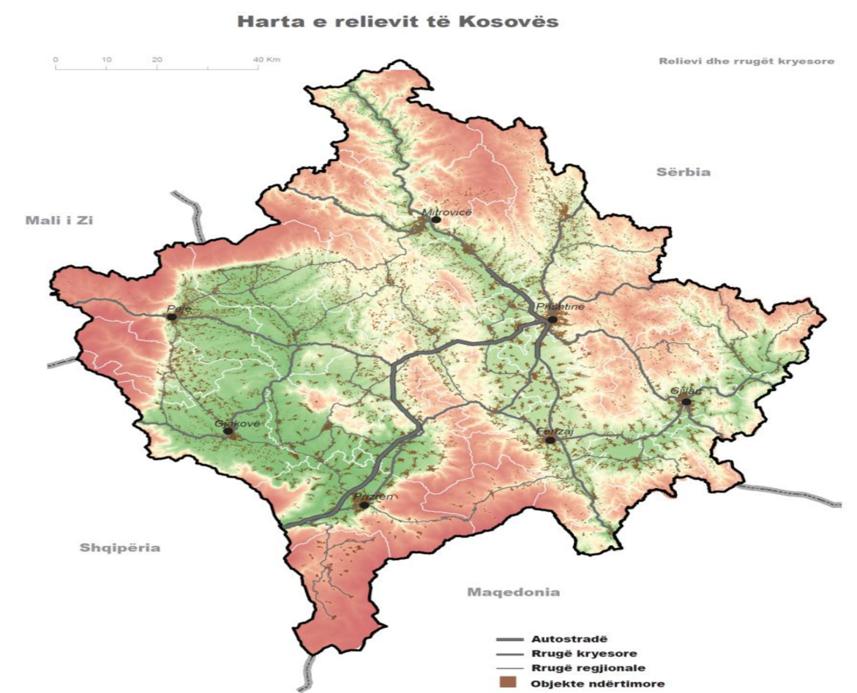

Administrative division of Kosovo - Currently, there are 38 municipalities in Kosovo with 1,469 settlements organized according to national laws.

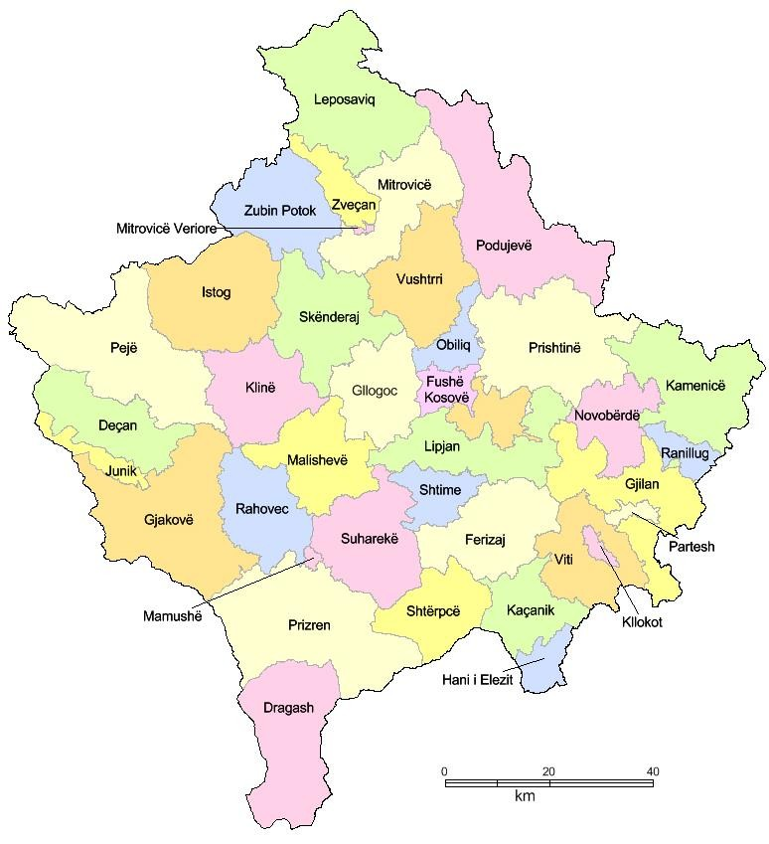

Population

To analyse the demographic situation of a country, the main sources are provided by data obtained from the census (which according to United Nations rules, is carried out every ten years) and vital statistics. The last census in Kosovo was conducted in 2011.

The state of Kosovo is characterized by a very young population structure, with an

average age of 30.2 years.

*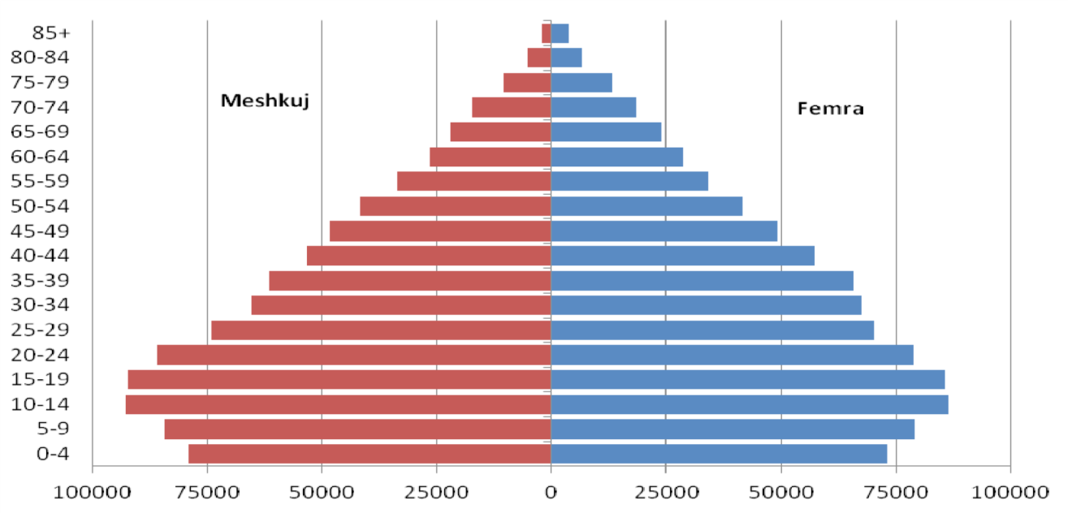Population pyramid dated 31 March 2011, by gender and age:*

Source: KAS, 2019

Population pyramids represent the population structure by years of census, age, and gender. Until the last census of 2011, the results were presented based on the concept of resident and non-resident population. While the 2011 census did not include the population living outside Kosovo for more than 12 months. Therefore, due to the change in methodology, we have a disproportionate share of the total population compared to previous years.

*Population by age, 2018*

|  |
| --- |
| 0  10  20  30  40  50  60  70  80  90  100  EU-28  Montenegro  NorthMacedonia  Albania  Serbia  Turkey  Kosovo (  1  )  **Lessthan15years**  **15-64**  **years**  **65**  **Yearsandover**  Note: BosniaandHerzegovina, notavailable.  (1) 2017.  *Source:* Eurostat (online data code: [demo_pjangroup)](https://ec.europa.eu/eurostat/product?code=demo_pjangroup&mode=view&language=EN) |

After 1990, the population of Kosovo was faced with the phenomenon of migration, which affected both its structure and its growth rates. The free and uncontrolled movement of the population has led to a shift in the ratio of rural to urban population. According to the census conducted in April 2011, 61% of the population lives in rural areas.

*Estimated population in Kosovo*

| Chuang | Total population of Kosovo estimated for the year: | | | | | | |
| --- | --- | --- | --- | --- | --- | --- | --- |
| 2012 (31 December 2012) | 2013 (31 December 2013) | 2014 (31 December 2014) | 2015 (31 December 2015) | 2016 (31 December 2016) | 2017 (31 December 2017) | 2018 (31 December 2018) |
| 1,815,606 | 1,820,631 | 1,804,944 | 1,771,604 | 1,783,531 | 1,798,506 | 1,795,666 |

[Source:](http://ask.rks-gov.net/popullsia/publikimet-e-statistikave-te-popullsise) Census 2011, KAS

According to calculations by the Kosovo Agency of Statistics, the average life expectancy for 2011 in Kosovo for both sexes was 76.7 years. Females had an average life expectancy of 79.4 years while males 74.1 years.

*Life expectancy at birth, 2011*

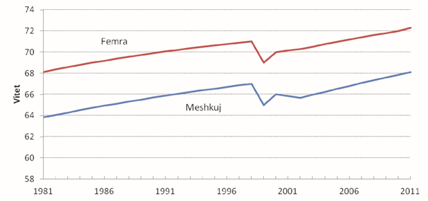

Source: World Bank database

**Health System in Kosovo**

The Ministry of Health of the Republic of Kosovo has the role of policy maker, setting norms and standards and overseeing the health system in the country.

Within the MoH, in addition to other units of the Central Administration, the Kosovo Agency for Medical Products and Equipment, the National Institute of Public Health of Kosovo and the National Blood Transfusion Center function as regulators in the respective fields; as well as the Health Inspectorate and the Pharmaceutical Inspectorate as law enforcement monitors!

The health system consists of the public sector and the private sector.

The public sector is financed from the central budget, through the regular budget process for Secondary and Tertiary Care (SHC, THC); and the Specific Grants Commission of the Ministry of Finance, for Primary Health Care (PHC).

Primary Health Care (PHC) - is the competence of municipalities, and is fully based on the concept of family medicine, namely the family medicine team, which consists of a specialist family medicine doctor and two family nurses. The PHC also offers dental health care: at the primary level by dentists; and at the secondary level in the Main Family Medicine Centres (specialist dentists).

Each municipality has its main unit, the Main Family Medicine Center, with departments according to the laws in force, and organizes and manages the constituent units in the territory of the municipality, which are Family Medicine Centers (FMCs) and Family Medicine Ambulanta (FMA).

The public network of PHC consists of a total of 429 institutions, namely 28 Main Family Medicine Centers (MFMCs), 183 Family Medicine Centers (FMCs), and 191 Family Medicine Ambulanta. There are 15 outpatient maternity wards within the MFMCs, as well as some outpatient specialist services, which will be gradually closed.

The financing of PHC, as mentioned above, is done from the state budget, as a specific grant for health, through the Grants Commission led by the Prime Minister of the country, and from the own source revenues of the municipality. This budget does not cover the needs for medicines and consumables; therefore, the Ministry of Health (MoH) supplies all municipalities with medicines and consumables, from the regular budget of the MoH.

Health services, mainly primary and outpatient specialist levels, are also provided in several other government departments. These costs are included in the database, and will be presented in the chapter with the relevant tables in this report.

Secondary Health Care (SHC) and Tertiary Health Care (THC) - Kosovo has integrated secondary and tertiary services into a public health service provider, namely the Hospital and University Clinical Service of Kosova (HUCSK), which in addition to specific health services for relevant institutions according to the level (hospital and outpatient-specialist, diagnostic, etc.), also provides education at the Faculty of Medicine for basic studies, postgraduate studies and relevant scientific research.

The health institutions of secondary and tertiary level of health care, which constitute the HUCSK, are as follows:

* University Clinical Center of Kosovo;
* University Dental Clinical Center of Kosovo;
* National Center of Occupational Medicine in Gjakova;
* National Center for Sports Medicine;
* National Telemedicine Center;
* General Hospital in Mitrovica;
* General Hospital in Gjilan;
* General Hospital in Peja;
* General Hospital in Gjakova;
* General Hospital in Prizren;
* General Hospital in Ferizaj;
* General Hospital in Vushtrria;
* Mental Health Centers with Community Integration Housing;
* Center for Integration and Rehabilitation of Chronic Psychiatric Patients in Shtime.

The Hospital and University Clinical Service of Kosova has 7076 employees registered in the salary system.

Specialist doctors are 22% of the staff, nurses are 60% and 18% of the staff are non-medical staff.

Expressed in numbers, 1562 are specialist doctors, 4239 of the workers are nurses and 1275 are other non-medical staff.

Work activities of the Hospital and University Clinical Service of Kosovo

*Total Services HUCSK, 2018*

*\* This table shows the work activities of Hospitals and Clinics for 2018, and show the use of their capacities.*

|  |  |  |  |  |  |  |  |  |  |  |  |  |
| --- | --- | --- | --- | --- | --- | --- | --- | --- | --- | --- | --- | --- |
| **Unit** | **Clinic** | **No. of beds** | **Days of healing** | **No. of hospitalized** | **No. of operated** | **Outpatient visits / daily stays**  **MH** | **Laboratory services** | **Other and / or special (diagnostic) services** | **No. of births** | **No. of dialysis** | **Average daily recovery** | **Capacity utilization** |
| UCCK | 37 | 1,908 | 465,488 | 78,791 | 22,715 | 517,880 | 1,246,917 | 903,413 | 9,963 | 39,374 | 5.91 | 66.84 |
| Hospitals | 7 | 2,000 | 381,340 | 84,222 | 18,376 | 825,381 | 1,571,406 | 549,889 | 12,128 | 85,072 | 4.53 | 52.24 |
| Mental health | 8 | 154 |  |  |  | 64,027 |  | 288,353 |  |  |  |  |
| Occupational Medicine | 1 |  |  |  |  | 28,361 | 112,464 | 48,345 |  |  |  |  |
| HUCSK | 1 |  |  |  |  | 51,829 |  | 278,693 |  |  |  |  |
| NCSM | 1 |  |  |  |  | 21,247 |  |  |  |  |  |  |
| Telemedicine | 1 |  |  |  |  |  |  | 34,641 |  |  |  |  |
| **Total** | **56** | **4,062** | **846,828** | **163,013** | **41,091** | **1,508,725** | **2,930,787** | **2,103,334** | **22,091** | **124,446** | **5.19** | **59.37** |

Source: HUCSK Work Report 2018, published by HUCSK

Health workers in Kosovo, according to the Chambers of Health Professionals of Kosovo:

*Chambers of healthcare professionals in the Republic of Kosovo licensed in 2018*

*\* The table below presents the Chambers of healthcare professionals divided by gender.*

|  |  |  |  |
| --- | --- | --- | --- |
| **Chambers** | **Total** | **Females** | **MALE** |
| Chamber of Doctors | 3,616 | 1,586 | 2,030 |
| Chamber of Nurses | 12,194 | 9,873 | 2,321 |
| Chamber of Dentists | 1,554 | 663 | 891 |
| Chamber of Physiotherapists | 405 | 247 | 158 |
| Chamber of Pharmacists | 1,472 | 1,072 | 400 |
| **Total** | **19,241** | **13,441** | **5,800** |

SHC and THC, as mentioned above, are financed from the state budget, through the regular annual budget process, which in principle is a budget based on previous (historical) years, which is approved according to the budget possibilities of the Budget of the Republic of Kosovo.

The private sector is financed by private sources and direct payment for services.

Legal acts in the country equate the private sector with the public.

The private sector is dynamic and developing rapidly, taking into account the legal incentivization by the state. Procedures for starting a private health institution are standardized by the MoH and are easy to implement.

The network of private health institutions in Kosovo, according to the data of the Ministry of Health, consists of 27 private hospitals and 1592 other private health institutions, respectively, 114 Polyclinics, 141 laboratories, 43 cabinets, and 1294 specialist clinics.

The initial financing of private institutions is done by the founder of the institution, while subsequently it is financed by the direct payment of the citizens for the health services provided.

**Health activity**

The health activity analysis in the Republic of Kosovo is the competence of the National Institute of Public Health of Kosovo, which must publish the Annual Report on the health status of the population. Since it has not been published for 2018, we will present the basic data from the 2016 Report.

Primary Health Care (PHC)

Staff

In PHC for 2016, according to the reported data, there are a total of 5,358 employees‚ of whom 1,087 (20.3%) doctors, 296 (5.5%) dentists, 7 (0.1%) pharmacists, 3,078 (57.4%) medical technicians/nurses, 44 (0.8%) health care associates, and 846 (15.8%) non-medical staff.

The number of inhabitants to one doctor is 1,587 which is close to the norm given for

Family Medicine. By municipalities, it varies from 845 in Obiliq to 6,993 inhabitants to

one doctor in Novoberde.

There are 5,830 inhabitants to one dentist in PHC in Kosovo.

The number of inhabitants to one nurse is 561 and varies from 806 to 370.

By municipalities, reported pharmacists are deficit staff;

The ratio between nurses and doctors is 3: 1, ranging from 2: 1 to 9: 1.

Workload indicators in PHC

A total of 3,688,571 visits to the doctor, 384,655 visits to the dentist and 6,006,009 visits to other health professionals were made in the PHC

The average daily workload of a doctor is 12.1 visits.

The average daily workload of a dentist is 4.6 visits.

The average daily workload of a nurse is 7 visits.

On average, there are 2.1 visits per doctor per capita per year, ranging from 8.0 to 0.6 visits per year.

On average, there are 0.2 visits to the dentist per capita per year.

Secondary Health Care (SHC)

Staff

In 2016, a total of 446 doctors, 115 health and non-health associates ;, as well as a total of 1015 nurses were employed general hospitals in Kosovo.

Workload indicators

According to the reports generated by the NIPHK, in total 1,952 beds were reported

in the Kosovo General Hospitals in 2016. 82,081 patients were hospitalized respectively treated in the hospitals.

The ratio per doctor varies from 4.2 to 0.5.

Hospital capacity utilization at the Kosovo level is 55.3%, with variations from 118.6% to 33.4%.

The average number of surgeries per doctor in Kosovo level is 36.

The average treatment in general hospitals is 4.7 days, with variations from 14.9 to 3.2 days.

The daily workload per doctor in Kosovo was 2.3 patients while the daily workload

per nurse was 1.0.

Hospital mortality by ward was the highest in the Neurology ward with 86.7% and

Surgery Intensive Care 62%.

Tertiary Health Care (THC)

Staff

In 2016, THC employed a total of 3,097 employees, out of which 597 doctors (19.3% of the total number of employees), 62 dentists (2.0%), pharmacists 10 (0.3%), 1,837 nurses (59.3%) health care associates 14 (0.5%) and non-health care employees 576 (18.6%). The total number of specialist doctors in UCCK was 535, while the total number of nurses in UCCK was 1,667.

Workload indicators in UCCK

In UCCK according to the reports generated by NIPHK, in 2016 were reported

a total of 1,898 beds and 504,826 days of treatment.

The number of patients hospitalized in the UCCK was 96,828 and in relation to clinical doctors, we have 180 patients per doctor.

The average daily doctor workload (patients hospitalized per doctor) at UCCK was

1.9.

The average (daily) workload of the nurse was 1.2.

**(Source: Analysis of the Health Status of the Population in Kosovo - 2016; NIPHK)**

**Financing the (public) health system in retrospective**

The Republic of Kosovo is considered a country with high middle income, according to the categorization of the World Bank. As a developing country, the Republic of Kosovo has many priorities, which need financing from the state budget. In this context it should be understood that not all the needs of the public health sector have been funded, in retrospective.

Lack of sufficient funds for the normal functioning of the system has caused the shift of costs to the pocket of the citizen, primarily for medicines and consumables (outpatient drugs), as well as for health services, in cases where these services are not provided in public sector.

The Ministry of Health, in order to address this issue and mitigate the problem, has launched a program for treatment outside public health institutions (in the country or abroad); but the means are not enough for all the needs; therefore, a number of citizens seek treatment abroad, spending considerable amounts of financial means, which unfortunately, at the moment we are not able to register, nor can we make an objective assessment, which could have been used for the purposes of this report.

The budget of the public health sector during the last decade had the following variable movements:

Budget of MoH for the period 2008 - 2018

*Table # 1: Expenditures in the Ministry of Health, for the years 2008 - 2018, by economic categories (in Euro):*

|  |  |  |  |  |  |  |  |  |  |  |  |
| --- | --- | --- | --- | --- | --- | --- | --- | --- | --- | --- | --- |
| **Economic category** | **2018** | **2017** | **2016** | **2015** | **2014** | **2013** | **2012** | **2011** | **2010** | **2009** | **2008** |
| Wages and salaries | 8,050,649 | 8,313,972 | 7,940,750 | 7,652,757 | 52,854,734 | 44,408,183 | 42,527,654 | 38,827,166 | 32,868,160 | 25,182,645 | 20,434,658 |
| Goods and services | 34,337,304 | 29,507,959 | 24,676,108 | 9,166,585 | 36,324,871 | 38,332,671 | 29,167,678 | 29,397,827 | 27,626,773 | 31,958,263 | 28,193,386 |
| Utility costs | 155,408 | 183,802 | 183,845 | 196,571 | 3,739,731 | 3,388,643 | 3,871,062 | 3,292,171 | 3,354,697 | 3,352,104 | 3,536,639 |
| Subsidies and transfers | 11,016,744 | 14,364,873 | 9,935,261 | 9,716,570 | 9,683,042 | 4,763,603 | 2,841,184 | 2,206,483 | 2,955,421 | 3,025,095 | 2,777,079 |
| Non-financial assets | 4,999,345 | 5,213,494 | 7,146,481 | 4,990,190 | 8,807,593 | 8,628,310 | 8,897,476 | 6,158,817 | 7,999,286 | 12,359,687 | 7,674,597 |
| **Total expenditures** | **58,559,449** | **57,584,100** | **49,882,445** | **31,722,673** | **111,409,971** | **99,521,409** | **87,305,055** | **79,882,464** | **74,804,338** | **75,877,794** | **62,616,358** |

Budget changes in 2015 and 2016, were made due to the allocation of Hospital and University Clinical Service of Kosova (HUCSK) as an independent budget organization; whereas in 2016, in the MoH from HUCSK only the budget for medicaments and consumables was spent.

It should be noted that during 2018 we had an increase in the budget for medicines and consumables for HUCSK!

The budget of Hospital and University Clinical Service of Kosova (HUCSK), for the year 2015 - 2018, was as follows:

*Table # 2: Expenditures in HUCSK, for the years 2015 - 2018, by economic categories (in Euro):*

*\* This table shows the expenditures for the secondary and tertiary level. In 2016, the budget allocated for drugs and consumables was transferred from the HUCSK to the MoH; therefore, there is a decrease in the level of funding in the economic category Goods and Services.*

|  |  |  |  |  |
| --- | --- | --- | --- | --- |
| **Economic category** | **2018** | **2017** | **2016** | **2015** |
| Wages and salaries | 58,242,230 | 51,586,625 | 51,294,776.17 | 49,882,132 |
| Goods and services | 13,659,911 | 13,049,585 | 10,812,241 | 27,286,586 |
| Utility costs | 3,617,547 | 2,060,463 | 3,351,393 | 3,482,745 |
| Subsidies and transfers |  |  |  |  |
| Non-financial assets | 9,473.831.71 | 3,856,439 | 3,772,213 | 5,490,853 |
| **Total** | **84,993,519** | **70,553,112** | **69,230,624** | **86,142,316** |

Municipal budget for Primary Health Care (PHC), for the period 2008-2018, was as follows:

*Table # 3: Expenditures for municipal health, for the years 2008 - 2018, by economic categories (in Euro):*

*\* In this table we notice that the budget allocated for health at the primary level has had an increasing trend over the years, mainly in the category Wages and Salaries for capacity building with health staff.*

|  |  |  |  |  |  |  |  |  |  |  |  |
| --- | --- | --- | --- | --- | --- | --- | --- | --- | --- | --- | --- |
| **Economic categories** | **2018** | **2017** | **2016** | **2015** | **2014** | **2013** | **2012** | **2011** | **2010** | **2009** | **2008** |
| Wages and salaries | 40,971,614 | 39,296,553 | 39,363,941 | 38,276,205 | 34,381,291 | 31,133,814 | 30,963,725 | 29,881,861 | 25,385,411 | 18,827,802 | 14,447,354 |
| Goods and services | 7,666,861 | 6,228,039 | 5,794,995 | 5,859,230 | 5,465,355 | 6,199,678 | 6,020,434 | 4,972,348 | 4,465,575 | 4,465,096 | 4,422,430 |
| Utility costs | 1,396,815 | 1,407,892 | 1,452,879 | 1,477,955 | 1,319,799 | 1,455,494 | 1,406,139 | 1,412,824 | 1,390,091 | 1,303,704 | 1,158,053 |
| Subsidies and transfers | 1,024,825 | 714,106 | 685,918 | 794,023 | 961,902 | 1,075,243 | 837,048 | 866,047 | 796,735 | 780,010 | 487,538 |
| Non-financial assets | 6,230,629 | 4,594,592 | 3,997,867 | 4,841,654 | 7,036,755 | 5,822,963 | 6,085,427 | 6,477,587 | 4,895,421 | 4,699,037 | 1,060,482 |
| **Total** | **57,290,744** | **52,241,181** | **51,295,600** | **51,249,067** | **49,165,102** | **45,687,192** | **45,312,774** | **43,610,666** | **36,933,233** | **30,075,650** | **21,575,857** |

Other departments, despite accounting for a very small percentage of health expenditures, are deemed necessary to be included in this report. Expenditures are dedicated to specific health institutions within the relevant departments, and relate to the MoJ - the Institute of Forensics, the Health Service of the MoD and the ANSA. This data has been collected for the first time for 2018!

*Table # 4: Expenditures of other public sector departments for health, 2018 (in Euro):*

*\* In this table we see that other ministries/agencies also spend on health mainly in terms of prevention and primary care:*

|  |  |
| --- | --- |
| **Institution** | **Amount** |
| Ministry of Justice | 851,282 |
| Ministry of Defence | 350,785 |
| Air Navigation Services Agency | 35,242 |
| **Total** | **1,237,309** |

The summary of public health expenditures, by main expenditures, for the last 11 years is presented in the following table:

*Table # 5: Public Sector Expenditures on Health, 2008-2018 (in Euro):*

*\* This table presents the health expenditures financed directly from the government grant.*

|  |  |  |  |  |  |  |  |  |  |  |  |
| --- | --- | --- | --- | --- | --- | --- | --- | --- | --- | --- | --- |
| **Institution** | **2018** | **2017** | **2016** | **2015** | **2014** | **2013** | **2012** | **2011** | **2010** | **2009** | **2008** |
| Ministry of Health | 58,559,449 | 57,584,100 | 49,882,445 | 31,722,673 | 111,409,971 | 99,521,409 | 87,305,055 | 79,882,464 | 74,804,338 | 75,877,794 | 62,616,358 |
| HUCSK | 84,993,519 | 70,553,112 | 69,230,624 | 86,142,316 |  |  |  |  |  |  |  |
| Municipalities (PHC) | 57,290,744 | 52,241,181 | 51,295,600 | 51,249,067 | 49,165,102 | 45,687,192 | 45,312,774 | 43,610,666 | 36,933,233 | 30,075,650 | 21,575,857 |
| Other ministries | 1,237,309 |  |  |  |  |  |  |  |  |  |  |
| **Total** | **202,081,021** | **180,378,393** | **170,408,669** | **169,114,056** | **160,575,073** | **145,208,601** | **132,617,829** | **123,493,130** | **111,737,571** | **105,953,444** | **84,192,215** |

As it can be seen in the table, there is a change in budget allocations in 2015 and 2016, these were made due to the allocation of HUCSK as an independent budget organization; whereas there is again a change in 2016, namely from HUCSK to MoH has been transferred only the budget for medicines, consumables and some capital projects; budget which returns to HUCSK in 2018.

Whereas, expressed as a percentage of Gross Domestic Product (GDP), health expenditures are presented in the following tables:

Note:

**Gross Domestic Product (GDP) -** The most important economic indicator in the System of National Accounts is the Gross Domestic Product (GDP), which represents the performance of a country's economy in a given period. There are three approaches to measuring GDP: the production, expenditure and revenue approach.

**Final household consumption:** Final household consumption is the main component of Gross Domestic Product with the approach to expenditures and represents the expenditures of resident households, in order to meet their needs and requirements for goods and services. This means not only goods and services paid for directly, but also their receipt in kind or from own production.

The estimation of household expenditures is based on household budget survey data. This survey is organized in KAS.

**General Government Final Consumption Expenditures:** The final consumption of the Government consists of the amount of goods and services purchased, the compensation of workers and the consumption of fixed capital, reduced by sales revenues.

**Final consumption of non-profit institutions serving households:** Non-profit institutions serving households consist of Non-governmental Organizations (NGOs).

**Source: Gross Domestic Product: 2008 - 2018 / Kosovo Agency of Statistics, 2019. - 14 p. : ilust. ; 24 cm. - (Series 3: Economic Statistics)**

*Table # 6: Gross Domestic Product according to economic activities at current prices, 2008 - 2018*

|  |  |  |  |  |  |  |  |  |  |  |  |
| --- | --- | --- | --- | --- | --- | --- | --- | --- | --- | --- | --- |
| **Economic activities** | (in million Euros) | | | | | | | | | | |
| **2008** | **2009** | **2010** | **2011** | **2012** | **2013** | **2014** | **2015** | **2016** | **2017** | **2018** |
| Health and social work activities | 49 | 57 | 73 | 84 | 91 | 96 | 107 | 118 | 125 | 129 | 144 |
| Gross Domestic Product | 3,538 | 3,610 | 4,031 | 4,556 | 4,797 | 5,071 | 5,325 | 5,674 | 6,037 | 6,356 | 6,672 |

Source: Gross Domestic Product: 2008 - 2018 / Kosovo Agency of Statistics, 2019. - 14 p. : illust. ; 24 cm. - (Series 3: Economic Statistics)

*Table # 7: Gross Domestic Product at current prices 2008 - 2018 (in million Euros)*

|  |  |  |  |  |  |  |  |  |  |  |  |
| --- | --- | --- | --- | --- | --- | --- | --- | --- | --- | --- | --- |
| **Economic activities** | **GDP share by activities** | | | | | | | | | | |
| **2008** | **2009** | **2010** | **2011** | **2012** | **2013** | **2014** | **2015** | **2016** | **2017** | **2018** |
| GDP at current prices (million Euros) | 3,538 | 3,610 | 4,031 | 4,556 | 4,797 | 5,071 | 5,325 | 5,674 | 6,037 | 6,356 | 6,672 |
| **GDP per capita (Euro)** | 2,057 | 2,066 | 2,271 | 2,529 | 2,654 | 2,794 | 2,950 | 3,202 | 3,368 | 3,534 | 3,716 |

Source: Gross Domestic Product: 2008 - 2018 / Kosovo Agency of Statistics, 2019. - 14 p. : illust. ; 24 cm. - (Series 3: Economic Statistics)

The table below shows that the budget has not managed to exceed 3% of GDP, as a government allocation for the public health sector.

*Table # 8: GDP, and % of GDP for health (main public expenditures), 2008-2018 (in million Euros)*

|  |  |  |  |  |  |  |  |  |  |  |  |
| --- | --- | --- | --- | --- | --- | --- | --- | --- | --- | --- | --- |
|  | **2008** | **2009** | **2010** | **2011** | **2012** | **2013** | **2014** | **2015** | **2016** | **2017** | **2018** |
| **Nominal GDP (million Euros)** | 3,538 | 3,610 | 4,031 | 4,556 | 4,797 | 5,071 | 5,325 | 5,674 | 6,037 | 6,356 | 6,672 |
| **MoH (million Euros)** | 63 | 76 | 75 | 80 | 87 | 100 | 111 | 32 | 50 | 58 | 59 |
| **HUCSK (million Euros)** |  |  |  |  |  |  |  | 86 | 69 | 71 | 85 |
| **Municipal Level (million Euros)** | 22 | 30 | 37 | 44 | 45 | 46 | 49 | 51 | 51 | 52 | 57 |
| **Health Expenditures/GDP** | **2.40%** | **2.90%** | **2.80%** | **2.70%** | **2.80%** | **2.90%** | **3.00%** | **3.00%** | **2.80%** | **2.80%** | **3.00%** |

Source: Ministry of Finance: Department of Macroeconomics and Treasury Department; Ministry of Health: Budget and Finance Division!

*Graph no. 1: Public spending on health, by years*

*\* This graph presents the movement of the health expenditure curve financed by the Government Grant, which has increased in the last 10 years, expressed in million Euros*

*Graph No. 2: Public expenditures on health, as a percentage of Gross Domestic Product, by years*

*\* This graph presents the movement of the health expenditure curve in relation to GDP in the last 10 years, expressed as a percentage.*

The graph above shows an important development for both health and the economy. Graph No. 2 shows a constant increase in public spending on health - an indicator that may indicate the development of health in the country. This increase also indicates another development - the contribution of health to Kosovo's GDP has increased over the years. This assertion also stands when looking at real GDP over the years disaggregated by economic activity - which clearly shows the growing contribution from the health sector along with social work activities.

*Graph no. 3: Comparison of Nominal Gross Domestic Product and public health expenditures, as a percentage of Gross Domestic Product, by years*

Expenditures for the public health sector, despite being considered significant, have so far failed to cover all the needs of the sector and citizens for health services, medicines and consumables.

Whereas, according to KAS data, the total GDP for health, for the period 2015 - 2018 has the following performance:

***Table # 9: GDP, and % of GDP for health (total) 2015-2018 (in million Euros)***

|  |  |  |  |  |  |
| --- | --- | --- | --- | --- | --- |
|  | **2018** | **2017** | **2016** | **2015** | **Explanation** |
| Nominal GDP | 6,671.50 | 6,356.50 | 6,037.30 | 5,674.40 | Source: years 2015-2019: KAS |
| Final consumption of households | 5,296.10 | 5,009.00 | 4,910.50 | 4,803.70 | Source: years 2015-2019: KAS |
| Private expenditures on health (% of final household consumption) | 3.00% | 3.00% | 3.00% | 3.00% | Source: KAS |
| Private expenses (million Euros) | 158,883.18 | 150,269.16 | 147,313.71 | 144,110.94 | Calculation = Final consumption of households x Private expenditures (% of final consumption of households) |
| **% of GDP for public health** | **3.00%** | **2.80%** | **2.80%** | **3.00%** | Calculation = Total Public Expenditure on Health/Nominal GDP |
| **% of GDP for private health expenditures** | **2.40%** | **2.40%** | **2.40%** | **2.50%** | Calculation = Total Private Expenditure on Health/Nominal GDP |
| **% of GDP for health** | **5.40%** | **5.20%** | **5.30%** | **5.50%** | Calculation = (Total Public Expenditure on Health + Total Private Expenditure on Health)/Nominal GDP |

Source: KAS, National Accounts 2021 with the report "Review of National Accounts 2008 - 2019”

**Financing the health system in 2018**

During 2018, according to official data of the Kosovo Agency of Statistics (KAS), real GDP had an increase of 3.8% while nominal GDP was about 4.9%. Consumption and investment had the highest contribution to this growth, whereas net exports had a negative contribution. However, although exports of goods did not perform well, the continued growth of exports of services is encouraging (5.5% in 2018).

Health financing is mainly realized by Budget of the Republic of Kosovo, own source revenues and lending from the World Bank. Own source revenues in Primary Health Care are used to partially finance the implementation of capital projects for municipal health.

The reform of the health system, during 2015 has enabled the separation of the HUCSK from the Ministry of Health, as an independent budget organization.

Consequently, the HUCSK, from 1 January 2015, has started to operate as an independent budget unit with all economic categories from the Ministry of Health. In 2016, with the amendments proposed by the Committee on Budget and Finance of the Republic of Kosovo, and with the voting of the Law on Budget by MPs of the Republic of Kosovo, the economic categories (Capital and medicaments and consumables) were transferred to the MoH.

**Public sector**

The public health sector in Kosovo consists of all health and administrative institutions which are dependent on the state budget to conduct their activities, including various government departments and executive agencies of departments which have the task of monitoring the implementation of legality in the sector.

The main public sector expenditures had the following expenditure structure:

*Table # 10: MoH expenditures, by economic categories:*

|  |  |
| --- | --- |
| **Economic category** | **Amount** (Euro) |
| Wages and salaries |  |
| Goods and services | 34,337,303.61 |
| Utility costs | 155,407.50 |
| Subsidies and transfers | 11,016,744.10 |
| Non-financial assets | 4,999,344.69 |
| **Total** | **58,559,448.67** |

The Ministry of Health has also had the support of donors this year, according to the table adapted to the legal reporting system in the country, according to economic categories:

|  |  |
| --- | --- |
| *Table # 11: Donations to the MoH, by economic categories:* | |
| **Economic category** | **Amount** (Euro) |
| Wages and salaries | 1,090,914.60 |
| Goods and services | 6,508,128.70 |
| Utility costs | 6,741.00 |
| Subsidies and transfers |  |
| Non-financial assets | 5,639,249.90 |
| **Total** | **13,245,034.20** |

Donations are provided by the following donors:

* TIKA, Turkey (Renovation and equipment: UCCK Intensive Care Unit);
* Her Excellence Office Sheikha Fatima Bint Mubara; Abu Dhabi (Construction and equipment: Pediatric Clinic, HUCSK);
* Accessible Quality Healthcare (AQH) (Swiss Agency for Development and Cooperation - SDC) (Support for CSP);
* Government of Japan (Supply of medical equipment);
* Government of Luxembourg (Kosovo Health Support Program);
* Global Fund (HIV Prevention in Kosovo and Strengthening TB Control in Kosovo;
* Direct Relief;
* Action for mothers and children (Supply of medicines);
* Care for Kosovo kids (Supply of medicines/consumables);
* Liri Med (Supply of consumables);
* Madekos (Supply of consumables);
* Medical Group (Supply of consumables);
* Opharma (Supply of consumables);
* Pharma Leader (Supply of consumables);
* Exclusiv shpk (Supply of medicines);
* Italian Cooperation (Kosovo Health System Support)
* WHO (Technical Assistance program for TB and AC funds for running several activities such as HIS, Health System, Environmental health etc);
* You are sunflower (Medical device);
* Medica LLC (Medical Devices);
* Helvetas/MLGA (Medical Devices);
* Fortesa home (Renovations);
* BAVARIA (Renovations);
* Others (Equipment);
* Others (Equipment);

*Table # 12: HUCSK expenditures, by economic categories:*

|  |  |
| --- | --- |
| **Economic category** | **Amount** (Euro) |
| Wages and salaries | 58,242,229.68 |
| Goods and services | 13,659,910.59 |
| Utility costs | 3,617,546.75 |
| Subsidies and transfers | - |
| Non-financial assets | 9,473,831.71 |
| **Total** | **84,993,518.73** |

*Table # 13: Expenditures of PHC (municipalities), by economic categories:*

|  |  |
| --- | --- |
| **Economic category** | **Amount** (Euro) |
| Wages and salaries | 40,971,613.87 |
| Goods and services | 7,666,861.33 |
| Utility costs | 1,396,815.48 |
| Subsidies and transfers | 1,024,824.74 |
| Non-financial assets | 6,230,628.97 |
| **Total** | **57,290,744.39** |

*Table # 14: Ministry of Justice (MoJ), by economic categories:*

|  |  |
| --- | --- |
| **Economic category** | **Amount** (Euro) |
| Wages and salaries | 583,632.00 |
| Goods and services | 143,538.50 |
| Utility costs | 48,500.00 |
| Subsidies and transfers |  |
| Non-financial assets | 75,611.17 |
| **Total** | **851,281.67** |

*Table # 15: Ministry of Defence (MoD), by economic categories*

|  |  |
| --- | --- |
| **Economic category** | **Amount** (Euro) |
| Wages and salaries |  |
| Goods and services | 237,946.32 |
| Utility costs | 29,500.00 |
| Subsidies and transfers |  |
| Non-financial assets | 83,339.00 |
| **Total** | **350,785.32** |

*Table # 16: Air Navigation Services Agency (ANSA), by economic categories*

|  |  |
| --- | --- |
| **Economic category** | **Amount** (Euro) |
| Wages and salaries | 29,472.85 |
| Goods and services | 5,768.92 |
| Utility costs |  |
| Subsidies and transfers |  |
| Non-financial assets |  |
| **Total** | **35,241.77** |

*Table # 17: Summary: Expenditure structure for key public expenditures (with donations), 2018:*

*The following table presents the expenditures by economic categories, and by the institutions listed below.*

|  |  |  |  |  |  |  |  |  |
| --- | --- | --- | --- | --- | --- | --- | --- | --- |
| **Economic category** | **MoH** | **MoH donations** | **HUCSK** | **Municipalities** | **MoJ** | **MoD** | **ANSA** | **Amount** (Euro) |
| Wages and salaries | 8,050,649 | 1,090,915 | 58,242,230 | 40,971,614 | 583,632 |  | 29,473 | 108,968,512 |
| Goods and services | 34,337,304 | 6,508,129 | 13,659,911 | 7,666,861 | 143,539 | 237,946 | 5,769 | 62,559,458 |
| Utility costs | 155,408 | 6,741 | 3,617,547 | 1,396,815 | 48,500 | 29,500 |  | 5,254,511 |
| Subsidies and transfers | 11,016,744 |  | - | 1,024,825 |  |  |  | 12,041,569 |
| Non-financial assets | 4,999,345 | 5,639,250 | 9,473,832 | 6,230,629 | 75,611 | 83,339 |  | 26,502,005 |
| **Total** | **58,559,449** | **13,245,034** | **84,993,519** | **57,290,744** | **851,282** | **350,785** | **35,242** | **215,326,055** |

Public Sector Expenditures on Health, for 2018, are summarized in the following table:

*Table # 18: Summary - Public Sector Expenditures on Health, 2018*

|  |  |
| --- | --- |
| **Public institutions** | **Amount (Euro)** |
| MoH | 58,559,448.67 |
| Donations to the Ministry of Health | 13,245,034.20 |
| HUCSK | 84,993,518.73 |
| PHC (municipality) | 57,290,744.39 |
| Ministry of Justice | 851,281.67 |
| Ministry of Defence | 350,785.32 |
| Air Navigation Services Agency | 35,241.77 |
| **Total** | **215,326,054.75** |

**Private sector**

The private health sector consists of private health institutions, licensed by the Ministry of Health to provide health services, within the Law on Health and bylaws which regulate this area.

Services offered in the private sector are hospital-day and inpatient services, outpatient specialist services, laboratory and imaging diagnostics, outpatient and inpatient rehabilitation physiotherapy, etc.

Information on the private sector was obtained from the Kosovo Agency of Statistics, publication of the Survey Results on Income and Living Conditions 2018; and the Macroeconomics Department of the Ministry of Finance, which processed and prepared the data.

The rest of the data is provided by the Central Bank of Kosovo and Kosovo Agency of Statistics, regarding voluntary health insurance in our country.

*Table # 19: Citizen's pocket expenditures for health, 2018:*

|  |  |
| --- | --- |
| **Service / expense** | **Amount** (Euro) |
| Medications | 97,272,506 |
| Pharmaceutical products other than medication | 238,285 |
| Medical equipment and other aids | 194,599 |
| Outpatient public health services | 1,580,178 |
| Outpatient private health services | 17,862,274 |
| Public dental services | 1,501,527 |
| Private dental services | 4,953,228 |
| Medical tests, laboratory, public radioscopy (Roentgen) | 564,804 |
| Medical analysis, laboratory, private radioscopy (Roentgen) | 5,708,305 |
| Public hospital services | 2,475,638 |
| Private hospital services | 8,955,593 |
| Health services abroad | 15,927,357 |
| Accommodation, food, ambulance transport abroad | 1,491,768 |
| Traditional medicine | 119,648 |
| Other medical services | 37,469 |
| **Total** | **158,883,180** |

Source: KAS - Results of the Survey on Income and Living Conditions (known as EU-SILC) in Kosovo, for 2018

*Table # 20: Expenditures on voluntary health insurance, 2018*

|  |  |
| --- | --- |
| **Institution** | **Amount** (Euro) |
| Voluntary health insurance companies (reported expenses) | € 18,040,766.00 |
| **Total** | **€ 18,040,766.00** |

Source: KAS - Publication - Health Statistics 2018

*Table # 21: Summary - Out-of-pocket health expenditures, 2018*

|  |  |
| --- | --- |
| **Service/expenditure** | **Amount** (Euro) |
| Out-of-pocket expenses (for the private sector) for health | 158,883,180.00 |
| Voluntary health insurance companies | 18,040,766.00 |
| **Total** | **176,923,946.00** |

Source: KAS - Publication - Health Statistics 2018

Expenditures on health care in the Republic of Kosovo for 2018 are presented in the following table:

*Table # 22: Expenditures on health care, Kosovo 2018 (reported data)*

|  |  |  |
| --- | --- | --- |
| **Institution/spender** | **Amount** | **Percentage** |
| Public health institutions | 202,081,021 | 51.52 |
| Donations to the Ministry of Health | 13,245,034 | 3.38 |
| Out-of-pocket expenses | 158,883,180 | 40.51 |
| Private health insurance companies (reported expenses) | 18,040,766 | 4.6 |
| **Total** | **392,250,001** | **100** |

Detailed data on health expenditures for 2018, according to specific software, are presented below:

NOTE: Capital investments are presented separately from other expenses!

Conclusions & recommendations:

* The level of financing of the health sector from government grants, expressed as a percentage of GDP from 2008 to 2018 has moved from 2.4% to 3.0%;
* During the aforementioned period, expenditures on health in addition to increasing, its contribution to the economy has also increased (expressed as the contribution of health and social activities to real GDP). In terms of health spending (from the public and private sector), Kosovo is comparable to Turkey in the region and Luxembourg and Romania in the EU - according to Eurostat data. It should be noted that health expenditures in Kosovo, expressed as a ratio to GDP, are below the regional and EU average. However, it should be borne in mind that because the average age in Kosovo is younger than in these countries, it is expected that health expenditures will be lower. However, private spending (or out-of-pocket) is high - and a contributing factor to this development is the lack of compulsory health insurance in Kosovo - unlike most of these countries.
* This level of public and private spending on health services in the country emphasizes in particular the enormous importance of the functioning of the Public Health Insurance Fund, which should serve as a financial shield for households in Kosovo.

*Graph No. 4: Public sector expenditures on health 2018, according to FS, HF, HP, HC and FA and FP*

*\* This graph imported from the HAPT system shows the distribution of the health budget, financed by the Government Grant, and spent according to service providers*

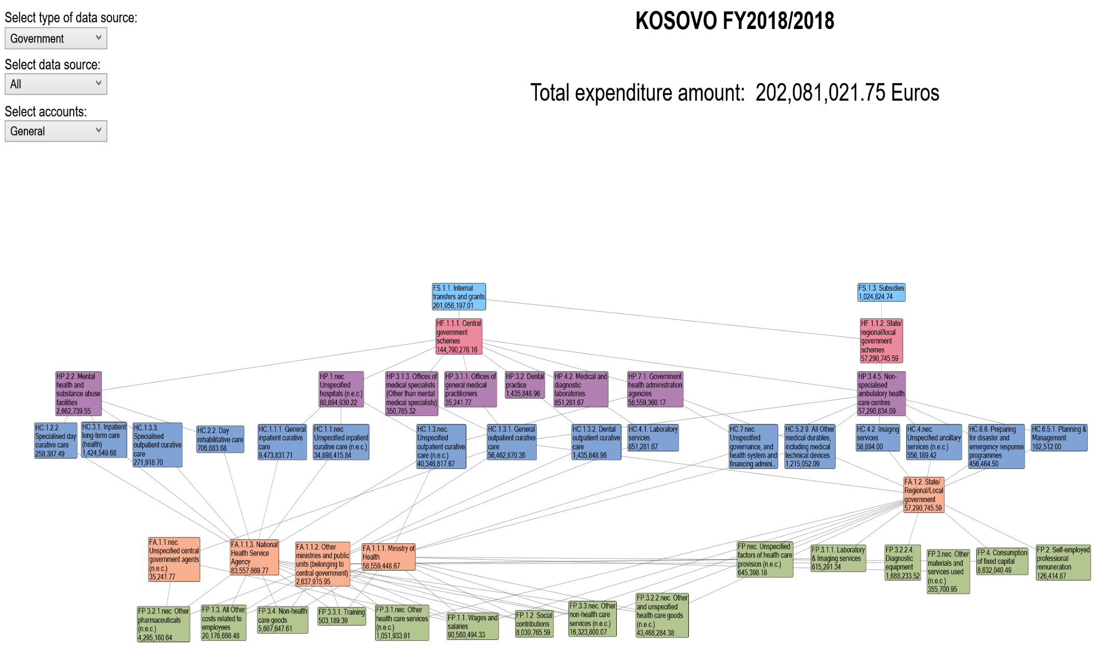

*Graph No. 5: Donor expenditures (in the Ministry of Health) 2018, according to FS, HF, HP, HC and FA and FP*

*\* This graph presents the donor expenditures in the MoH, distributed by funding source, service provider and nature of expenditure*

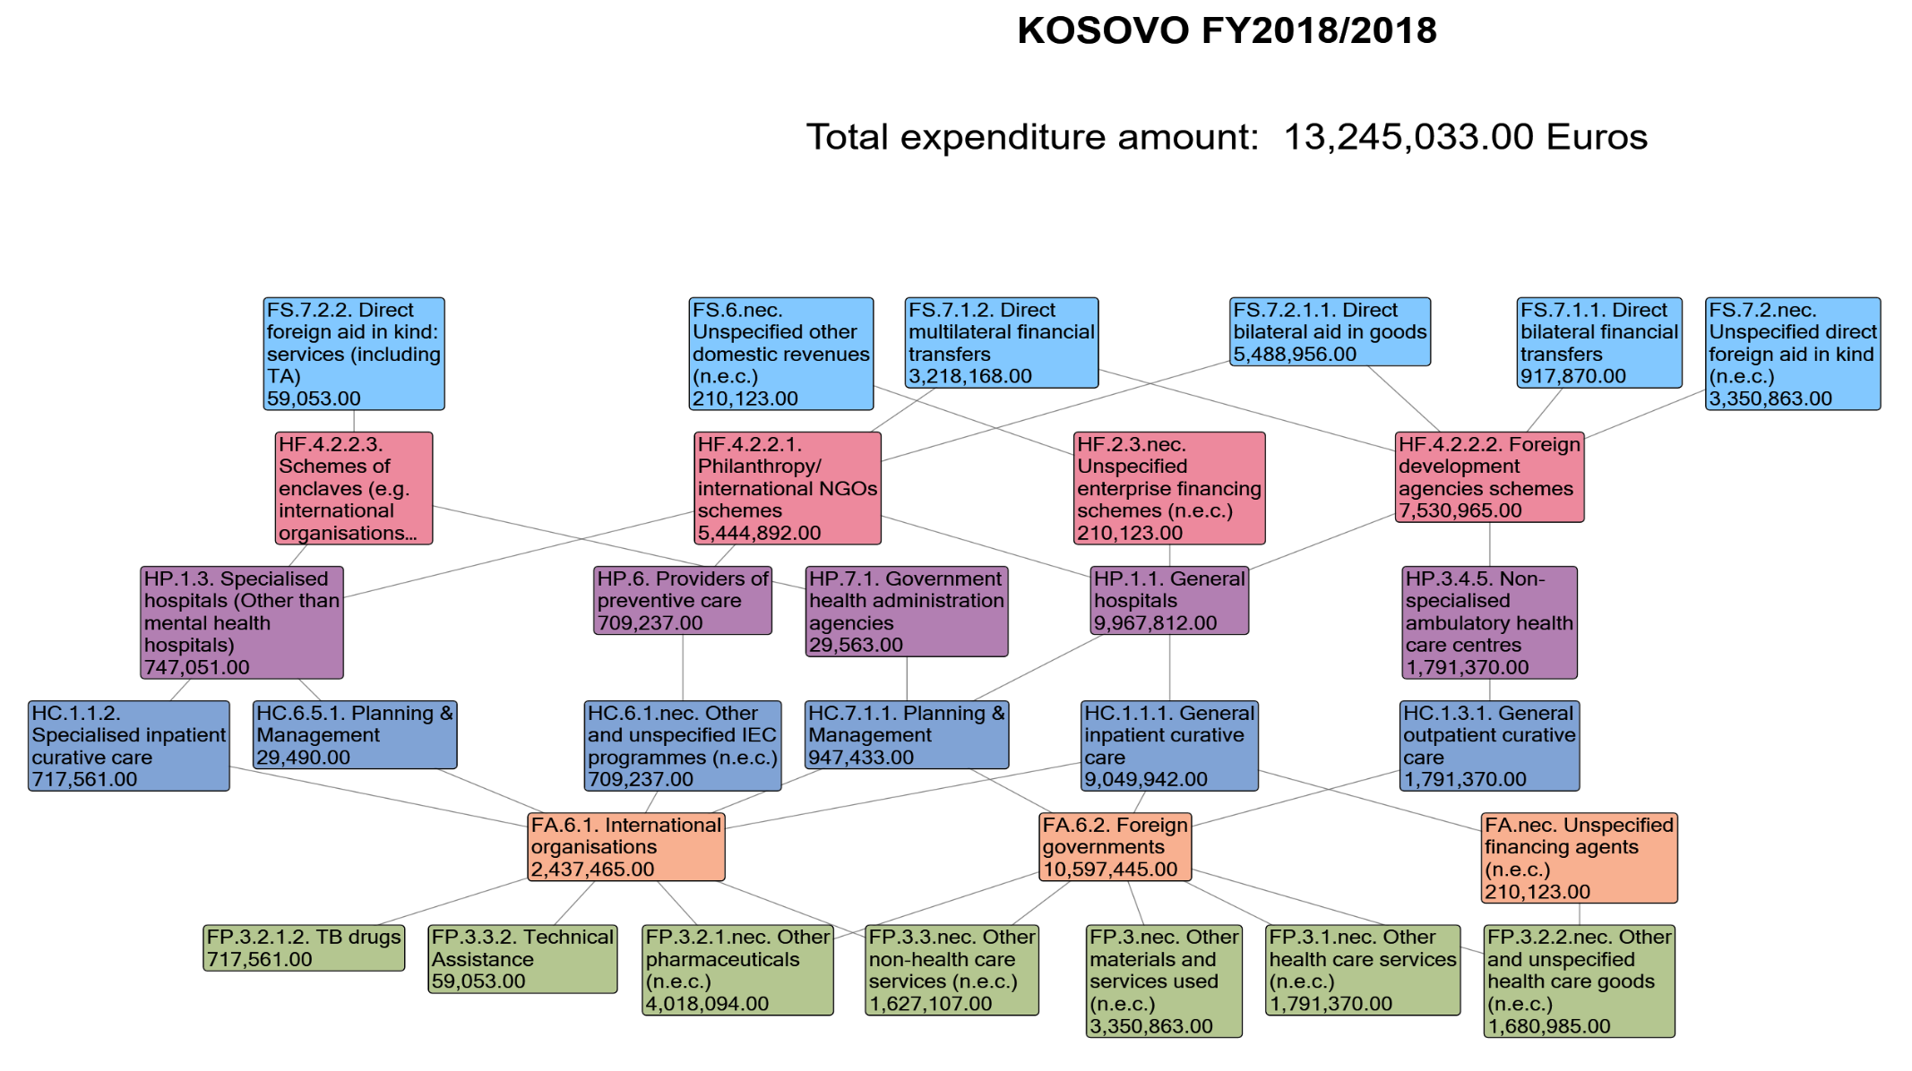

*Graph No. 6: Citizen's pocket expenses for health, 2018:*

*\* The following graph presents the total household expenditures for health services and health medicines and equipment, distributed according to the functions of the health system.*

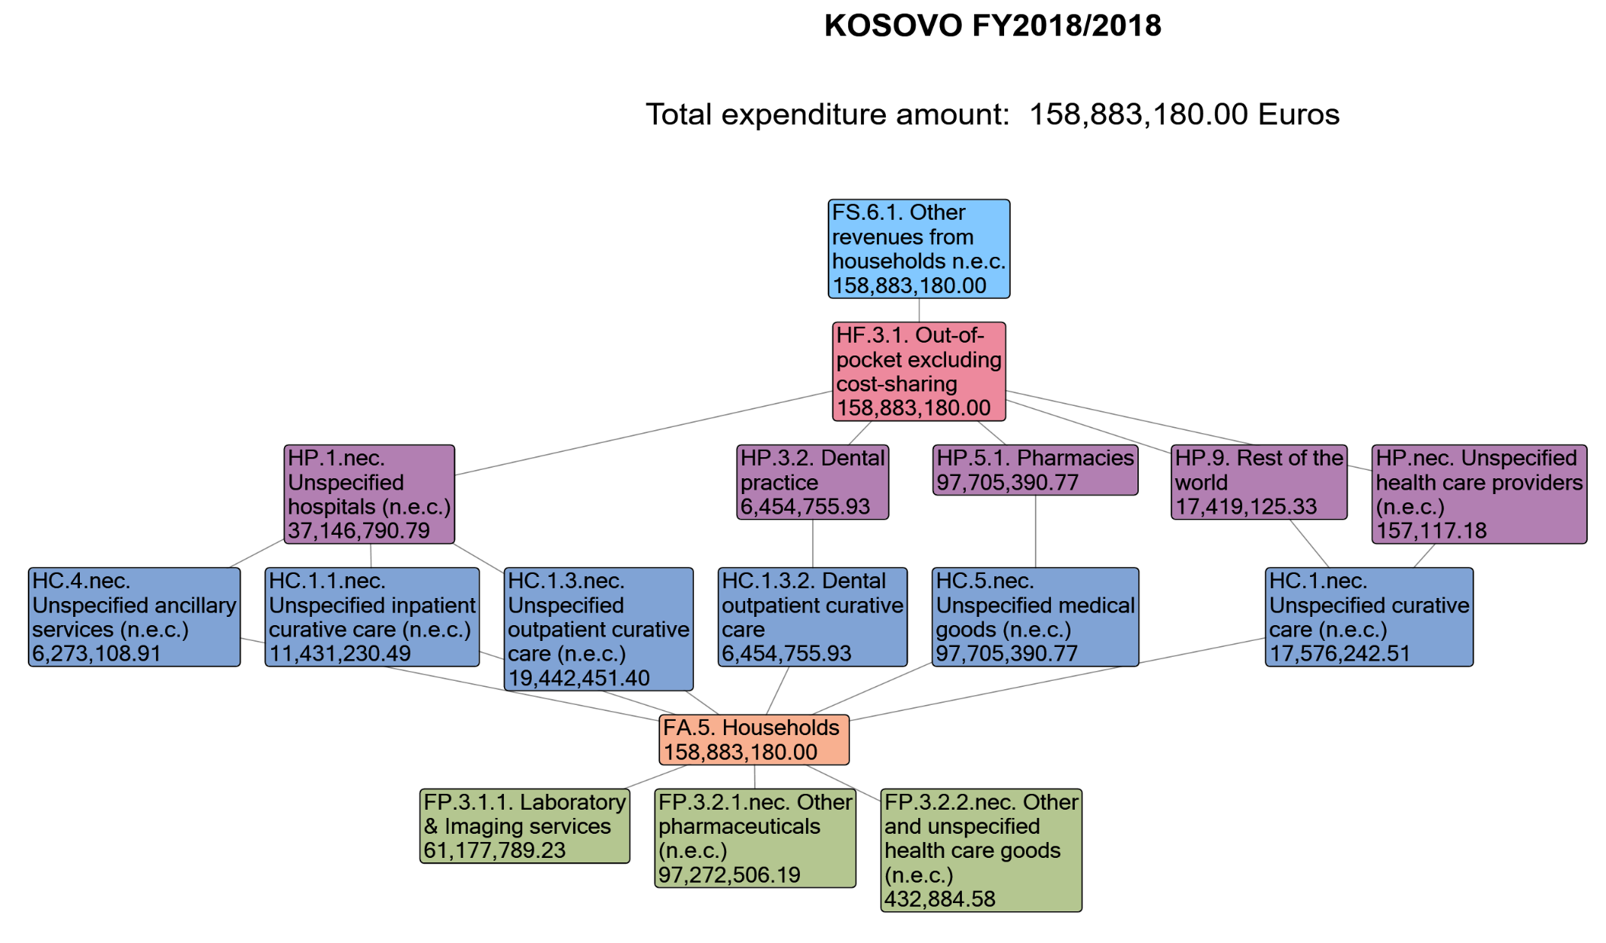

*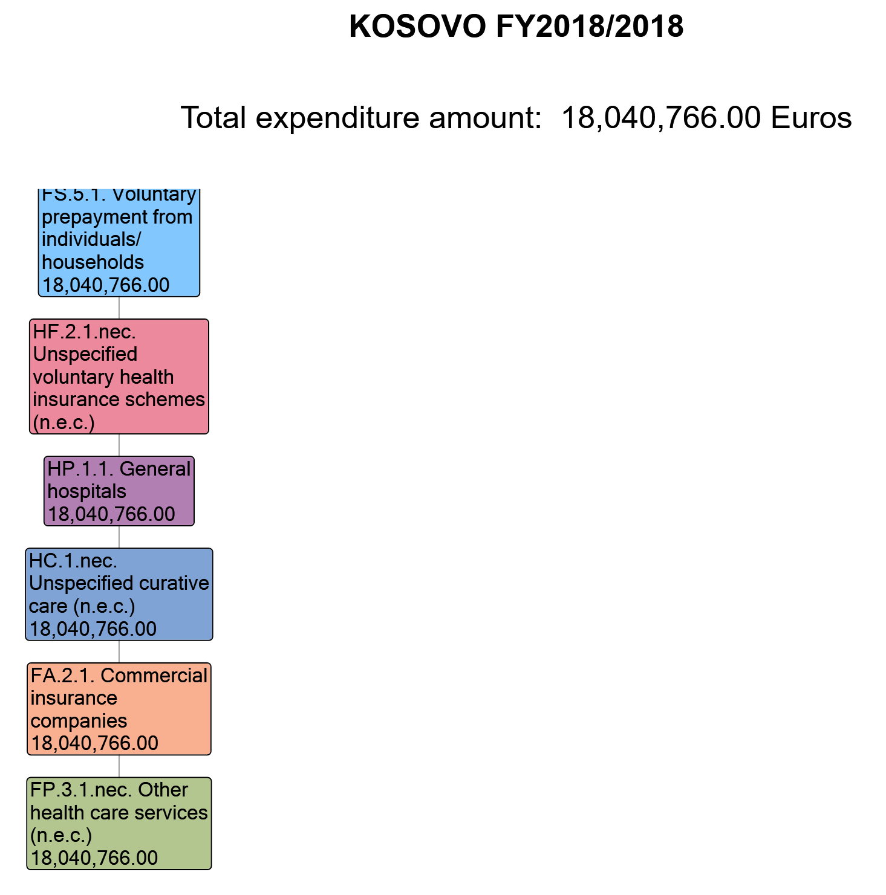Graph No. 7: Expenditures for voluntary health insurance, 2018*

*Graph No. 8: Health care expenditures, Kosovo 2018*

* The following graph presents the total expenditures for health services, distributed by public and private sector, Revenues of health care financing schemes; financing schemes; health care providers, healthcare functions and capital investments

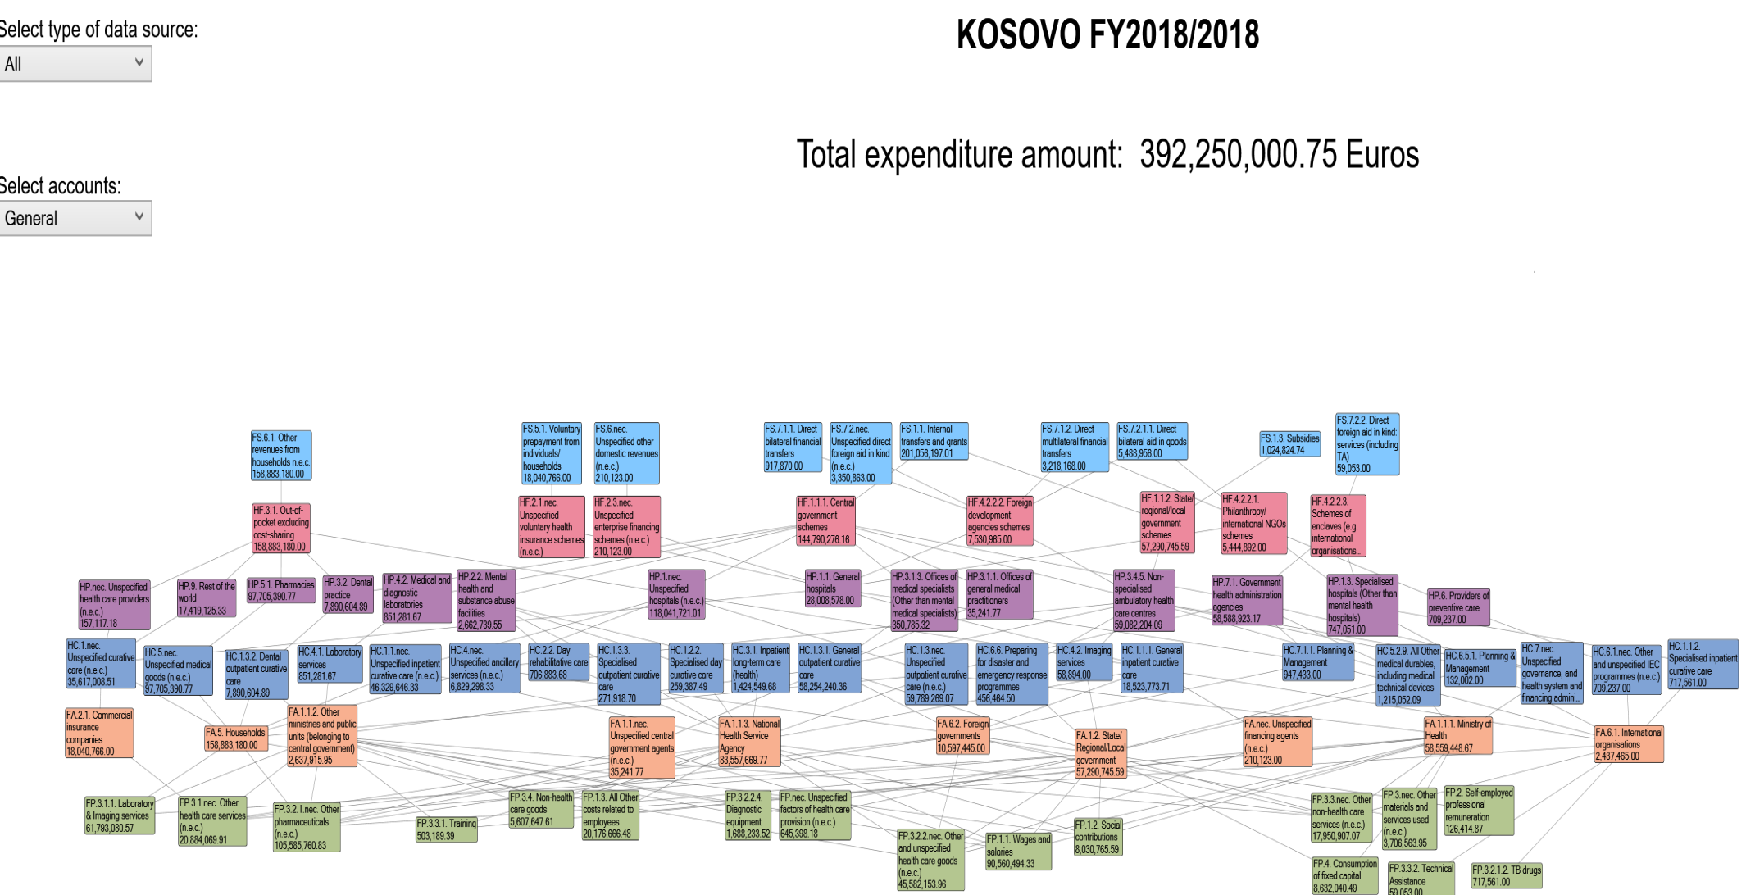

Abbreviations used in the HAPT system:

Clarification:

FS - Revenues of health care financing schemes

HF - Funding schemes

HP - Health care providers

HC - Health care functions

HK - Capital Investments

*Translations of terminology in Albanian language:*

|  |  |  |
| --- | --- | --- |
| **Classific.**  **name** | **FS - Revenues of health care financing schemes** | **FS - Të ardhurat e skemave të financimit të kujdesit shëndetësor** |
| **Code** | **Name** | **Emri** |
| FS.1.1 | Internal transfers and grants | Transfere dhe grante të brendshme |
| FS.1.2 | Transfers by government on behalf of specific groups | Transfere nga qeveria në emër të grupeve specifike |
| FS.1.3 | Subsidies | Subvencionet |
| FS.2 | Transfers distributed by government from foreign origin | Transferet e shpërndara nga qeveria me origjinë të huaj |
| FS.4.2 | Compulsory prepayment from employers | Parapagimi i detyrueshëm nga punëdhënësit |
| FS.5.1 | Voluntary prepayment from individuals/households | Parapagimi vullnetar nga individë / familje |
| FS.6.nec | Unspecified other domestic revenues | Të ardhura të tjera të papërcaktuara vendase |
|  | **HF - Financing schemes** | HF - Skemat e financimit |
| HF.1.1.1 | Central government schemes | Skemat e qeverisjes qendrore |
| HF.1.1.2 | State/regional/local government schemes | Skemat e qeverisjes shtetërore / lokale |
| HF.1.1.nec | Unspecified government schemes (n.e.c.) | Skema qeveritare të paspecifikuara |
| HF.2.1.1.3 | Other primary coverage schemes | Skema të tjera të mbulimit parësor |
| HF.2.1.nec | Unspecified voluntary health insurance schemes (n.e.c.) | Skemat e paspecifikuara të sigurimit shëndetësor vullnetar (n.e.c.) |
| HF.2.2.1 | NPISH financing schemes (excluding HF.2.2.2) | Skemat e financimit NPISH (përjashtuar HF.2.2.2) |
| HF.2.3.2 | Health care providers financing schemes | Skemat e financimit të ofruesve të kujdesit shëndetësor |
| HF.2.nec | Unspecified voluntary health care payment schemes (n.e.c.) | Skemat e paspecifikuara të pagesës së kujdesit shëndetësor |
| HF.4.1.2 | Other compulsory schemes (non-resident) | Skema të tjera të detyrueshme (jorezident) |
| HF.4.2.2.1 | Philanthropy/international NGOs schemes | Skemat e filantropisë / OJQ-ve ndërkombëtare |
| HF.4.2.2.4 | Scientific research training | Trajnim kërkimor shkencor |
| HF.nec | Unspecified financing schemes (n.e.c.) | Skemat e paspecifikuara të financimit |
|  | **HP - Health care providers** | HP - Ofruesit e kujdesit shëndetësor |
| HP.1 | Hospitals | Spitale |
| HP.1.1 | General hospitals | Spitalet e përgjithshme |
| HP.1.2 | Mental health hospitals | Spitalet e shëndetit mendor |
| HP.1.nec | Unspecified hospitals (n.e.c.) | Spitalet e paspecifikuara (n.e.c.) |
| HP.3 | Providers of ambulatory health care | Ofruesit e kujdesit shëndetësor ambulator |
| HP.3.1.1 | Offices of general medical practitioners | Zyrat e mjekëve të përgjithshëm |
| HP.3.1.nec | Unspecified medical practices (n.e.c.) | Praktikat mjekësore të paspecifikuara |
| HP.3.3 | Other health care practitioners | Praktikues të tjerë të kujdesit shëndetësor |
| HP.3.4.1 | Family planning centres | Qendrat e planifikimit familjar |
| HP.3.4.4 | Dialysis care centres | Qendrat e kujdesit për dializën |
| HP.3.5 | Providers of home health care services | Ofruesit e shërbimeve të kujdesit shëndetësor në shtëpi |
| HP.3.nec | Unspecified providers of ambulatory health care (n.e.c.) | Ofruesit e paspecifikuar të kujdesit shëndetësor ambulator |
| HP.4.9 | Other providers of ancillary services | Ofruesit e tjerë të shërbimeve ndihmëse |
| HP.7 | Providers of health care system administration and financing | Ofruesit e administrimit dhe financimit të sistemit të kujdesit shëndetësor |
| HP.7.1 | Government health administration agencies | Agjensitë qeveritare të administrimit shëndetësor |
| HP.nec | Unspecified health care providers (n.e.c.) | Ofruesit e kujdesit shëndetësor të paspecifikuar |
|  | **HC - Health care functions** | **HC - Funksionet e kujdesit shëndetësor** |
| HC.1.1.1 | General inpatient curative care | Kujdesi kurues i përgjithshëm spitalor |
| HC.1.1.2 | Specialised inpatient curative care | Kujdesi kurues i specializuar |
| HC.1.1.nec | Unspecified inpatient curative care (n.e.c.) | Kujdes kurativ i paspecifikuar |
| HC.1.2.2 | Specialised day curative care | Kujdesi kurues i specializuar ditor |
| HC.1.3.1 | General outpatient curative care | Kujdesi kurues i përgjithshëm ambulator |
| HC.1.3.3 | Specialised outpatient curative care | Kujdesi kurues ambulator i specializuar |
| HC.1.3.nec | Unspecified outpatient curative care | Kujdesi ambulator i paspecifikuar |
| HC.2.2 | Day rehabilitative care | Kujdes rehabilitues ditor |
| HC.3.2 | Day long-term care (health) | Kujdesi afatgjatë ditor (shëndetësia) |
| HC.4.1 | Laboratory services | Shërbimet laboratorike |
| HC.4.nec | Unspecified ancillary services (n.e.c.) | Shërbime ndihmëse të paspecifikuara |
| HC.5.1.1 | Prescribed medicines | Ilaçet e përshkruara |
| HC.5.1.3 | Other medical non-durable goods | Mallra të tjerë jo-të qëndrueshëm mjekësorë |
| HC.5.2.9 | All Other medical durables, including medical technical devices | Të gjitha mallrat e tjera mjekësore, përfshirë pajisjet teknike mjekësore |
| HC.6.1.1.1 | Tobacco IEC programmes | Programet e IEC-it të duhanit |
| HC.6.1.1.3 | Drugs IEC programmes | Programet e IEC-së për droga |
| HC.6.1.nec | Other and unspecified IEC programmes (n.e.c.) | Programe të tjera dhe të paspecifikuara të IEC (n.e.c.) |
| HC.6.5.3 | Procurement & supply management | Menaxhimi i prokurimit dhe furnizimit |
| HC.6.5.4. | Other and unspecified interventions | Ndërhyrje të tjera dhe të paspecifikuara |
| HC.7.2 | Administration of health financing | Administrimi i financimit të shëndetit |
| HC.7.3 | Salaries | Pagat |
| HC.9 | Other health care services not elsewhere classified (n.e.c.) | Shërbime të tjera të kujdesit shëndetësor që nuk klasifikohen diku tjetër (n.e.c.) |
|  | **HK - Capital Account** | **HK - Investime Kapitale** |
| HK.1.1.1.1 | Residential and non-residential buildings | Ndërtesa banimi dhe jo-rezidenciale |
| HK.1.1.1.2 | Other structures | Strukturat e tjera |
| HK.1.1.2.1 | Medical equipment | Pajisje mjekësore |
| HK.1.1.2.2 | Transport equipment | Pajisje transporti |
| HK.1.1.2.3 | ICT equipment | Pajisje TIK |
| HK.1.1.2.4 | Machinery and equipment n.e.c. | Makineritë dhe pajisjet |
| HK.1.2 | Changes in inventories | Ndryshimet në inventarë |
| HK.2.2 | Other non-produced non-financial assets | Pasuri të tjera jo të prodhuara jo-financiare |

Annex 1: Tables from HAPT

*Table Nr. 1:*

|  |  |  |  |  |  |  |  |  |  |  |  |  |  |  |  |  |  |  |  |  |  |  |  |  |  |  |  |  |  |  |  |  |  |  |  |  |  |  |  |  |
| --- | --- | --- | --- | --- | --- | --- | --- | --- | --- | --- | --- | --- | --- | --- | --- | --- | --- | --- | --- | --- | --- | --- | --- | --- | --- | --- | --- | --- | --- | --- | --- | --- | --- | --- | --- | --- | --- | --- | --- | --- |
|  |  |  |  | **Revenues of health care financing schemes** | | **FS.1** | |  | |  | | **FS.5** | |  | | **FS.6** | |  | |  | | **FS.7** | |  | |  | |  | |  | |  | |  | |  | |  | | **All FS** |
|  |  |  |  |  | | FS.1.1 | | FS.1.3 | |  | | FS.5.1 | |  | | FS.6.1 | | FS.6.nec | |  | | FS.7.1 | |  | |  | | FS.7.2 | |  | |  | |  | |  | |  |
|  |  |  |  |  | |  | |  | |  | |  | |  | |  | |  | |  | |  | | FS.7.1.1 | | FS.7.1.2 | |  | | FS.7.2.1 | |  | | FS.7.2.2 | | FS.7.2.nec | |  |
|  |  |  |  |  | |  | |  | |  | |  | |  | |  | |  | |  | |  | |  | |  | |  | |  | | FS.7.2.1.1 | |  | |  | |  |
| **Financing schemes** | | | | *Euros (EUR), Million* | | **Transfers from government domestic revenue (allocated to health purposes)** | | Internal transfers and grants | | Subsidies | | **Voluntary prepayment** | | Voluntary prepayment from individuals/households | | **Other domestic revenues n.e.c.** | | Other revenues from households n.e.c. | | Unspecified other domestic revenues (n.e.c.) | | **Direct foreign transfers** | | Direct foreign financial transfers | | Direct bilateral financial transfers | | Direct multilateral financial transfers | | Direct foreign aid in kind | | Direct foreign aid in goods | | Direct bilateral aid in goods | | Direct foreign aid in kind: services (including TA) | | Unspecified direct foreign aid in kind (n.e.c.) | |  |
| **HF.1** |  |  |  | **Government schemes and compulsory contributory health care financing schemes** | | **202.08** | | **201.06** | | **1.02** | |  | |  | |  | |  | |  | |  | |  | |  | |  | |  | |  | |  | |  | |  | | 202.08 |
|  | HF.1.1 |  |  | Government schemes | | **202.08** | | 201.06 | | 1.02 | |  | |  | |  | |  | |  | |  | |  | |  | |  | |  | |  | |  | |  | |  | | 202.08 |
|  |  | HF.1.1.1 |  | Central government schemes | | **144.79** | | 144.79 | |  | |  | |  | |  | |  | |  | |  | |  | |  | |  | |  | |  | |  | |  | |  | | 144.79 |
|  |  | HF.1.1.2 |  | State/regional/local government schemes | | **57.29** | | 56.27 | | 1.02 | |  | |  | |  | |  | |  | |  | |  | |  | |  | |  | |  | |  | |  | |  | | 57.29 |
| **HF.2** |  |  |  | **Voluntary health care payment schemes** | |  | |  | |  | | **18.04** | | **18.04** | | **0.21** | |  | | **0.21** | |  | |  | |  | |  | |  | |  | |  | |  | |  | | 18.25 |
|  | HF.2.1 |  |  | Voluntary health insurance schemes | |  | |  | |  | | **18.04** | | 18.04 | |  | |  | |  | |  | |  | |  | |  | |  | |  | |  | |  | |  | | 18.04 |
|  |  | HF.2.1.nec |  | Unspecified voluntary health insurance schemes (n.e.c.) | |  | |  | |  | | **18.04** | | 18.04 | |  | |  | |  | |  | |  | |  | |  | |  | |  | |  | |  | |  | | 18.04 |
|  | HF.2.3 |  |  | Enterprise financing schemes | |  | |  | |  | |  | |  | | **0.21** | |  | | 0.21 | |  | |  | |  | |  | |  | |  | |  | |  | |  | | 0.21 |
|  |  | HF.2.3.nec |  | Unspecified enterprise financing schemes (n.e.c.) | |  | |  | |  | |  | |  | | **0.21** | |  | | 0.21 | |  | |  | |  | |  | |  | |  | |  | |  | |  | | 0.21 |
| **HF.3** |  |  |  | **Household out-of-pocket payment** | |  | |  | |  | |  | |  | | **158.88** | | **158.88** | |  | |  | |  | |  | |  | |  | |  | |  | |  | |  | | 158.88 |
|  | HF.3.1 |  |  | Out-of-pocket excluding cost-sharing | |  | |  | |  | |  | |  | | **158.88** | | 158.88 | |  | |  | |  | |  | |  | |  | |  | |  | |  | |  | | 158.88 |
| **HF.4** |  |  |  | **Rest of the world financing schemes (non-resident)** | |  | |  | |  | |  | |  | |  | |  | |  | | **13.03** | | **4.14** | | **0.92** | | **3.22** | | **8.90** | | **5.49** | | **5.49** | | **0.06** | | **3.35** | | 13.03 |
|  | HF.4.2 |  |  | Voluntary schemes (non-resident) | |  | |  | |  | |  | |  | |  | |  | |  | | **13.03** | | 4.14 | | 0.92 | | 3.22 | | 8.90 | | 5.49 | | 5.49 | | 0.06 | | 3.35 | | 13.03 |
|  |  | HF.4.2.2 |  | Other schemes (non-resident) | |  | |  | |  | |  | |  | |  | |  | |  | | **13.03** | | 4.14 | | 0.92 | | 3.22 | | 8.90 | | 5.49 | | 5.49 | | 0.06 | | 3.35 | | 13.03 |
|  |  |  | HF.4.2.2.1 | Philanthropy/international NGOs schemes | |  | |  | |  | |  | |  | |  | |  | |  | | **5.44** | | 1.43 | |  | | 1.43 | | 4.02 | | 4.02 | | 4.02 | |  | |  | | 5.44 |
|  |  |  | HF.4.2.2.2 | Foreign development agencies schemes | |  | |  | |  | |  | |  | |  | |  | |  | | **7.53** | | 2.71 | | 0.92 | | 1.79 | | 4.82 | | 1.47 | | 1.47 | |  | | 3.35 | | 7.53 |
|  |  |  | HF.4.2.2.3 | Schemes of enclaves (e.g. international organisations or embassies) | |  | |  | |  | |  | |  | |  | |  | |  | | **0.06** | |  | |  | |  | | 0.06 | |  | |  | | 0.06 | |  | | 0.06 |
| **All HF** | | | | | | **202.08** | | 201.06 | | 1.02 | | **18.04** | | 18.04 | | **159.09** | | 158.88 | | 0.21 | | **13.03** | | 4.14 | | 0.92 | | 3.22 | | 8.90 | | 5.49 | | 5.49 | | 0.06 | | 3.35 | | 392.25 |
| **Memorandum items** | | | | | |  | |  | |  | |  | |  | |  | |  | |  | |  | |  | |  | |  | |  | |  | |  | |  | |  | |  |
|  | Financing agents managing the financing schemes | | | | **202.08** | | 201.06 | | 1.02 | | **18.04** | | 18.04 | | **158.88** | | 158.88 | |  | | **13.03** | | 4.14 | | 0.92 | | 3.22 | | 8.90 | | 5.49 | | 5.49 | | 0.06 | | 3.35 | | 392.04 | |
|  |  | HF.RI.1.1 |  | Government (FA.1 General government) | | **202.08** | | 201.06 | | 1.02 | |  | |  | |  | |  | |  | |  | |  | |  | |  | |  | |  | |  | |  | |  | | 202.08 |
|  |  | HF.RI.1.2 |  | Corporations (FA.2 Insurance + FA.3 Corporations) | |  | |  | |  | | **18.04** | | 18.04 | |  | |  | |  | |  | |  | |  | |  | |  | |  | |  | |  | |  | | 18.04 |
|  |  | HF.RI.1.3 |  | Households (FA.5 Households) | |  | |  | |  | |  | |  | | **158.88** | | 158.88 | |  | |  | |  | |  | |  | |  | |  | |  | |  | |  | | 158.88 |
|  |  | HF.RI.1.5 |  | Rest of the world (FA.6 Rest of the world) | |  | |  | |  | |  | |  | |  | |  | |  | | **13.03** | | 4.14 | | 0.92 | | 3.22 | | 8.90 | | 5.49 | | 5.49 | | 0.06 | | 3.35 | | 13.03 |
|  | Financing schemes and the related cost-sharing together | | | | **202.08** | | 201.06 | | 1.02 | | **18.04** | | 18.04 | |  | |  | |  | |  | |  | |  | |  | |  | |  | |  | |  | |  | | 220.12 | |
|  |  | HF.RI.2 |  | Governmental schemes and compulsory contributory health insurance schemes together with cost sharing (HF.1 + HF.3.2.1) | | **202.08** | | 201.06 | | 1.02 | |  | |  | |  | |  | |  | |  | |  | |  | |  | |  | |  | |  | |  | |  | | 202.08 |
|  |  | HF.RI.3 |  | Voluntary health insurance schemes together with cost sharing (HF.2.1+HF.3.2.2) | |  | |  | |  | | **18.04** | | 18.04 | |  | |  | |  | |  | |  | |  | |  | |  | |  | |  | |  | |  | | 18.04 |
|  |  |  |  |  | |  | |  | |  | |  | |  | |  | |  | |  | |  | |  | |  | |  | |  | |  | |  | |  | |  | |  |
| Used data sources: |  |  |  |  | |  | |  | |  | |  | |  | |  | |  | |  | |  | |  | |  | |  | |  | |  | |  | |  | |  | |  |
|  | | | | | | | | | | | | | | | | | | | | | | | | | | | | | | | | | | | | | | | | |
| Donors | Project Hope, TIKA, Her Highness Sheikha Fatima Bint Mubara Abu Dhabi Office, Accesible and quality health care (AQH) - SDC), Japan, Luxembourg, Global Fund 1, Global Fund 2, Direct Relief, Action for mothers and children, Care for Kosovo kids, Liri Med, Madekos, MedicalGroup, Opharma, Pharma Leader, Exclusiv shpk, Italian Cooperation, WHO 1, WHO 2, You are sunflower, Medica SHPK, Helvetas/MAPL, Fortesa home, BAVARIA, Other 1, Other 2 | | | | | | | | | | | | | | | | | | | | | | | | | | | | | | | | | | | | | | | |
| Insurances | Insurance Company | | | | | | | | | | | | | | | | | | | | | | | | | | | | | | | | | | | | | | | |
| Government sources | ASHNA, IK Komunat, KI SHSKUK, Komunat, Mental Health, Ministria e Drejtesise - IK, MInistria e Drejtsise, Ministria e Mbrojtjes, Ministria e Mbrojtjes - IK, Ministria e Shendetsis, MoH - Capital Expenditure, QSKUK, Secondary Hos | | | | | | | | | | | | | | | | | | | | | | | | | | | | | | | | | | | | | | | |
| Households | Household | | | | | | | | | | | | | | | | | | | | | | | | | | | | | | | | | | | | | | | |

*Table Nr. 2:*

|  |  |  |  |  |  |  |  |  |  |  |  |  |  |  |  |  |  |  |  |  |  |  |  |  |  |  |  |  |  |  |  |  |  |  |  |  |  |  |  |  |  |  |  |  |  |
| --- | --- | --- | --- | --- | --- | --- | --- | --- | --- | --- | --- | --- | --- | --- | --- | --- | --- | --- | --- | --- | --- | --- | --- | --- | --- | --- | --- | --- | --- | --- | --- | --- | --- | --- | --- | --- | --- | --- | --- | --- | --- | --- | --- | --- | --- |
|  |  |  | **Financing schemes** | **HF.1** |  | |  |  | **HF.2** | |  | |  |  | | |  | | **HF.3** | |  | | **HF.4** | |  | |  | |  |  |  | **All HF** | **Memorandum items** |  |  |  |  | |  | |  | | |  |  |
|  |  |  |  | HF.1.1 | |  |  |  | | HF.2.1 | |  | HF.2.3 | | |  | |  | | HF.3.1 | |  | | HF.4.2 | |  | |  |  |  |  | Financing agents managing the financing schemes |  |  |  | |  | | Financing schemes and the related cost-sharing together | | |  |  |
|  |  |  |  |  | | HF.1.1.1 | HF.1.1.2 |  | |  | | HF.2.1.nec |  | | | HF.2.3.nec | |  | |  | |  | |  | | HF.4.2.2 | |  |  |  |  | HF.RI.1.1 | HF.RI.1.2 | HF.RI.1.3 | | HF.RI.1.5 | | HF.RI.2 | HF.RI.3 |
|  |  |  |  |  | |  |  |  | |  | |  |  | | |  | |  | |  | |  | |  | |  | | HF.4.2.2.1 | HF.4.2.2.2 | HF.4.2.2.3 |  |  |  |  | |  | |  |  |
| **Health care providers** | | | *Euros (EUR), Million* | **Government schemes and compulsory contributory health care financing schemes** | Government schemes | Central government schemes | | State/regional/local government schemes | | **Voluntary health care payment schemes** | | Voluntary health insurance schemes | Unspecified voluntary health insurance schemes (n.e.c.) | | Enterprise financing schemes | Unspecified enterprise financing schemes (n.e.c.) | | **Household out-of-pocket payment** | | Out-of-pocket excluding cost-sharing | | **Rest of the world financing schemes (non-resident)** | | Voluntary schemes (non-resident) | | Other schemes (non-resident) | | Philanthropy/international NGOs schemes | | Foreign development agencies schemes | Schemes of enclaves (e.g. international organisations or embassies) |  |  |  | Government (FA.1 General government) | Corporations (FA.2 Insurance + FA.3 Corporations) | | Households (FA.5 Households) | | Rest of the world (FA.6 Rest of the world) | |  | Governmental schemes and compulsory contributory health insurance schemes together with cost sharing (HF.1 + HF.3.2.1) | | Voluntary health insurance schemes together with cost sharing (HF.2.1+HF.3.2.2) |
| **HP.1** |  |  | **Hospitals** | **80.89** | **80.89** | | **80.89** |  | **18.25** | | **18.04** | | **18.04** | **0.21** | | | **0.21** | | **37.15** | | **37.15** | | **10.50** | | **10.50** | | **10.50** | | **4.74** | **5.74** | **0.03** | **146.80** | **245.52** | **146.59** | **80.89** | **18.04** | **37.15** | | **10.50** | | **98.94** | | | **80.89** | **18.04** |
|  | HP.1.1 |  | General hospitals |  |  | |  |  | **18.25** | | 18.04 | | 18.04 | 0.21 | | | 0.21 | |  | |  | | **9.76** | | 9.76 | | 9.76 | | 4.02 | 5.74 |  | 28.01 | 45.84 | 27.80 |  | 18.04 |  | | 9.76 | | 18.04 | | |  | 18.04 |
|  | HP.1.3 |  | Specialised hospitals (Other than mental health hospitals) |  |  | |  |  |  | |  | |  |  | | |  | |  | |  | | **0.75** | | 0.75 | | 0.75 | | 0.72 |  | 0.03 | 0.75 | 0.75 | 0.75 |  |  |  | | 0.75 | |  | | |  |  |
|  | HP.1.nec |  | Unspecified hospitals (n.e.c.) | **80.89** | 80.89 | | 80.89 |  |  | |  | |  |  | | |  | | **37.15** | | 37.15 | |  | |  | |  | |  |  |  | 118.04 | 198.94 | 118.04 | 80.89 |  | 37.15 | |  | | 80.89 | | | 80.89 |  |
| **HP.2** |  |  | **Residential long-term care facilities** | **2.66** | **2.66** | | **2.66** |  |  | |  | |  |  | | |  | |  | |  | |  | |  | |  | |  |  |  | **2.66** | **5.33** | **2.66** | **2.66** |  |  | |  | | **2.66** | | | **2.66** |  |
|  | HP.2.2 |  | Mental health and substance abuse facilities | **2.66** | 2.66 | | 2.66 |  |  | |  | |  |  | | |  | |  | |  | |  | |  | |  | |  |  |  | 2.66 | 5.33 | 2.66 | 2.66 |  |  | |  | | 2.66 | | | 2.66 |  |
| **HP.3** |  |  | **Providers of ambulatory health care** | **59.11** | **59.11** | | **1.82** | **57.29** |  | |  | |  |  | | |  | | **6.45** | | **6.45** | | **1.79** | | **1.79** | | **1.79** | |  | **1.79** |  | **67.36** | **126.47** | **67.36** | **59.11** |  | **6.45** | | **1.79** | | **59.11** | | | **59.11** |  |
|  | HP.3.1 |  | Medical practices | **0.39** | 0.39 | | 0.39 |  |  | |  | |  |  | | |  | |  | |  | |  | |  | |  | |  |  |  | 0.39 | 0.77 | 0.39 | 0.39 |  |  | |  | | 0.39 | | | 0.39 |  |
|  |  | HP.3.1.1 | Offices of general medical practitioners | **0.04** | 0.04 | | 0.04 |  |  | |  | |  |  | | |  | |  | |  | |  | |  | |  | |  |  |  | 0.04 | 0.07 | 0.04 | 0.04 |  |  | |  | | 0.04 | | | 0.04 |  |
|  |  | HP.3.1.3 | Offices of medical specialists (Other than mental medical specialists) | **0.35** | 0.35 | | 0.35 |  |  | |  | |  |  | | |  | |  | |  | |  | |  | |  | |  |  |  | 0.35 | 0.70 | 0.35 | 0.35 |  |  | |  | | 0.35 | | | 0.35 |  |
|  | HP.3.2 |  | Dental practice | **1.44** | 1.44 | | 1.44 |  |  | |  | |  |  | | |  | | **6.45** | | 6.45 | |  | |  | |  | |  |  |  | 7.89 | 9.33 | 7.89 | 1.44 |  | 6.45 | |  | | 1.44 | | | 1.44 |  |
|  | HP.3.4 |  | Ambulatory health care centres | **57.29** | 57.29 | | 0.00 | 57.29 |  | |  | |  |  | | |  | |  | |  | | **1.79** | | 1.79 | | 1.79 | |  | 1.79 |  | 59.08 | 116.37 | 59.08 | 57.29 |  |  | | 1.79 | | 57.29 | | | 57.29 |  |
|  |  | HP.3.4.5 | Non-specialised ambulatory health care centres | **57.29** | 57.29 | | 0.00 | 57.29 |  | |  | |  |  | | |  | |  | |  | | **1.79** | | 1.79 | | 1.79 | |  | 1.79 |  | 59.08 | 116.37 | 59.08 | 57.29 |  |  | | 1.79 | | 57.29 | | | 57.29 |  |
| **HP.4** |  |  | **Providers of ancillary services** | **0.85** | **0.85** | | **0.85** |  |  | |  | |  |  | | |  | |  | |  | |  | |  | |  | |  |  |  | **0.85** | **1.70** | **0.85** | **0.85** |  |  | |  | | **0.85** | | | **0.85** |  |
|  | HP.4.2 |  | Medical and diagnostic laboratories | **0.85** | 0.85 | | 0.85 |  |  | |  | |  |  | | |  | |  | |  | |  | |  | |  | |  |  |  | 0.85 | 1.70 | 0.85 | 0.85 |  |  | |  | | 0.85 | | | 0.85 |  |
| **HP.5** |  |  | **Retailers and Other providers of medical goods** |  |  | |  |  |  | |  | |  |  | | |  | | **97.71** | | **97.71** | |  | |  | |  | |  |  |  | **97.71** | **97.71** | **97.71** |  |  | **97.71** | |  | |  | | |  |  |
|  | HP.5.1 |  | Pharmacies |  |  | |  |  |  | |  | |  |  | | |  | | **97.71** | | 97.71 | |  | |  | |  | |  |  |  | 97.71 | 97.71 | 97.71 |  |  | 97.71 | |  | |  | | |  |  |
| **HP.6** |  |  | **Providers of preventive care** |  |  | |  |  |  | |  | |  |  | | |  | |  | |  | | **0.71** | | **0.71** | | **0.71** | | **0.71** |  |  | **0.71** | **0.71** | **0.71** |  |  |  | | **0.71** | |  | | |  |  |
| **HP.7** |  |  | **Providers of health care system administration and financing** | **58.56** | **58.56** | | **58.56** |  |  | |  | |  |  | | |  | |  | |  | | **0.03** | | **0.03** | | **0.03** | |  |  | **0.03** | **58.59** | **117.15** | **58.59** | **58.56** |  |  | | **0.03** | | **58.56** | | | **58.56** |  |
|  | HP.7.1 |  | Government health administration agencies | **58.56** | 58.56 | | 58.56 |  |  | |  | |  |  | | |  | |  | |  | | **0.03** | | 0.03 | | 0.03 | |  |  | 0.03 | 58.59 | 117.15 | 58.59 | 58.56 |  |  | | 0.03 | | 58.56 | | | 58.56 |  |
| **HP.9** |  |  | **Rest of the world** |  |  | |  |  |  | |  | |  |  | | |  | | **17.42** | | **17.42** | |  | |  | |  | |  |  |  | **17.42** | **17.42** | **17.42** |  |  | **17.42** | |  | |  | | |  |  |
| **HP.nec** |  |  | **Unspecified health care providers (n.e.c.)** |  |  | |  |  |  | |  | |  |  | | |  | | **0.16** | | **0.16** | |  | |  | |  | |  |  |  | **0.16** | **0.16** | **0.16** |  |  | **0.16** | |  | |  | | |  |  |
| **All HP** |  |  |  | 202.08 | 202.08 | | 144.79 | 57.29 | 18.25 | | 18.04 | | 18.04 | 0.21 | | | 0.21 | | 158.88 | | 158.88 | | 13.03 | | 13.03 | | 13.03 | | 5.44 | 7.53 | 0.06 | 392.25 | 612.16 | 392.04 | 202.08 | 18.04 | 158.88 | | 13.03 | | 220.12 | | | 202.08 | 18.04 |

*Table Nr. 3:*

|  |  |  |  |  |  |  |  |  |  |  |  |  |  |  |  |  |  |  |  |  |  |  |  |  |  |  |  |  |  |  |
| --- | --- | --- | --- | --- | --- | --- | --- | --- | --- | --- | --- | --- | --- | --- | --- | --- | --- | --- | --- | --- | --- | --- | --- | --- | --- | --- | --- | --- | --- | --- |
|  |  |  | **Financing schemes** | **HF.1** |  |  |  | **HF.2** |  |  |  |  | **HF.3** |  | **HF.4** |  |  |  |  |  | **All HF** | **Memorandum items** |  |  |  |  |  |  |  |  |
|  |  |  |  | HF.1.1 |  |  |  | HF.2.1 |  | HF.2.3 |  |  | HF.3.1 |  | HF.4.2 |  |  |  |  |  | Financing agents managing the financing schemes |  |  |  |  | Financing schemes and the related cost-sharing together |  |  |
|  |  |  |  |  | HF.1.1.1 | HF.1.1.2 |  |  | HF.2.1.nec |  | HF.2.3.nec |  |  |  |  | HF.4.2.2 |  |  |  |  | HF.RI.1.1 | HF.RI.1.2 | HF.RI.1.3 | HF.RI.1.5 | HF.RI.2 | HF.RI.3 |
|  |  |  |  |  |  |  |  |  |  |  |  |  |  |  |  |  | HF.4.2.2.1 | HF.4.2.2.2 | HF.4.2.2.3 |  |  |  |  |  |  |  |
| **Health care functions** | | | *Euros (EUR), Million* | **Government schemes and compulsory contributory health care financing schemes** | Government schemes | Central government schemes | State/regional/local government schemes | **Voluntary health care payment schemes** | Voluntary health insurance schemes | Unspecified voluntary health insurance schemes (n.e.c.) | Enterprise financing schemes | Unspecified enterprise financing schemes (n.e.c.) | **Household out-of-pocket payment** | Out-of-pocket excluding cost-sharing | **Rest of the world financing schemes (non-resident)** | Voluntary schemes (non-resident) | Other schemes (non-resident) | Philanthropy/international NGOs schemes | Foreign development agencies schemes | Schemes of enclaves (e.g. international organisations or embassies) |  |  |  | Government (FA.1 General government) | Corporations (FA.2 Insurance + FA.3 Corporations) | Households (FA.5 Households) | Rest of the world (FA.6 Rest of the world) |  | Governmental schemes and compulsory contributory health insurance schemes together with cost sharing (HF.1 + HF.3.2.1) | Voluntary health insurance schemes together with cost sharing (HF.2.1+HF.3.2.2) |
| **HC.1** |  |  | **Curative care** | **143.15** | **143.15** | **87.07** | **56.08** | **18.25** | **18.04** | **18.04** | **0.21** | **0.21** | **54.90** | **54.90** | **11.35** | **11.35** | **11.35** | **4.74** | **6.61** |  | **227.65** | **388.63** | **227.44** | **143.15** | **18.04** | **54.90** | **11.35** | **161.19** | **143.15** | **18.04** |
|  | HC.1.1 |  | Inpatient curative care | **44.37** | 44.37 | 44.37 |  | **0.21** |  |  | 0.21 | 0.21 | **11.43** | 11.43 | **9.56** | 9.56 | 9.56 | 4.74 | 4.82 |  | 65.57 | 109.73 | 65.36 | 44.37 |  | 11.43 | 9.56 | 44.37 | 44.37 |  |
|  |  | HC.1.1.1 | General inpatient curative care | **9.47** | 9.47 | 9.47 |  | **0.21** |  |  | 0.21 | 0.21 |  |  | **8.84** | 8.84 | 8.84 | 4.02 | 4.82 |  | 18.52 | 27.79 | 18.31 | 9.47 |  |  | 8.84 | 9.47 | 9.47 |  |
|  |  | HC.1.1.2 | Specialised inpatient curative care |  |  |  |  |  |  |  |  |  |  |  | **0.72** | 0.72 | 0.72 | 0.72 |  |  | 0.72 | 0.72 | 0.72 |  |  |  | 0.72 |  |  |  |
|  |  | HC.1.1.nec | Unspecified inpatient curative care (n.e.c.) | **34.90** | 34.90 | 34.90 |  |  |  |  |  |  | **11.43** | 11.43 |  |  |  |  |  |  | 46.33 | 81.23 | 46.33 | 34.90 |  | 11.43 |  | 34.90 | 34.90 |  |
|  | HC.1.2 |  | Day curative care | **0.26** | 0.26 | 0.26 |  |  |  |  |  |  |  |  |  |  |  |  |  |  | 0.26 | 0.52 | 0.26 | 0.26 |  |  |  | 0.26 | 0.26 |  |
|  |  | HC.1.2.2 | Specialised day curative care | **0.26** | 0.26 | 0.26 |  |  |  |  |  |  |  |  |  |  |  |  |  |  | 0.26 | 0.52 | 0.26 | 0.26 |  |  |  | 0.26 | 0.26 |  |
|  | HC.1.3 |  | Outpatient curative care | **98.52** | 98.52 | 42.44 | 56.08 |  |  |  |  |  | **25.90** | 25.90 | **1.79** | 1.79 | 1.79 |  | 1.79 |  | 126.21 | 224.72 | 126.21 | 98.52 |  | 25.90 | 1.79 | 98.52 | 98.52 |  |
|  |  | HC.1.3.1 | General outpatient curative care | **56.46** | 56.46 | 0.39 | 56.08 |  |  |  |  |  |  |  | **1.79** | 1.79 | 1.79 |  | 1.79 |  | 58.25 | 114.72 | 58.25 | 56.46 |  |  | 1.79 | 56.46 | 56.46 |  |
|  |  | HC.1.3.2 | Dental outpatient curative care | **1.44** | 1.44 | 1.44 |  |  |  |  |  |  | **6.45** | 6.45 |  |  |  |  |  |  | 7.89 | 9.33 | 7.89 | 1.44 |  | 6.45 |  | 1.44 | 1.44 |  |
|  |  | HC.1.3.3 | Specialised outpatient curative care | **0.27** | 0.27 | 0.27 |  |  |  |  |  |  |  |  |  |  |  |  |  |  | 0.27 | 0.54 | 0.27 | 0.27 |  |  |  | 0.27 | 0.27 |  |
|  |  | HC.1.3.nec | Unspecified outpatient curative care (n.e.c.) | **40.35** | 40.35 | 40.35 |  |  |  |  |  |  | **19.44** | 19.44 |  |  |  |  |  |  | 59.79 | 100.14 | 59.79 | 40.35 |  | 19.44 |  | 40.35 | 40.35 |  |
|  | HC.1.nec |  | Unspecified curative care (n.e.c.) |  |  |  |  | **18.04** | 18.04 | 18.04 |  |  | **17.58** | 17.58 |  |  |  |  |  |  | 35.62 | 53.66 | 35.62 |  | 18.04 | 17.58 |  | 18.04 |  | 18.04 |
| **HC.2** |  |  | **Rehabilitative care** | **0.71** | **0.71** | **0.71** |  |  |  |  |  |  |  |  |  |  |  |  |  |  | **0.71** | **1.41** | **0.71** | **0.71** |  |  |  | **0.71** | **0.71** |  |
|  | HC.2.2 |  | Day rehabilitative care | **0.71** | 0.71 | 0.71 |  |  |  |  |  |  |  |  |  |  |  |  |  |  | 0.71 | 1.41 | 0.71 | 0.71 |  |  |  | 0.71 | 0.71 |  |
| **HC.1+HC.2** |  |  | **Curative care and rehabilitative care** | **143.86** | **143.86** | **87.78** | **56.08** | **18.25** | **18.04** | **18.04** | **0.21** | **0.21** | **54.90** | **54.90** | **11.35** | **11.35** | **11.35** | **4.74** | **6.61** |  | **228.36** |  |  |  |  |  |  |  |  |  |
|  | HC.1.1+HC.2.1 |  | Inpatient curative and rehabilitative care | **44.37** | 44.37 | 44.37 |  | **0.21** |  |  | 0.21 | 0.21 | **11.43** | 11.43 | **9.56** | 9.56 | 9.56 | 4.74 | 4.82 |  | 65.57 |  |  |  |  |  |  |  |  |  |
|  | HC.1.2+HC.2.2 |  | Day curative and rehabilitative care | **0.97** | 0.97 | 0.97 |  |  |  |  |  |  |  |  |  |  |  |  |  |  | 0.97 |  |  |  |  |  |  |  |  |  |
|  | HC.1.3+HC.2.3 |  | Outpatient curative and rehabilitative care | **98.52** | 98.52 | 42.44 | 56.08 |  |  |  |  |  | **25.90** | 25.90 | **1.79** | 1.79 | 1.79 |  | 1.79 |  | 126.21 |  |  |  |  |  |  |  |  |  |
|  | HC.1.nec + HC.2.nec |  | Other curative and rehabilitative care |  |  |  |  | **18.04** | 18.04 | 18.04 |  |  | **17.58** | 17.58 |  |  |  |  |  |  | 35.62 |  |  |  |  |  |  |  |  |  |
| **HC.3** |  |  | **Long-term care (health)** | **1.42** | **1.42** | **1.42** |  |  |  |  |  |  |  |  |  |  |  |  |  |  | **1.42** | **2.85** | **1.42** | **1.42** |  |  |  | **1.42** | **1.42** |  |
|  | HC.3.1 |  | Inpatient long-term care (health) | **1.42** | 1.42 | 1.42 |  |  |  |  |  |  |  |  |  |  |  |  |  |  | 1.42 | 2.85 | 1.42 | 1.42 |  |  |  | 1.42 | 1.42 |  |
| **HC.4** |  |  | **Ancillary services (non-specified by function)** | **1.47** | **1.47** | **0.85** | **0.62** |  |  |  |  |  | **6.27** | **6.27** |  |  |  |  |  |  | **7.74** | **9.21** | **7.74** | **1.47** |  | **6.27** |  | **1.47** | **1.47** |  |
|  | HC.4.1 |  | Laboratory services | **0.85** | 0.85 | 0.85 |  |  |  |  |  |  |  |  |  |  |  |  |  |  | 0.85 | 1.70 | 0.85 | 0.85 |  |  |  | 0.85 | 0.85 |  |
|  | HC.4.2 |  | Imaging services | **0.06** | 0.06 |  | 0.06 |  |  |  |  |  |  |  |  |  |  |  |  |  | 0.06 | 0.12 | 0.06 | 0.06 |  |  |  | 0.06 | 0.06 |  |
|  | HC.4.nec |  | Unspecified ancillary services (n.e.c.) | **0.56** | 0.56 |  | 0.56 |  |  |  |  |  | **6.27** | 6.27 |  |  |  |  |  |  | 6.83 | 7.39 | 6.83 | 0.56 |  | 6.27 |  | 0.56 | 0.56 |  |
| **HC.5** |  |  | **Medical goods (non-specified by function)** | **1.22** | **1.22** | **1.18** | **0.04** |  |  |  |  |  | **97.71** | **97.71** |  |  |  |  |  |  | **98.92** | **100.14** | **98.92** | **1.22** |  | **97.71** |  | **1.22** | **1.22** |  |
|  | HC.5.2 |  | Therapeutic appliances and Other medical goods | **1.22** | 1.22 | 1.18 | 0.04 |  |  |  |  |  |  |  |  |  |  |  |  |  | 1.22 | 2.43 | 1.22 | 1.22 |  |  |  | 1.22 | 1.22 |  |
|  |  | HC.5.2.9 | All Other medical durables, including medical technical devices | **1.22** | 1.22 | 1.18 | 0.04 |  |  |  |  |  |  |  |  |  |  |  |  |  | 1.22 | 2.43 | 1.22 | 1.22 |  |  |  | 1.22 | 1.22 |  |
|  | HC.5.nec |  | Unspecified medical goods (n.e.c.) |  |  |  |  |  |  |  |  |  | **97.71** | 97.71 |  |  |  |  |  |  | 97.71 | 97.71 | 97.71 |  |  | 97.71 |  |  |  |  |
| **HC.6** |  |  | **Preventive care** | **0.56** | **0.56** |  | **0.56** |  |  |  |  |  |  |  | **0.74** | **0.74** | **0.74** | **0.71** |  | **0.03** | **1.30** | **1.86** | **1.30** | **0.56** |  |  | **0.74** | **0.56** | **0.56** |  |
|  | HC.6.1 |  | Information, education and counseling (IEC) programmes |  |  |  |  |  |  |  |  |  |  |  | **0.71** | 0.71 | 0.71 | 0.71 |  |  | 0.71 | 0.71 | 0.71 |  |  |  | 0.71 |  |  |  |
|  |  | HC.6.1.nec | Other and unspecified IEC programmes (n.e.c.) |  |  |  |  |  |  |  |  |  |  |  | **0.71** | 0.71 | 0.71 | 0.71 |  |  | 0.71 | 0.71 | 0.71 |  |  |  | 0.71 |  |  |  |
|  | HC.6.5 |  | Epidemiological surveillance and risk and disease control programmes | **0.10** | 0.10 |  | 0.10 |  |  |  |  |  |  |  | **0.03** | 0.03 | 0.03 |  |  | 0.03 | 0.13 | 0.23 | 0.13 | 0.10 |  |  | 0.03 | 0.10 | 0.10 |  |
|  |  | HC.6.5.1 | Planning & Management | **0.10** | 0.10 |  | 0.10 |  |  |  |  |  |  |  | **0.03** | 0.03 | 0.03 |  |  | 0.03 | 0.13 | 0.23 | 0.13 | 0.10 |  |  | 0.03 | 0.10 | 0.10 |  |
|  | HC.6.6 |  | Preparing for disaster and emergency response programmes | **0.46** | 0.46 |  | 0.46 |  |  |  |  |  |  |  |  |  |  |  |  |  | 0.46 | 0.91 | 0.46 | 0.46 |  |  |  | 0.46 | 0.46 |  |
| **HC.7** |  |  | **Governance, and health system and financing administration** | **53.56** | **53.56** | **53.56** |  |  |  |  |  |  |  |  | **0.95** | **0.95** | **0.95** |  | **0.92** | **0.03** | **54.51** | **108.07** | **54.51** | **53.56** |  |  | **0.95** | **53.56** | **53.56** |  |
|  | HC.7.1 |  | Governance and Health system administration |  |  |  |  |  |  |  |  |  |  |  | **0.95** | 0.95 | 0.95 |  | 0.92 | 0.03 | 0.95 | 0.95 | 0.95 |  |  |  | 0.95 |  |  |  |
|  |  | HC.7.1.1 | Planning & Management |  |  |  |  |  |  |  |  |  |  |  | **0.95** | 0.95 | 0.95 |  | 0.92 | 0.03 | 0.95 | 0.95 | 0.95 |  |  |  | 0.95 |  |  |  |
|  | HC.7.nec |  | Unspecified governance, and health system and financing administration (n.e.c.) | **53.56** | 53.56 | 53.56 |  |  |  |  |  |  |  |  |  |  |  |  |  |  | 53.56 | 107.12 | 53.56 | 53.56 |  |  |  | 53.56 | 53.56 |  |
| **All HC** |  |  |  | 202.08 | 202.08 | 144.79 | 57.29 | 18.25 | 18.04 | 18.04 | 0.21 | 0.21 | 158.88 | 158.88 | 13.03 | 13.03 | 13.03 | 5.44 | 7.53 | 0.06 | 392.25 | 612.16 | 392.04 | 202.08 | 18.04 | 158.88 | 13.03 | 220.12 | 202.08 | 18.04 |

*Table Nr. 4:*

|  |  |  |  |  |  |  |  |  |  |  |  |  |  |  |  |  |  |  |  |  |  |  |  |  |  |  |
| --- | --- | --- | --- | --- | --- | --- | --- | --- | --- | --- | --- | --- | --- | --- | --- | --- | --- | --- | --- | --- | --- | --- | --- | --- | --- | --- |
|  |  |  | **Health care providers** | **HP.1** |  |  |  | **HP.2** |  | **HP.3** |  |  |  |  |  |  | **HP.4** |  | **HP.5** |  | **HP.6** | **HP.7** |  | **HP.9** | **HP.nec** | **All HP** |
|  |  |  |  | HP.1.1 | HP.1.3 | HP.1.nec |  | HP.2.2 |  | HP.3.1 |  |  | HP.3.2 | HP.3.4 |  |  | HP.4.2 |  | HP.5.1 |  |  | HP.7.1 |  |  |  |
|  |  |  |  |  |  |  |  |  |  |  | HP.3.1.1 | HP.3.1.3 |  |  | HP.3.4.5 |  |  |  |  |  |  |  |  |  |  |
| **Health care functions** | | | *Euros (EUR), Million* | **Hospitals** | General hospitals | Specialised hospitals (Other than mental health hospitals) | Unspecified hospitals (n.e.c.) | **Residential long-term care facilities** | Mental health and substance abuse facilities | **Providers of ambulatory health care** | Medical practices | Offices of general medical practitioners | Offices of medical specialists (Other than mental medical specialists) | Dental practice | Ambulatory health care centres | Non-specialised ambulatory health care centres | **Providers of ancillary services** | Medical and diagnostic laboratories | **Retailers and Other providers of medical goods** | Pharmacies | **Providers of preventive care** | **Providers of health care system administration and financing** | Government health administration agencies | **Rest of the world** | **Unspecified health care providers (n.e.c.)** |  |
| **HC.1** |  |  | **Curative care** | **139.58** | **27.09** | **0.72** | **111.77** | **0.53** | **0.53** | **66.14** | **0.39** | **0.04** | **0.35** | **7.89** | **57.87** | **57.87** |  |  |  |  |  | **3.82** | **3.82** | **17.42** | **0.16** | 227.65 |
|  | HC.1.1 |  | Inpatient curative care | **65.57** | 9.05 | 0.72 | 55.80 |  |  |  |  |  |  |  |  |  |  |  |  |  |  |  |  |  |  | 65.57 |
|  |  | HC.1.1.1 | General inpatient curative care | **18.52** | 9.05 |  | 9.47 |  |  |  |  |  |  |  |  |  |  |  |  |  |  |  |  |  |  | 18.52 |
|  |  | HC.1.1.2 | Specialised inpatient curative care | **0.72** |  | 0.72 |  |  |  |  |  |  |  |  |  |  |  |  |  |  |  |  |  |  |  | 0.72 |
|  |  | HC.1.1.nec | Unspecified inpatient curative care (n.e.c.) | **46.33** |  |  | 46.33 |  |  |  |  |  |  |  |  |  |  |  |  |  |  |  |  |  |  | 46.33 |
|  | HC.1.2 |  | Day curative care |  |  |  |  | **0.26** | 0.26 |  |  |  |  |  |  |  |  |  |  |  |  |  |  |  |  | 0.26 |
|  |  | HC.1.2.2 | Specialised day curative care |  |  |  |  | **0.26** | 0.26 |  |  |  |  |  |  |  |  |  |  |  |  |  |  |  |  | 0.26 |
|  | HC.1.3 |  | Outpatient curative care | **55.97** |  |  | 55.97 | **0.27** | 0.27 | **66.14** | 0.39 | 0.04 | 0.35 | 7.89 | 57.87 | 57.87 |  |  |  |  |  | **3.82** | 3.82 |  |  | 126.21 |
|  |  | HC.1.3.1 | General outpatient curative care |  |  |  |  |  |  | **58.25** | 0.39 | 0.04 | 0.35 |  | 57.87 | 57.87 |  |  |  |  |  |  |  |  |  | 58.25 |
|  |  | HC.1.3.2 | Dental outpatient curative care |  |  |  |  |  |  | **7.89** |  |  |  | 7.89 |  |  |  |  |  |  |  |  |  |  |  | 7.89 |
|  |  | HC.1.3.3 | Specialised outpatient curative care |  |  |  |  | **0.27** | 0.27 |  |  |  |  |  |  |  |  |  |  |  |  |  |  |  |  | 0.27 |
|  |  | HC.1.3.nec | Unspecified outpatient curative care (n.e.c.) | **55.97** |  |  | 55.97 |  |  |  |  |  |  |  |  |  |  |  |  |  |  | **3.82** | 3.82 |  |  | 59.79 |
|  | HC.1.nec |  | Unspecified curative care (n.e.c.) | **18.04** | 18.04 |  |  |  |  |  |  |  |  |  |  |  |  |  |  |  |  |  |  | **17.42** | **0.16** | 35.62 |
| **HC.2** |  |  | **Rehabilitative care** |  |  |  |  | **0.71** | **0.71** |  |  |  |  |  |  |  |  |  |  |  |  |  |  |  |  | 0.71 |
|  | HC.2.2 |  | Day rehabilitative care |  |  |  |  | **0.71** | 0.71 |  |  |  |  |  |  |  |  |  |  |  |  |  |  |  |  | 0.71 |
| **HC.1+HC.2** |  |  | **Curative care and rehabilitative care** | **139.58** | **27.09** | **0.72** | **111.77** | **1.24** | **1.24** | **66.14** | **0.39** | **0.04** | **0.35** | **7.89** | **57.87** | **57.87** |  |  |  |  |  | **3.82** | **3.82** | **17.42** | **0.16** | 228.36 |
|  | HC.1.1+HC.2.1 |  | Inpatient curative and rehabilitative care | **65.57** | 9.05 | 0.72 | 55.80 |  |  |  |  |  |  |  |  |  |  |  |  |  |  |  |  |  |  | 65.57 |
|  | HC.1.2+HC.2.2 |  | Day curative and rehabilitative care |  |  |  |  | **0.97** | 0.97 |  |  |  |  |  |  |  |  |  |  |  |  |  |  |  |  | 0.97 |
|  | HC.1.3+HC.2.3 |  | Outpatient curative and rehabilitative care | **55.97** |  |  | 55.97 | **0.27** | 0.27 | **66.14** | 0.39 | 0.04 | 0.35 | 7.89 | 57.87 | 57.87 |  |  |  |  |  | **3.82** | 3.82 |  |  | 126.21 |
|  | HC.1.nec + HC.2.nec |  | Other curative and rehabilitative care | **18.04** | 18.04 |  |  |  |  |  |  |  |  |  |  |  |  |  |  |  |  |  |  | **17.42** | **0.16** | 35.62 |
| **HC.3** |  |  | **Long-term care (health)** |  |  |  |  | **1.42** | **1.42** |  |  |  |  |  |  |  |  |  |  |  |  |  |  |  |  | 1.42 |
|  | HC.3.1 |  | Inpatient long-term care (health) |  |  |  |  | **1.42** | 1.42 |  |  |  |  |  |  |  |  |  |  |  |  |  |  |  |  | 1.42 |
| **HC.4** |  |  | **Ancillary services (non-specified by function)** | **6.27** |  |  | **6.27** |  |  | **0.62** |  |  |  |  | **0.62** | **0.62** | **0.85** | **0.85** |  |  |  |  |  |  |  | 7.74 |
|  | HC.4.1 |  | Laboratory services |  |  |  |  |  |  |  |  |  |  |  |  |  | **0.85** | 0.85 |  |  |  |  |  |  |  | 0.85 |
|  | HC.4.2 |  | Imaging services |  |  |  |  |  |  | **0.06** |  |  |  |  | 0.06 | 0.06 |  |  |  |  |  |  |  |  |  | 0.06 |
|  | HC.4.nec |  | Unspecified ancillary services (n.e.c.) | **6.27** |  |  | 6.27 |  |  | **0.56** |  |  |  |  | 0.56 | 0.56 |  |  |  |  |  |  |  |  |  | 6.83 |
| **HC.5** |  |  | **Medical goods (non-specified by function)** |  |  |  |  |  |  | **0.04** |  |  |  |  | **0.04** | **0.04** |  |  | **97.71** | **97.71** |  | **1.18** | **1.18** |  |  | 98.92 |
|  | HC.5.2 |  | Therapeutic appliances and Other medical goods |  |  |  |  |  |  | **0.04** |  |  |  |  | 0.04 | 0.04 |  |  |  |  |  | **1.18** | 1.18 |  |  | 1.22 |
|  |  | HC.5.2.9 | All Other medical durables, including medical technical devices |  |  |  |  |  |  | **0.04** |  |  |  |  | 0.04 | 0.04 |  |  |  |  |  | **1.18** | 1.18 |  |  | 1.22 |
|  | HC.5.nec |  | Unspecified medical goods (n.e.c.) |  |  |  |  |  |  |  |  |  |  |  |  |  |  |  | **97.71** | 97.71 |  |  |  |  |  | 97.71 |
| **HC.6** |  |  | **Preventive care** | **0.03** |  | **0.03** |  |  |  | **0.56** |  |  |  |  | **0.56** | **0.56** |  |  |  |  | **0.71** |  |  |  |  | 1.30 |
|  | HC.6.1 |  | Information, education and counseling (IEC) programmes |  |  |  |  |  |  |  |  |  |  |  |  |  |  |  |  |  | **0.71** |  |  |  |  | 0.71 |
|  |  | HC.6.1.nec | Other and unspecified IEC programmes (n.e.c.) |  |  |  |  |  |  |  |  |  |  |  |  |  |  |  |  |  | **0.71** |  |  |  |  | 0.71 |
|  | HC.6.5 |  | Epidemiological surveillance and risk and disease control programmes | **0.03** |  | 0.03 |  |  |  | **0.10** |  |  |  |  | 0.10 | 0.10 |  |  |  |  |  |  |  |  |  | 0.13 |
|  |  | HC.6.5.1 | Planning & Management | **0.03** |  | 0.03 |  |  |  | **0.10** |  |  |  |  | 0.10 | 0.10 |  |  |  |  |  |  |  |  |  | 0.13 |
|  | HC.6.6 |  | Preparing for disaster and emergency response programmes |  |  |  |  |  |  | **0.46** |  |  |  |  | 0.46 | 0.46 |  |  |  |  |  |  |  |  |  | 0.46 |
| **HC.7** |  |  | **Governance, and health system and financing administration** | **0.92** | **0.92** |  |  |  |  | **0.00** |  |  |  |  | **0.00** | **0.00** |  |  |  |  |  | **53.59** | **53.59** |  |  | 54.51 |
|  | HC.7.1 |  | Governance and Health system administration | **0.92** | 0.92 |  |  |  |  |  |  |  |  |  |  |  |  |  |  |  |  | **0.03** | 0.03 |  |  | 0.95 |
|  |  | HC.7.1.1 | Planning & Management | **0.92** | 0.92 |  |  |  |  |  |  |  |  |  |  |  |  |  |  |  |  | **0.03** | 0.03 |  |  | 0.95 |
|  | HC.7.nec |  | Unspecified governance, and health system and financing administration (n.e.c.) |  |  |  |  |  |  | **0.00** |  |  |  |  | 0.00 | 0.00 |  |  |  |  |  | **53.56** | 53.56 |  |  | 53.56 |
| **All HC** |  |  |  | 146.80 | 28.01 | 0.75 | 118.04 | 2.66 | 2.66 | 67.36 | 0.39 | 0.04 | 0.35 | 7.89 | 59.08 | 59.08 | 0.85 | 0.85 | 97.71 | 97.71 | 0.71 | 58.59 | 58.59 | 17.42 | 0.16 | 392.25 |

*Table Nr. 5:*

|  |  |  |  |  |  |  |  |  |  |  |  |  |  |  |  |  |  |  |  |  |  |  |  |  |  |  |  |  |
| --- | --- | --- | --- | --- | --- | --- | --- | --- | --- | --- | --- | --- | --- | --- | --- | --- | --- | --- | --- | --- | --- | --- | --- | --- | --- | --- | --- | --- |
|  |  |  | **Factors of health care provision** | **FP.1** |  |  |  | **FP.2** | **FP.3** |  |  |  |  |  |  |  |  |  |  |  |  |  |  |  |  | **FP.4** | **FP.nec** | **All FP** |
|  |  |  |  | FP.1.1 | FP.1.2 | FP.1.3 |  |  | FP.3.1 |  |  | FP.3.2 |  |  |  |  |  |  | FP.3.3 |  |  |  | FP.3.4 | FP.3.nec |  |  |  |
|  |  |  |  |  |  |  |  |  |  | FP.3.1.1 | FP.3.1.nec |  | FP.3.2.1 |  |  | FP.3.2.2 |  |  |  | FP.3.3.1 | FP.3.3.2 | FP.3.3.nec |  |  |  |  |  |
|  |  |  |  |  |  |  |  |  |  |  |  |  |  | FP.3.2.1.2 | FP.3.2.1.nec |  | FP.3.2.2.4 | FP.3.2.2.nec |  |  |  |  |  |  |  |  |  |
| **Health care providers** | | | *Euros (EUR), Million* | **Compensation of employees** | Wages and salaries | Social contributions | All Other costs related to employees | **Self-employed professional remuneration** | **Materials and services used** | Health care services | Laboratory & Imaging services | Other health care services (n.e.c.) | Health care goods | Pharmaceuticals | TB drugs | Other pharmaceuticals (n.e.c.) | Other health care goods | Diagnostic equipment | Other and unspecified health care goods (n.e.c.) | Non-health care services | Training | Technical Assistance | Other non-health care services (n.e.c.) | Non-health care goods | Other materials and services used (n.e.c.) | **Consumption of fixed capital** | **Unspecified factors of health care provision (n.e.c.)** |  |
| **HP.1** |  |  | **Hospitals** | **55.34** | **46.28** | **0.36** | **8.70** |  | **91.46** | **55.21** | **37.15** | **18.07** | **19.66** | **8.49** | **0.72** | **7.78** | **11.17** |  | **11.17** | **8.83** | **0.04** | **0.03** | **8.76** | **4.40** | **3.35** |  |  | 146.80 |
|  | HP.1.1 |  | General hospitals |  |  |  |  |  | **28.01** | 18.04 |  | 18.04 | 5.70 | 4.02 |  | 4.02 | 1.68 |  | 1.68 | 0.92 |  |  | 0.92 |  | 3.35 |  |  | 28.01 |
|  | HP.1.3 |  | Specialised hospitals (Other than mental health hospitals) |  |  |  |  |  | **0.75** |  |  |  | 0.72 | 0.72 | 0.72 |  |  |  |  | 0.03 |  | 0.03 |  |  |  |  |  | 0.75 |
|  | HP.1.nec |  | Unspecified hospitals (n.e.c.) | **55.34** | 46.28 | 0.36 | 8.70 |  | **62.70** | 37.17 | 37.15 | 0.03 | 13.25 | 3.76 |  | 3.76 | 9.49 |  | 9.49 | 7.88 | 0.04 |  | 7.84 | 4.40 |  |  |  | 118.04 |
| **HP.2** |  |  | **Residential long-term care facilities** | **1.71** | **1.42** | **0.01** | **0.27** |  | **0.95** | **0.00** |  | **0.00** | **0.13** | **0.13** |  | **0.13** |  |  |  | **0.39** | **0.03** |  | **0.36** | **0.44** |  |  |  | 2.66 |
|  | HP.2.2 |  | Mental health and substance abuse facilities | **1.71** | 1.42 | 0.01 | 0.27 |  | **0.95** | 0.00 |  | 0.00 | 0.13 | 0.13 |  | 0.13 |  |  |  | 0.39 | 0.03 |  | 0.36 | 0.44 |  |  |  | 2.66 |
| **HP.3** |  |  | **Providers of ambulatory health care** | **42.07** | **35.51** | **6.37** | **0.19** | **0.13** | **20.94** | **9.67** | **6.85** | **2.82** | **4.09** | **0.41** |  | **0.41** | **3.68** | **1.69** | **1.99** | **7.15** | **0.01** |  | **7.14** | **0.03** |  | **3.63** | **0.60** | 67.36 |
|  | HP.3.1 |  | Medical practices | **0.03** | 0.03 |  |  |  | **0.36** |  |  |  | 0.36 | 0.27 |  | 0.27 | 0.08 | 0.08 |  |  |  |  |  |  |  |  |  | 0.39 |
|  |  | HP.3.1.1 | Offices of general medical practitioners | **0.03** | 0.03 |  |  |  | **0.01** |  |  |  | 0.01 | 0.01 |  | 0.01 |  |  |  |  |  |  |  |  |  |  |  | 0.04 |
|  |  | HP.3.1.3 | Offices of medical specialists (Other than mental medical specialists) |  |  |  |  |  | **0.35** |  |  |  | 0.35 | 0.27 |  | 0.27 | 0.08 | 0.08 |  |  |  |  |  |  |  |  |  | 0.35 |
|  | HP.3.2 |  | Dental practice | **1.19** | 1.00 | 0.01 | 0.19 |  | **6.70** | 6.45 | 6.45 | 0.00 | 0.14 | 0.14 |  | 0.14 |  |  |  | 0.08 | 0.01 |  | 0.07 | 0.03 |  |  |  | 7.89 |
|  | HP.3.4 |  | Ambulatory health care centres | **40.85** | 34.48 | 6.37 |  | **0.13** | **13.88** | 3.21 | 0.40 | 2.82 | 3.60 |  |  |  | 3.60 | 1.60 | 1.99 | 7.07 |  |  | 7.07 | 0.00 |  | **3.63** | **0.60** | 59.08 |
|  |  | HP.3.4.5 | Non-specialised ambulatory health care centres | **40.85** | 34.48 | 6.37 |  | **0.13** | **13.88** | 3.21 | 0.40 | 2.82 | 3.60 |  |  |  | 3.60 | 1.60 | 1.99 | 7.07 |  |  | 7.07 | 0.00 |  | **3.63** | **0.60** | 59.08 |
| **HP.4** |  |  | **Providers of ancillary services** | **0.58** | **0.58** |  |  |  | **0.22** | **0.22** | **0.22** |  |  |  |  |  |  |  |  |  |  |  |  |  |  |  | **0.05** | 0.85 |
|  | HP.4.2 |  | Medical and diagnostic laboratories | **0.58** | 0.58 |  |  |  | **0.22** | 0.22 | 0.22 |  |  |  |  |  |  |  |  |  |  |  |  |  |  |  | **0.05** | 0.85 |
| **HP.5** |  |  | **Retailers and Other providers of medical goods** |  |  |  |  |  | **97.71** |  |  |  | **97.71** | **97.27** |  | **97.27** | **0.43** |  | **0.43** |  |  |  |  |  |  |  |  | 97.71 |
|  | HP.5.1 |  | Pharmacies |  |  |  |  |  | **97.71** |  |  |  | 97.71 | 97.27 |  | 97.27 | 0.43 |  | 0.43 |  |  |  |  |  |  |  |  | 97.71 |
| **HP.6** |  |  | **Providers of preventive care** |  |  |  |  |  | **0.71** |  |  |  |  |  |  |  |  |  |  | **0.71** |  |  | **0.71** |  |  |  |  | 0.71 |
| **HP.7** |  |  | **Providers of health care system administration and financing** | **19.07** | **6.76** | **1.29** | **11.02** |  | **34.52** |  |  |  | **31.99** |  |  |  | **31.99** |  | **31.99** | **1.43** | **0.42** | **0.03** | **0.98** | **0.75** | **0.36** | **5.00** |  | 58.59 |
|  | HP.7.1 |  | Government health administration agencies | **19.07** | 6.76 | 1.29 | 11.02 |  | **34.52** |  |  |  | 31.99 |  |  |  | 31.99 |  | 31.99 | 1.43 | 0.42 | 0.03 | 0.98 | 0.75 | 0.36 | **5.00** |  | 58.59 |
| **HP.9** |  |  | **Rest of the world** |  |  |  |  |  | **17.42** | **17.42** | **17.42** |  |  |  |  |  |  |  |  |  |  |  |  |  |  |  |  | 17.42 |
| **HP.nec** |  |  | **Unspecified health care providers (n.e.c.)** |  |  |  |  |  | **0.16** | **0.16** | **0.16** |  |  |  |  |  |  |  |  |  |  |  |  |  |  |  |  | 0.16 |
| **All HP** |  |  |  | 118.77 | 90.56 | 8.03 | 20.18 | 0.13 | 264.08 | 82.68 | 61.79 | 20.88 | 153.57 | 106.30 | 0.72 | 105.59 | 47.27 | 1.69 | 45.58 | 18.51 | 0.50 | 0.06 | 17.95 | 5.61 | 3.71 | 8.63 | 0.65 | 392.25 |

*Table Nr.6:*

|  |  |  |  |  |  |  |  |  |  |  |  |  |  |  |  |  |  |  |  |
| --- | --- | --- | --- | --- | --- | --- | --- | --- | --- | --- | --- | --- | --- | --- | --- | --- | --- | --- | --- |
|  |  |  |  | **Financing agents** | **FA.1** |  |  |  |  |  |  | **FA.2** |  | **FA.5** | **FA.6** |  |  | **FA.nec** | **All FA** |
|  |  |  |  |  | FA.1.1 |  |  |  |  | FA.1.2 |  | FA.2.1 |  |  | FA.6.1 | FA.6.2 |  |  |
|  |  |  |  |  |  | FA.1.1.1 | FA.1.1.2 | FA.1.1.3 | FA.1.1.nec |  |  |  |  |  |  |  |  |  |
| **Financing schemes** | | | | *Euros (EUR), Million* | **General government** | Central government | Ministry of Health | Other ministries and public units (belonging to central government) | National Health Service Agency | Unspecified central government agents (n.e.c.) | State/Regional/Local government | **Insurance corporations** | Commercial insurance companies | **Households** | **Rest of the world** | International organisations | Foreign governments | **Unspecified financing agents (n.e.c.)** |  |
| **HF.1** |  |  |  | **Government schemes and compulsory contributory health care financing schemes** | **202.08** | **144.79** | **58.56** | **2.64** | **83.56** | **0.04** | **57.29** |  |  |  |  |  |  |  | 202.08 |
|  | HF.1.1 |  |  | Government schemes | **202.08** | 144.79 | 58.56 | 2.64 | 83.56 | 0.04 | 57.29 |  |  |  |  |  |  |  | 202.08 |
|  |  | HF.1.1.1 |  | Central government schemes | **144.79** | 144.79 | 58.56 | 2.64 | 83.56 | 0.04 |  |  |  |  |  |  |  |  | 144.79 |
|  |  | HF.1.1.2 |  | State/regional/local government schemes | **57.29** |  |  |  |  |  | 57.29 |  |  |  |  |  |  |  | 57.29 |
| **HF.2** |  |  |  | **Voluntary health care payment schemes** |  |  |  |  |  |  |  | **18.04** | **18.04** |  |  |  |  | **0.21** | 18.25 |
|  | HF.2.1 |  |  | Voluntary health insurance schemes |  |  |  |  |  |  |  | **18.04** | 18.04 |  |  |  |  |  | 18.04 |
|  |  | HF.2.1.nec |  | Unspecified voluntary health insurance schemes (n.e.c.) |  |  |  |  |  |  |  | **18.04** | 18.04 |  |  |  |  |  | 18.04 |
|  | HF.2.3 |  |  | Enterprise financing schemes |  |  |  |  |  |  |  |  |  |  |  |  |  | **0.21** | 0.21 |
|  |  | HF.2.3.nec |  | Unspecified enterprise financing schemes (n.e.c.) |  |  |  |  |  |  |  |  |  |  |  |  |  | **0.21** | 0.21 |
| **HF.3** |  |  |  | **Household out-of-pocket payment** |  |  |  |  |  |  |  |  |  | **158.88** |  |  |  |  | 158.88 |
|  | HF.3.1 |  |  | Out-of-pocket excluding cost-sharing |  |  |  |  |  |  |  |  |  | **158.88** |  |  |  |  | 158.88 |
| **HF.4** |  |  |  | **Rest of the world financing schemes (non-resident)** |  |  |  |  |  |  |  |  |  |  | **13.03** | **2.44** | **10.60** |  | 13.03 |
|  | HF.4.2 |  |  | Voluntary schemes (non-resident) |  |  |  |  |  |  |  |  |  |  | **13.03** | 2.44 | 10.60 |  | 13.03 |
|  |  | HF.4.2.2 |  | Other schemes (non-resident) |  |  |  |  |  |  |  |  |  |  | **13.03** | 2.44 | 10.60 |  | 13.03 |
|  |  |  | HF.4.2.2.1 | Philanthropy/international NGOs schemes |  |  |  |  |  |  |  |  |  |  | **5.44** | 2.38 | 3.07 |  | 5.44 |
|  |  |  | HF.4.2.2.2 | Foreign development agencies schemes |  |  |  |  |  |  |  |  |  |  | **7.53** |  | 7.53 |  | 7.53 |
|  |  |  | HF.4.2.2.3 | Schemes of enclaves (e.g. international organisations or embassies) |  |  |  |  |  |  |  |  |  |  | **0.06** | 0.06 |  |  | 0.06 |
| **All HF** | | | | | **202.08** | 144.79 | 58.56 | 2.64 | 83.56 | 0.04 | 57.29 | **18.04** | 18.04 | **158.88** | **13.03** | 2.44 | 10.60 | **0.21** | 392.25 |
| **Memorandum items** | | | | |  |  |  |  |  |  |  |  |  |  |  |  |  |  |  |
|  | Financing agents managing the financing schemes | | | | **202.08** | 144.79 | 58.56 | 2.64 | 83.56 | 0.04 | 57.29 | **18.04** | 18.04 | **158.88** | **13.03** | 2.44 | 10.60 |  | 392.04 |
|  |  | HF.RI.1.1 |  | Government (FA.1 General government) | **202.08** | 144.79 | 58.56 | 2.64 | 83.56 | 0.04 | 57.29 |  |  |  |  |  |  |  | 202.08 |
|  |  | HF.RI.1.2 |  | Corporations (FA.2 Insurance + FA.3 Corporations) |  |  |  |  |  |  |  | **18.04** | 18.04 |  |  |  |  |  | 18.04 |
|  |  | HF.RI.1.3 |  | Households (FA.5 Households) |  |  |  |  |  |  |  |  |  | **158.88** |  |  |  |  | 158.88 |
|  |  | HF.RI.1.5 |  | Rest of the world (FA.6 Rest of the world) |  |  |  |  |  |  |  |  |  |  | **13.03** | 2.44 | 10.60 |  | 13.03 |
|  | Financing schemes and the related cost-sharing together | | | | **202.08** | 144.79 | 58.56 | 2.64 | 83.56 | 0.04 | 57.29 | **18.04** | 18.04 |  |  |  |  |  | 220.12 |
|  |  | HF.RI.2 |  | Governmental schemes and compulsory contributory health insurance schemes together with cost sharing (HF.1 + HF.3.2.1) | **202.08** | 144.79 | 58.56 | 2.64 | 83.56 | 0.04 | 57.29 |  |  |  |  |  |  |  | 202.08 |
|  |  | HF.RI.3 |  | Voluntary health insurance schemes together with cost sharing (HF.2.1+HF.3.2.2) |  |  |  |  |  |  |  | **18.04** | 18.04 |  |  |  |  |  | 18.04 |

1. Data on the area of ​​the Republic of Kosovo were obtained from the Kosovo Cadastral Agency (April 2017)