Republika e Kosovës
Republika Kosova -Republic of Kosovo
Qeveria - Vlada - Government

MINISTRIA E SHËNDETËSISË / MINISTARSTVO ZDRAVSTVA / MINISTRY OF HEALTH

National Health Accounts Report for 2018

Prishtina,
July 2021

Content:

- Introduction;
- Methodology
- Facts about the Republic of Kosovo;
- Health System in Kosovo;
- Health activity;
- Financing the health system in retrospective;
- Financing the health system in 2018;
- Conclusion;
- Graphs according to HAPT;

List of abbreviations:
MoH | Ministry of Health of the Republic of Kosovo
HUCSK | Hospital and University Clinical Service of Kosova
WHO | World Health Organization
HAPT | Health Accounts Production Tool
KAS | Kosovo Agency of Statistics
PHC | Primary Health Care
SHC | Secondary Health Care
THC | Tertiary Health Care
WB | World Bank
CBK | Central Bank of Kosovo
MFMC | Main Family Medicine Centre
FMC | Family Medicine Center
FMA | Family Medicine Ambulanta
MoJ | Ministry of Justice
MoD | Ministry of Defense
ANSA | Air Navigation Services Agency
GDP | Gross Domestic Product
FS | Revenues of health care financing schemes
HF | Financing Schemes
HP | Health Care Providers
HC | Health Care Functions
HK | Capital Investments (Capital Account)

Introduction
The Ministry of Health of the Republic of Kosovo, seeing the enormous importance of analysing accurate data/facts for the decision-making process, has taken concrete steps to improve the situation in the country's health system.

Ongoing health system reform, in addition to structural changes and reorganization of funding, as key factors, has focused on health information systems, changes in management/accountability, as well as on system financing analysis.

The analysis of health financing is being carried out in cooperation with the WHO Office in the Republic of Kosovo, and the expertise of WHO consultants. The procedure is implemented and led by the Interdepartmental Committee for Reporting national health accounts, established by the former Minister of Health, Mr. Uran Ismaili (Decision no. 05-5344, dated 03.10.2019 composed of: Arsim Qavdarbasha, MoH; Nazmie Fazliu, MoF; Bardh Kukaj, Macroeconomics, MoF; Halim Kastrati, Treasury, MoF; Liridon Dervishaj, HIF; Luljeta Selimi, KAS; Kadrije Berisha, MoH; Vjosa Kalaja, MoH; Ragip Hyseni, MoH; Kosovare Murseli, MoH), under the close supervision and support of the Secretary General of the Ministry of Health, Dr. Naim Bardiqi.

The report is prepared through HAPT software (Health Accounts Production Tool), the WHO standard module for all reporting countries, which the Commission is adopting and applying to local conditions.

Despite the evident progress in reporting and data collection, the report has limitations when it comes to private sector expenditures, in particular citizens' expenditures on treatment outside public health institutions.

Various data sources were used for the drafting of this Report, such as the Reports of the Budget and Finance Department of the Ministry of Health, Donation reports from the Department of European Integration and Policy Coordination of MoH, Treasury Reports of the Ministry of Finance for budgets of MoH, HUCSK and Municipalities; Macroeconomic reports of the Ministry of Finance, KAS data, data on health expenditures of other departments, data of the CBK; and technical assistance provided by the WHO Office in Kosovo was used.

Since KAS has reviewed the Gross Domestic Product (GDP) data according to two approaches (according to economic activities and expenditure approach), with current prices and prices of the previous year for the period 2008-2019 in the publication “Statistics of National Accounts” respectively has done the revision with the title “Review of National Accounts 2008-2019” the revised data have been used in the finalization phase of this report.

All amounts used in this Report are in Euro, unless otherwise indicated in the table.

Methodology

The analysis of health financing is being carried out in cooperation with the WHO Office in the Republic of Kosovo, and the expertise of WHO consultants. The procedure is implemented and led by the Interdepartmental Committee for Reporting national health accounts. Despite the difficulties in building the relevant capacities and technical knowledge for this process, the working group has continued with the preparation and drafting of the national health accounts report for 2018, with the following methodology:

Initially, the need for the necessary reporting data was identified, dividing the public and private sectors, as well as identifying the sources of this data.

Subsequently, the requests for supply of the necessary data were submitted, based on the legislation and practices in force, namely, the system of registration and reporting of expenditures in the Treasury Department of the Ministry of Finance, for the public sector. Various data sources were used for the compilation of this Report, such as the Reports of the Department of Budget and Finance of the Ministry of Health, the reports of donations from the Department of European Integration and Policy Coordination of the Ministry of Health, the Treasury Reports of the Ministry of Finance for the budgets of MoH, HUCSK and Municipalities; Macroeconomic reports of the Ministry of Finance, data of the Kosovo Agency of Statistics, data on health expenditures of other departments, data of the Central Bank of Kosovo, etc., and technical assistance provided by the WHO Office in Kosovo was used.

Regarding the private sector, after long consultations, and attempts to find the most adequate way of data collection, after consultations with international experts and relevant training with the international consultant, it was decided to use the Household Expenditure Survey, a survey conducted by the Kosovo Agency of Statistics on a periodic basis, as an adequate source of data. Expenditures from the private sector, or as it is called out-of-pocket payments, are the only expenses for which assumptions have been used to estimate. Unlike out-of-pocket payments, all other expenses are current, and therefore no assumptions have been used to estimate them. The following methodology was used to estimate these expenditures: the percentage of household expenditures on health relative to total household expenditures (taken from the Household Expenditure Survey - from the Kosovo Agency of Statistics) was multiplied by the nominal value of private consumption (or final consumption of households) obtained from National Accounts published by the Kosovo Agency of Statistics. Also, Specific expenditures in the category of out-of-pocket payments are broken down based on disaggregated data retrieved from the Kosovo Agency of Statistics. As mentioned earlier, this assessment is based on the methodology developed and by consultants engaged by the WHO to provide technical assistance to the Ministry of Health in Kosovo.

Since KAS has reviewed the Gross Domestic Product (GDP) data according to two approaches (according to economic activities and expenditure approach), with current prices and prices of the previous year for the period 2008-2019 in the publication “Statistics of National Accounts”, namely has revised with the title “Review of National Accounts 2008-2019”, the revised data have been used in the finalization phase of this report.

Regarding the limitations of this methodology, a total of two have been identified. The first concerns the estimation of out-of-pocket payments. As mentioned above, unlike all other expenses which are based on actual data, out-of-pocket payments are an estimate. This estimate may sometimes not be completely accurate as it is based on rounded data (without decimal point), where any additional figure can change the total amount considerably. The second, again, has to do with out-of-pocket payments - specifically about the fact that in 2018 data from the Household Expenditure Survey were used - by the Kosovo Agency of Statistics for 2017. It should be noted that it rarely happens that the structure of costs from year-to-year change substantially. There are exceptions for the years when public health undergoes drastic changes (as in the case of various epidemics or pandemics). Also, not only Kosovo, but many countries do not conduct the Household Expenditure Survey every year.

Facts about Kosovo

The Republic of Kosovo has an area of 10,905.25 km. It is located in south-eastern part of Europe, bordered by Albania to the southwest, Montenegro to the northwest, Serbia to the northeast and Macedonia to the south.

The territory lies within geographical latitude of 41° 51’ and 43° 16’, and within geographical longitude of 19° 59’ and 21° 47’.

The territory of the Republic of Kosovo is characterized by different altitudes. The lowest point of Kosovo is located in the Drini i Bardhë river valley, on the border with Albania and reaches the altitude of 270 m above sea level, and the highest point is in western Kosovo, in Gjeravica with 2,656 m.

In terms of hydrography, Kosovo is divided into river basins: Drini i Bardhë, Ibri, Morava e Binçës and Lepenci. Kosovo river flows into three marine watersheds: the Black Sea, the Adriatic Sea and the Aegean Sea.

The climate of the Republic of Kosovo is largely continental, resulting in warm summers and cold winters, with Mediterranean and continental influences (average temperatures in the country fluctuate from + 30 °C in summer to - 10 °C in winter). However, due to uneven elevations in some parts of the country, there are changes in temperature and precipitation distribution.

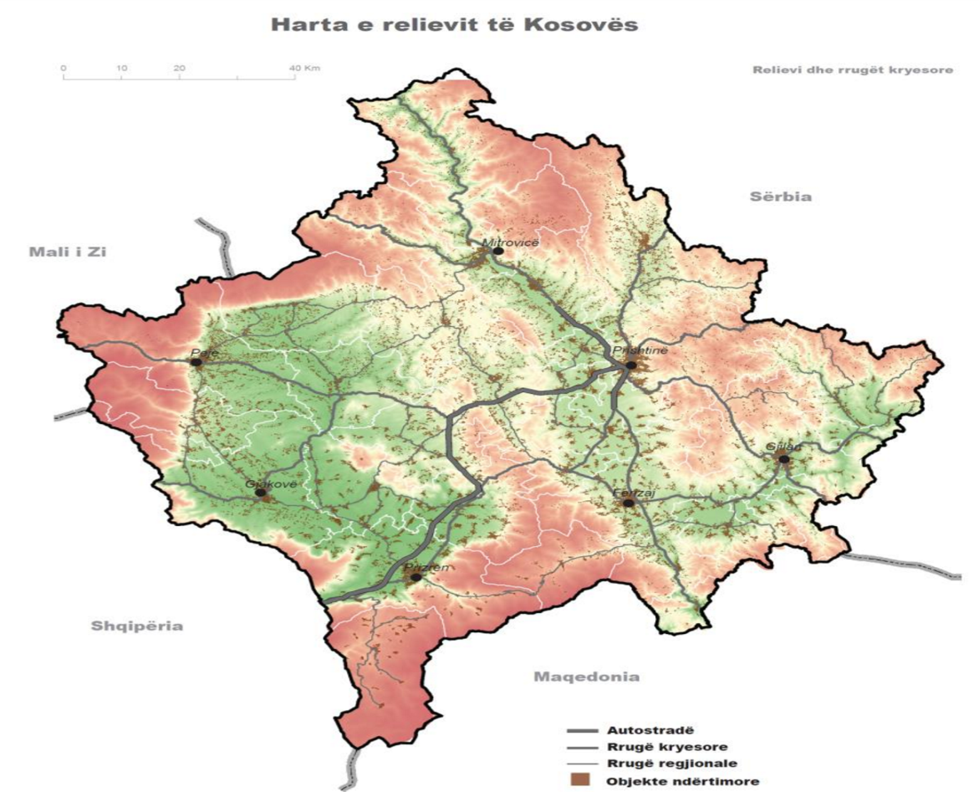
Administrative division of Kosovo - Currently, there are 38 municipalities in Kosovo with 1,469 settlements organized according to national laws.

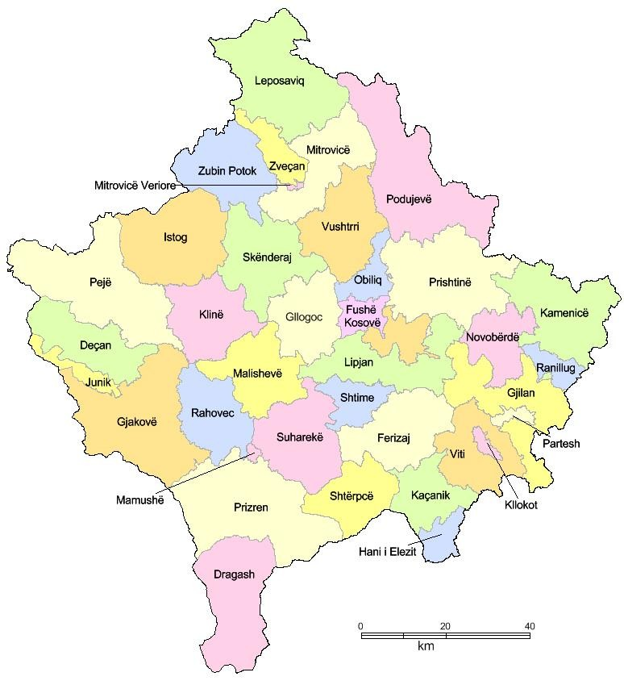

Population

To analyse the demographic situation of a country, the main sources are provided by data obtained from the census (which according to United Nations rules, is carried out every ten years) and vital statistics. The last census in Kosovo was conducted in 2011.

The state of Kosovo is characterized by a very young population structure, with an
average age of 30.2 years.

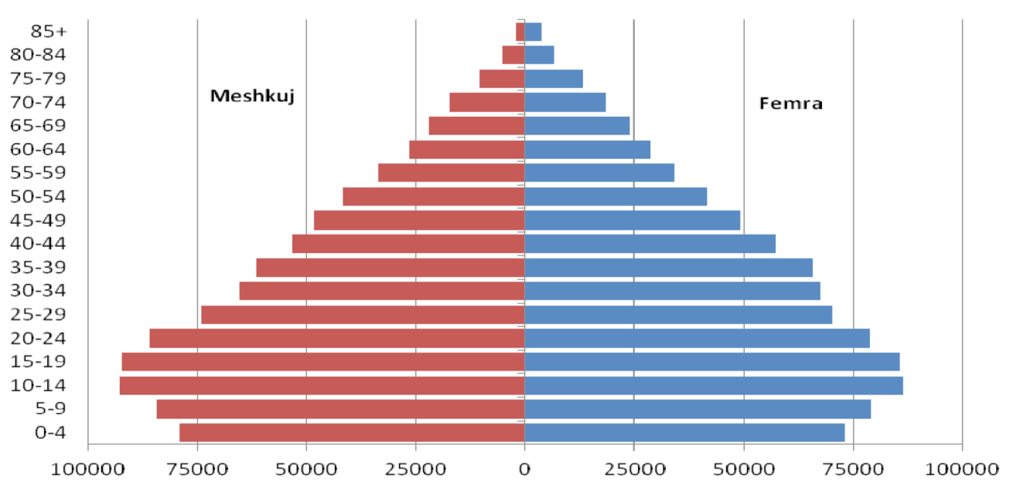
Population pyramid dated 31 March 2011, by gender and age:
Source: KAS, 2019

Population pyramids represent the population structure by years of census, age, and gender. Until the last census of 2011, the results were presented based on the concept of resident and non-resident population. While the 2011 census did not include the population living outside Kosovo for more than 12 months. Therefore, due to the change in methodology, we have a disproportionate share of the total population compared to previous years.

Population by age, 2018
0
10
20
30
40
50
60
70
80
90
100
EU-28
Montenegro
NorthMacedonia
Albania
Serbia
Turkey
Kosovo (
1
)
Lessthan15years
15-64
years
65
Yearsandover
Note: BosniaandHerzegovina, notavailable.
(1) 2017.
Source: Eurostat (online data code: demo_pjangroup)

After 1990, the population of Kosovo was faced with the phenomenon of migration, which affected both its structure and its growth rates. The free and uncontrolled movement of the population has led to a shift in the ratio of rural to urban population. According to the census conducted in April 2011, 61% of the population lives in rural areas.

Estimated population in Kosovo
Chuang | Total population of Kosovo estimated for the year:
Chuang | 2012 (31 December 2012) | 2013 (31 December 2013) | 2014 (31 December 2014) | 2015 (31 December 2015) | 2016 (31 December 2016) | 2017 (31 December 2017) | 2018 (31 December 2018)
Chuang | 1,815,606 | 1,820,631 | 1,804,944 | 1,771,604 | 1,783,531 | 1,798,506 | 1,795,666
Source: Census 2011, KAS

According to calculations by the Kosovo Agency of Statistics, the average life expectancy for 2011 in Kosovo for both sexes was 76.7 years. Females had an average life expectancy of 79.4 years while males 74.1 years.

Life expectancy at birth, 2011
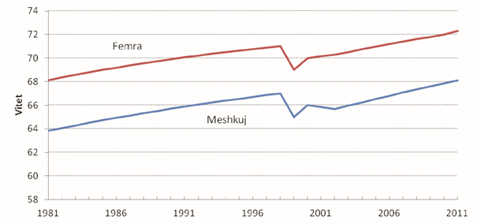
Source: World Bank database

Health System in Kosovo

The Ministry of Health of the Republic of Kosovo has the role of policy maker, setting norms and standards and overseeing the health system in the country.

Within the MoH, in addition to other units of the Central Administration, the Kosovo Agency for Medical Products and Equipment, the National Institute of Public Health of Kosovo and the National Blood Transfusion Center function as regulators in the respective fields; as well as the Health Inspectorate and the Pharmaceutical Inspectorate as law enforcement monitors!

The health system consists of the public sector and the private sector.

The public sector is financed from the central budget, through the regular budget process for Secondary and Tertiary Care (SHC, THC); and the Specific Grants Commission of the Ministry of Finance, for Primary Health Care (PHC).

Primary Health Care (PHC) - is the competence of municipalities, and is fully based on the concept of family medicine, namely the family medicine team, which consists of a specialist family medicine doctor and two family nurses. The PHC also offers dental health care: at the primary level by dentists; and at the secondary level in the Main Family Medicine Centres (specialist dentists).

Each municipality has its main unit, the Main Family Medicine Center, with departments according to the laws in force, and organizes and manages the constituent units in the territory of the municipality, which are Family Medicine Centers (FMCs) and Family Medicine Ambulanta (FMA).

The public network of PHC consists of a total of 429 institutions, namely 28 Main Family Medicine Centers (MFMCs), 183 Family Medicine Centers (FMCs), and 191 Family Medicine Ambulanta. There are 15 outpatient maternity wards within the MFMCs, as well as some outpatient specialist services, which will be gradually closed.

The financing of PHC, as mentioned above, is done from the state budget, as a specific grant for health, through the Grants Commission led by the Prime Minister of the country, and from the own source revenues of the municipality. This budget does not cover the needs for medicines and consumables; therefore, the Ministry of Health (MoH) supplies all municipalities with medicines and consumables, from the regular budget of the MoH.

Health services, mainly primary and outpatient specialist levels, are also provided in several other government departments. These costs are included in the database, and will be presented in the chapter with the relevant tables in this report.

Secondary Health Care (SHC) and Tertiary Health Care (THC) - Kosovo has integrated secondary and tertiary services into a public health service provider, namely the Hospital and University Clinical Service of Kosova (HUCSK), which in addition to specific health services for relevant institutions according to the level (hospital and outpatient-specialist, diagnostic, etc.), also provides education at the Faculty of Medicine for basic studies, postgraduate studies and relevant scientific research.

The health institutions of secondary and tertiary level of health care, which constitute the HUCSK, are as follows:

- University Clinical Center of Kosovo;
- University Dental Clinical Center of Kosovo;
- National Center of Occupational Medicine in Gjakova;
- National Center for Sports Medicine;
- National Telemedicine Center;
- General Hospital in Mitrovica;
- General Hospital in Gjilan;
- General Hospital in Peja;
- General Hospital in Gjakova;
- General Hospital in Prizren;
- General Hospital in Ferizaj;
- General Hospital in Vushtrria;
- Mental Health Centers with Community Integration Housing;
- Center for Integration and Rehabilitation of Chronic Psychiatric Patients in Shtime.

The Hospital and University Clinical Service of Kosova has 7076 employees registered in the salary system.

Specialist doctors are 22% of the staff, nurses are 60% and 18% of the staff are non-medical staff.

Expressed in numbers, 1562 are specialist doctors, 4239 of the workers are nurses and 1275 are other non-medical staff.

Work activities of the Hospital and University Clinical Service of Kosovo

Total Services HUCSK, 2018
* This table shows the work activities of Hospitals and Clinics for 2018, and show the use of their capacities.
Unit | Clinic | No. of beds | Days of healing | No. of hospitalized | No. of operated | Outpatient visits / daily stays  MH | Laboratory services | Other and / or special (diagnostic) services | No. of births | No. of dialysis | Average daily recovery | Capacity utilization
UCCK | 37 | 1,908 | 465,488 | 78,791 | 22,715 | 517,880 | 1,246,917 | 903,413 | 9,963 | 39,374 | 5.91 | 66.84
Hospitals | 7 | 2,000 | 381,340 | 84,222 | 18,376 | 825,381 | 1,571,406 | 549,889 | 12,128 | 85,072 | 4.53 | 52.24
Mental health | 8 | 154 |  |  |  | 64,027 |  | 288,353
Occupational Medicine | 1 |  |  |  |  | 28,361 | 112,464 | 48,345
HUCSK | 1 |  |  |  |  | 51,829 |  | 278,693
NCSM | 1 |  |  |  |  | 21,247
Telemedicine | 1 |  |  |  |  |  |  | 34,641
Total | 56 | 4,062 | 846,828 | 163,013 | 41,091 | 1,508,725 | 2,930,787 | 2,103,334 | 22,091 | 124,446 | 5.19 | 59.37
Source: HUCSK Work Report 2018, published by HUCSK

Health workers in Kosovo, according to the Chambers of Health Professionals of Kosovo:

Chambers of healthcare professionals in the Republic of Kosovo licensed in 2018
* The table below presents the Chambers of healthcare professionals divided by gender.
Chambers | Total | Females | MALE
Chamber of Doctors | 3,616 | 1,586 | 2,030
Chamber of Nurses | 12,194 | 9,873 | 2,321
Chamber of Dentists | 1,554 | 663 | 891
Chamber of Physiotherapists | 405 | 247 | 158
Chamber of Pharmacists | 1,472 | 1,072 | 400
Total | 19,241 | 13,441 | 5,800

SHC and THC, as mentioned above, are financed from the state budget, through the regular annual budget process, which in principle is a budget based on previous (historical) years, which is approved according to the budget possibilities of the Budget of the Republic of Kosovo.

The private sector is financed by private sources and direct payment for services.

Legal acts in the country equate the private sector with the public.

The private sector is dynamic and developing rapidly, taking into account the legal incentivization by the state. Procedures for starting a private health institution are standardized by the MoH and are easy to implement.

The network of private health institutions in Kosovo, according to the data of the Ministry of Health, consists of 27 private hospitals and 1592 other private health institutions, respectively, 114 Polyclinics, 141 laboratories, 43 cabinets, and 1294 specialist clinics.

The initial financing of private institutions is done by the founder of the institution, while subsequently it is financed by the direct payment of the citizens for the health services provided.

Health activity

The health activity analysis in the Republic of Kosovo is the competence of the National Institute of Public Health of Kosovo, which must publish the Annual Report on the health status of the population. Since it has not been published for 2018, we will present the basic data from the 2016 Report.

Primary Health Care (PHC)

Staff
In PHC for 2016, according to the reported data, there are a total of 5,358 employees‚ of whom 1,087 (20.3%) doctors, 296 (5.5%) dentists, 7 (0.1%) pharmacists, 3,078 (57.4%) medical technicians/nurses, 44 (0.8%) health care associates, and 846 (15.8%) non-medical staff.
The number of inhabitants to one doctor is 1,587 which is close to the norm given for
Family Medicine. By municipalities, it varies from 845 in Obiliq to 6,993 inhabitants to
one doctor in Novoberde.
There are 5,830 inhabitants to one dentist in PHC in Kosovo.
The number of inhabitants to one nurse is 561 and varies from 806 to 370.
By municipalities, reported pharmacists are deficit staff;
The ratio between nurses and doctors is 3: 1, ranging from 2: 1 to 9: 1.

Workload indicators in PHC
A total of 3,688,571 visits to the doctor, 384,655 visits to the dentist and 6,006,009 visits to other health professionals were made in the PHC
The average daily workload of a doctor is 12.1 visits.
The average daily workload of a dentist is 4.6 visits.
The average daily workload of a nurse is 7 visits.
On average, there are 2.1 visits per doctor per capita per year, ranging from 8.0 to 0.6 visits per year.
On average, there are 0.2 visits to the dentist per capita per year.

Secondary Health Care (SHC)

Staff
In 2016, a total of 446 doctors, 115 health and non-health associates ;, as well as a total of 1015 nurses were employed general hospitals in Kosovo.

Workload indicators
According to the reports generated by the NIPHK, in total 1,952 beds were reported
in the Kosovo General Hospitals in 2016. 82,081 patients were hospitalized respectively treated in the hospitals.
The ratio per doctor varies from 4.2 to 0.5.

Hospital capacity utilization at the Kosovo level is 55.3%, with variations from 118.6% to 33.4%.
The average number of surgeries per doctor in Kosovo level is 36.
The average treatment in general hospitals is 4.7 days, with variations from 14.9 to 3.2 days.
The daily workload per doctor in Kosovo was 2.3 patients while the daily workload
per nurse was 1.0.
Hospital mortality by ward was the highest in the Neurology ward with 86.7% and
Surgery Intensive Care 62%.

Tertiary Health Care (THC)

Staff
In 2016, THC employed a total of 3,097 employees, out of which 597 doctors (19.3% of the total number of employees), 62 dentists (2.0%), pharmacists 10 (0.3%), 1,837 nurses (59.3%) health care associates 14 (0.5%) and non-health care employees 576 (18.6%). The total number of specialist doctors in UCCK was 535, while the total number of nurses in UCCK was 1,667.

Workload indicators in UCCK
In UCCK according to the reports generated by NIPHK, in 2016 were reported
a total of 1,898 beds and 504,826 days of treatment.
The number of patients hospitalized in the UCCK was 96,828 and in relation to clinical doctors, we have 180 patients per doctor.

The average daily doctor workload (patients hospitalized per doctor) at UCCK was
1.9.
The average (daily) workload of the nurse was 1.2.

(Source: Analysis of the Health Status of the Population in Kosovo - 2016; NIPHK)

Financing the (public) health system in retrospective

The Republic of Kosovo is considered a country with high middle income, according to the categorization of the World Bank. As a developing country, the Republic of Kosovo has many priorities, which need financing from the state budget. In this context it should be understood that not all the needs of the public health sector have been funded, in retrospective.

Lack of sufficient funds for the normal functioning of the system has caused the shift of costs to the pocket of the citizen, primarily for medicines and consumables (outpatient drugs), as well as for health services, in cases where these services are not provided in public sector.

The Ministry of Health, in order to address this issue and mitigate the problem, has launched a program for treatment outside public health institutions (in the country or abroad); but the means are not enough for all the needs; therefore, a number of citizens seek treatment abroad, spending considerable amounts of financial means, which unfortunately, at the moment we are not able to register, nor can we make an objective assessment, which could have been used for the purposes of this report.

The budget of the public health sector during the last decade had the following variable movements:

Budget of MoH for the period 2008 - 2018

Table # 1: Expenditures in the Ministry of Health, for the years 2008 - 2018, by economic categories (in Euro):
Economic category | 2018 | 2017 | 2016 | 2015 | 2014 | 2013 | 2012 | 2011 | 2010 | 2009 | 2008
Wages and salaries | 8,050,649 | 8,313,972 | 7,940,750 | 7,652,757 | 52,854,734 | 44,408,183 | 42,527,654 | 38,827,166 | 32,868,160 | 25,182,645 | 20,434,658
Goods and services | 34,337,304 | 29,507,959 | 24,676,108 | 9,166,585 | 36,324,871 | 38,332,671 | 29,167,678 | 29,397,827 | 27,626,773 | 31,958,263 | 28,193,386
Utility costs | 155,408 | 183,802 | 183,845 | 196,571 | 3,739,731 | 3,388,643 | 3,871,062 | 3,292,171 | 3,354,697 | 3,352,104 | 3,536,639
Subsidies and transfers | 11,016,744 | 14,364,873 | 9,935,261 | 9,716,570 | 9,683,042 | 4,763,603 | 2,841,184 | 2,206,483 | 2,955,421 | 3,025,095 | 2,777,079
Non-financial assets | 4,999,345 | 5,213,494 | 7,146,481 | 4,990,190 | 8,807,593 | 8,628,310 | 8,897,476 | 6,158,817 | 7,999,286 | 12,359,687 | 7,674,597
Total expenditures | 58,559,449 | 57,584,100 | 49,882,445 | 31,722,673 | 111,409,971 | 99,521,409 | 87,305,055 | 79,882,464 | 74,804,338 | 75,877,794 | 62,616,358

Budget changes in 2015 and 2016, were made due to the allocation of Hospital and University Clinical Service of Kosova (HUCSK) as an independent budget organization; whereas in 2016, in the MoH from HUCSK only the budget for medicaments and consumables was spent.

It should be noted that during 2018 we had an increase in the budget for medicines and consumables for HUCSK!

The budget of Hospital and University Clinical Service of Kosova (HUCSK), for the year 2015 - 2018, was as follows:

Table # 2: Expenditures in HUCSK, for the years 2015 - 2018, by economic categories (in Euro):
* This table shows the expenditures for the secondary and tertiary level. In 2016, the budget allocated for drugs and consumables was transferred from the HUCSK to the MoH; therefore, there is a decrease in the level of funding in the economic category Goods and Services.
Economic category | 2018 | 2017 | 2016 | 2015
Wages and salaries | 58,242,230 | 51,586,625 | 51,294,776.17 | 49,882,132
Goods and services | 13,659,911 | 13,049,585 | 10,812,241 | 27,286,586
Utility costs | 3,617,547 | 2,060,463 | 3,351,393 | 3,482,745
Subsidies and transfers
Non-financial assets | 9,473.831.71 | 3,856,439 | 3,772,213 | 5,490,853
Total | 84,993,519 | 70,553,112 | 69,230,624 | 86,142,316

Municipal budget for Primary Health Care (PHC), for the period 2008-2018, was as follows:

Table # 3: Expenditures for municipal health, for the years 2008 - 2018, by economic categories (in Euro):
* In this table we notice that the budget allocated for health at the primary level has had an increasing trend over the years, mainly in the category Wages and Salaries for capacity building with health staff.
Economic categories | 2018 | 2017 | 2016 | 2015 | 2014 | 2013 | 2012 | 2011 | 2010 | 2009 | 2008
Wages and salaries | 40,971,614 | 39,296,553 | 39,363,941 | 38,276,205 | 34,381,291 | 31,133,814 | 30,963,725 | 29,881,861 | 25,385,411 | 18,827,802 | 14,447,354
Goods and services | 7,666,861 | 6,228,039 | 5,794,995 | 5,859,230 | 5,465,355 | 6,199,678 | 6,020,434 | 4,972,348 | 4,465,575 | 4,465,096 | 4,422,430
Utility costs | 1,396,815 | 1,407,892 | 1,452,879 | 1,477,955 | 1,319,799 | 1,455,494 | 1,406,139 | 1,412,824 | 1,390,091 | 1,303,704 | 1,158,053
Subsidies and transfers | 1,024,825 | 714,106 | 685,918 | 794,023 | 961,902 | 1,075,243 | 837,048 | 866,047 | 796,735 | 780,010 | 487,538
Non-financial assets | 6,230,629 | 4,594,592 | 3,997,867 | 4,841,654 | 7,036,755 | 5,822,963 | 6,085,427 | 6,477,587 | 4,895,421 | 4,699,037 | 1,060,482
Total | 57,290,744 | 52,241,181 | 51,295,600 | 51,249,067 | 49,165,102 | 45,687,192 | 45,312,774 | 43,610,666 | 36,933,233 | 30,075,650 | 21,575,857

Other departments, despite accounting for a very small percentage of health expenditures, are deemed necessary to be included in this report. Expenditures are dedicated to specific health institutions within the relevant departments, and relate to the MoJ - the Institute of Forensics, the Health Service of the MoD and the ANSA. This data has been collected for the first time for 2018!

Table # 4: Expenditures of other public sector departments for health, 2018 (in Euro):
* In this table we see that other ministries/agencies also spend on health mainly in terms of prevention and primary care:
Institution | Amount
Ministry of Justice | 851,282
Ministry of Defence | 350,785
Air Navigation Services Agency | 35,242
Total | 1,237,309

The summary of public health expenditures, by main expenditures, for the last 11 years is presented in the following table:

Table # 5: Public Sector Expenditures on Health, 2008-2018 (in Euro):
* This table presents the health expenditures financed directly from the government grant.
Institution | 2018 | 2017 | 2016 | 2015 | 2014 | 2013 | 2012 | 2011 | 2010 | 2009 | 2008
Ministry of Health | 58,559,449 | 57,584,100 | 49,882,445 | 31,722,673 | 111,409,971 | 99,521,409 | 87,305,055 | 79,882,464 | 74,804,338 | 75,877,794 | 62,616,358
HUCSK | 84,993,519 | 70,553,112 | 69,230,624 | 86,142,316
Municipalities (PHC) | 57,290,744 | 52,241,181 | 51,295,600 | 51,249,067 | 49,165,102 | 45,687,192 | 45,312,774 | 43,610,666 | 36,933,233 | 30,075,650 | 21,575,857
Other ministries | 1,237,309
Total | 202,081,021 | 180,378,393 | 170,408,669 | 169,114,056 | 160,575,073 | 145,208,601 | 132,617,829 | 123,493,130 | 111,737,571 | 105,953,444 | 84,192,215

As it can be seen in the table, there is a change in budget allocations in 2015 and 2016, these were made due to the allocation of HUCSK as an independent budget organization; whereas there is again a change in 2016, namely from HUCSK to MoH has been transferred only the budget for medicines, consumables and some capital projects; budget which returns to HUCSK in 2018.

Whereas, expressed as a percentage of Gross Domestic Product (GDP), health expenditures are presented in the following tables:

Note:
Gross Domestic Product (GDP) - The most important economic indicator in the System of National Accounts is the Gross Domestic Product (GDP), which represents the performance of a country's economy in a given period. There are three approaches to measuring GDP: the production, expenditure and revenue approach.
Final household consumption: Final household consumption is the main component of Gross Domestic Product with the approach to expenditures and represents the expenditures of resident households, in order to meet their needs and requirements for goods and services. This means not only goods and services paid for directly, but also their receipt in kind or from own production.
The estimation of household expenditures is based on household budget survey data. This survey is organized in KAS.
General Government Final Consumption Expenditures: The final consumption of the Government consists of the amount of goods and services purchased, the compensation of workers and the consumption of fixed capital, reduced by sales revenues.
Final consumption of non-profit institutions serving households: Non-profit institutions serving households consist of Non-governmental Organizations (NGOs).
Source: Gross Domestic Product: 2008 - 2018 / Kosovo Agency of Statistics, 2019. - 14 p. : ilust. ; 24 cm. - (Series 3: Economic Statistics)

Table # 6: Gross Domestic Product according to economic activities at current prices, 2008 - 2018
Economic activities | (in million Euros)
Economic activities | 2008 | 2009 | 2010 | 2011 | 2012 | 2013 | 2014 | 2015 | 2016 | 2017 | 2018
Health and social work activities | 49 | 57 | 73 | 84 | 91 | 96 | 107 | 118 | 125 | 129 | 144
Gross Domestic Product | 3,538 | 3,610 | 4,031 | 4,556 | 4,797 | 5,071 | 5,325 | 5,674 | 6,037 | 6,356 | 6,672
Source: Gross Domestic Product: 2008 - 2018 / Kosovo Agency of Statistics, 2019. - 14 p. : illust. ; 24 cm. - (Series 3: Economic Statistics)

Table # 7: Gross Domestic Product at current prices 2008 - 2018 (in million Euros)
Economic activities | GDP share by activities
Economic activities | 2008 | 2009 | 2010 | 2011 | 2012 | 2013 | 2014 | 2015 | 2016 | 2017 | 2018
GDP at current prices (million Euros) | 3,538 | 3,610 | 4,031 | 4,556 | 4,797 | 5,071 | 5,325 | 5,674 | 6,037 | 6,356 | 6,672
GDP per capita (Euro) | 2,057 | 2,066 | 2,271 | 2,529 | 2,654 | 2,794 | 2,950 | 3,202 | 3,368 | 3,534 | 3,716
Source: Gross Domestic Product: 2008 - 2018 / Kosovo Agency of Statistics, 2019. - 14 p. : illust. ; 24 cm. - (Series 3: Economic Statistics)

The table below shows that the budget has not managed to exceed 3% of GDP, as a government allocation for the public health sector.

Table # 8: GDP, and % of GDP for health (main public expenditures), 2008-2018 (in million Euros)
 | 2008 | 2009 | 2010 | 2011 | 2012 | 2013 | 2014 | 2015 | 2016 | 2017 | 2018
Nominal GDP (million Euros) | 3,538 | 3,610 | 4,031 | 4,556 | 4,797 | 5,071 | 5,325 | 5,674 | 6,037 | 6,356 | 6,672
MoH (million Euros) | 63 | 76 | 75 | 80 | 87 | 100 | 111 | 32 | 50 | 58 | 59
HUCSK (million Euros) |  |  |  |  |  |  |  | 86 | 69 | 71 | 85
Municipal Level (million Euros) | 22 | 30 | 37 | 44 | 45 | 46 | 49 | 51 | 51 | 52 | 57
Health Expenditures/GDP | 2.40% | 2.90% | 2.80% | 2.70% | 2.80% | 2.90% | 3.00% | 3.00% | 2.80% | 2.80% | 3.00%
Source: Ministry of Finance: Department of Macroeconomics and Treasury Department; Ministry of Health: Budget and Finance Division!

Graph no. 1: Public spending on health, by years

* This graph presents the movement of the health expenditure curve financed by the Government Grant, which has increased in the last 10 years, expressed in million Euros

Graph No. 2: Public expenditures on health, as a percentage of Gross Domestic Product, by years
* This graph presents the movement of the health expenditure curve in relation to GDP in the last 10 years, expressed as a percentage.

The graph above shows an important development for both health and the economy. Graph No. 2 shows a constant increase in public spending on health - an indicator that may indicate the development of health in the country. This increase also indicates another development - the contribution of health to Kosovo's GDP has increased over the years. This assertion also stands when looking at real GDP over the years disaggregated by economic activity - which clearly shows the growing contribution from the health sector along with social work activities.

Graph no. 3: Comparison of Nominal Gross Domestic Product and public health expenditures, as a percentage of Gross Domestic Product, by years

Expenditures for the public health sector, despite being considered significant, have so far failed to cover all the needs of the sector and citizens for health services, medicines and consumables.

Whereas, according to KAS data, the total GDP for health, for the period 2015 - 2018 has the following performance:

Table # 9: GDP, and % of GDP for health (total) 2015-2018 (in million Euros)
 | 2018 | 2017 | 2016 | 2015 | Explanation
Nominal GDP | 6,671.50 | 6,356.50 | 6,037.30 | 5,674.40 | Source: years 2015-2019: KAS
Final consumption of households | 5,296.10 | 5,009.00 | 4,910.50 | 4,803.70 | Source: years 2015-2019: KAS
Private expenditures on health (% of final household consumption) | 3.00% | 3.00% | 3.00% | 3.00% | Source: KAS
Private expenses (million Euros) | 158,883.18 | 150,269.16 | 147,313.71 | 144,110.94 | Calculation = Final consumption of households x Private expenditures (% of final consumption of households)
% of GDP for public health | 3.00% | 2.80% | 2.80% | 3.00% | Calculation = Total Public Expenditure on Health/Nominal GDP
% of GDP for private health expenditures | 2.40% | 2.40% | 2.40% | 2.50% | Calculation = Total Private Expenditure on Health/Nominal GDP
% of GDP for health | 5.40% | 5.20% | 5.30% | 5.50% | Calculation = (Total Public Expenditure on Health + Total Private Expenditure on Health)/Nominal GDP
Source: KAS, National Accounts 2021 with the report "Review of National Accounts 2008 - 2019”

Financing the health system in 2018

During 2018, according to official data of the Kosovo Agency of Statistics (KAS), real GDP had an increase of 3.8% while nominal GDP was about 4.9%. Consumption and investment had the highest contribution to this growth, whereas net exports had a negative contribution. However, although exports of goods did not perform well, the continued growth of exports of services is encouraging (5.5% in 2018).

Health financing is mainly realized by Budget of the Republic of Kosovo, own source revenues and lending from the World Bank. Own source revenues in Primary Health Care are used to partially finance the implementation of capital projects for municipal health.

The reform of the health system, during 2015 has enabled the separation of the HUCSK from the Ministry of Health, as an independent budget organization.

Consequently, the HUCSK, from 1 January 2015, has started to operate as an independent budget unit with all economic categories from the Ministry of Health. In 2016, with the amendments proposed by the Committee on Budget and Finance of the Republic of Kosovo, and with the voting of the Law on Budget by MPs of the Republic of Kosovo, the economic categories (Capital and medicaments and consumables) were transferred to the MoH.

Public sector

The public health sector in Kosovo consists of all health and administrative institutions which are dependent on the state budget to conduct their activities, including various government departments and executive agencies of departments which have the task of monitoring the implementation of legality in the sector.

The main public sector expenditures had the following expenditure structure:
Table # 10: MoH expenditures, by economic categories:
Economic category | Amount (Euro)
Wages and salaries
Goods and services | 34,337,303.61
Utility costs | 155,407.50
Subsidies and transfers | 11,016,744.10
Non-financial assets | 4,999,344.69
Total | 58,559,448.67

The Ministry of Health has also had the support of donors this year, according to the table adapted to the legal reporting system in the country, according to economic categories:

Table # 11: Donations to the MoH, by economic categories:
Economic category | Amount (Euro)
Wages and salaries | 1,090,914.60
Goods and services | 6,508,128.70
Utility costs | 6,741.00
Subsidies and transfers
Non-financial assets | 5,639,249.90
Total | 13,245,034.20

Donations are provided by the following donors:

- TIKA, Turkey (Renovation and equipment: UCCK Intensive Care Unit);
- Her Excellence Office Sheikha Fatima Bint Mubara; Abu Dhabi (Construction and equipment: Pediatric Clinic, HUCSK);
- Accessible Quality Healthcare (AQH) (Swiss Agency for Development and Cooperation - SDC) (Support for CSP);
- Government of Japan (Supply of medical equipment);
- Government of Luxembourg (Kosovo Health Support Program);
- Global Fund (HIV Prevention in Kosovo and Strengthening TB Control in Kosovo;
- Direct Relief;
- Action for mothers and children (Supply of medicines);
- Care for Kosovo kids (Supply of medicines/consumables);
- Liri Med (Supply of consumables);
- Madekos (Supply of consumables);
- Medical Group (Supply of consumables);
- Opharma (Supply of consumables);
- Pharma Leader (Supply of consumables);
- Exclusiv shpk (Supply of medicines);
- Italian Cooperation (Kosovo Health System Support)
- WHO (Technical Assistance program for TB and AC funds for running several activities such as HIS, Health System, Environmental health etc);
- You are sunflower (Medical device);
- Medica LLC (Medical Devices);
- Helvetas/MLGA (Medical Devices);
- Fortesa home (Renovations);
- BAVARIA (Renovations);
- Others (Equipment);
- Others (Equipment);

Table # 12: HUCSK expenditures, by economic categories:
Economic category | Amount (Euro)
Wages and salaries | 58,242,229.68
Goods and services | 13,659,910.59
Utility costs | 3,617,546.75
Subsidies and transfers | -
Non-financial assets | 9,473,831.71
Total | 84,993,518.73

Table # 13: Expenditures of PHC (municipalities), by economic categories:
Economic category | Amount (Euro)
Wages and salaries | 40,971,613.87
Goods and services | 7,666,861.33
Utility costs | 1,396,815.48
Subsidies and transfers | 1,024,824.74
Non-financial assets | 6,230,628.97
Total | 57,290,744.39

Table # 14: Ministry of Justice (MoJ), by economic categories:
Economic category | Amount (Euro)
Wages and salaries | 583,632.00
Goods and services | 143,538.50
Utility costs | 48,500.00
Subsidies and transfers
Non-financial assets | 75,611.17
Total | 851,281.67

Table # 15: Ministry of Defence (MoD), by economic categories
Economic category | Amount (Euro)
Wages and salaries
Goods and services | 237,946.32
Utility costs | 29,500.00
Subsidies and transfers
Non-financial assets | 83,339.00
Total | 350,785.32

Table # 16: Air Navigation Services Agency (ANSA), by economic categories
Economic category | Amount (Euro)
Wages and salaries | 29,472.85
Goods and services | 5,768.92
Utility costs
Subsidies and transfers
Non-financial assets
Total | 35,241.77

Table # 17: Summary: Expenditure structure for key public expenditures (with donations), 2018:
The following table presents the expenditures by economic categories, and by the institutions listed below.
Economic category | MoH | MoH donations | HUCSK | Municipalities | MoJ | MoD | ANSA | Amount (Euro)
Wages and salaries | 8,050,649 | 1,090,915 | 58,242,230 | 40,971,614 | 583,632 |  | 29,473 | 108,968,512
Goods and services | 34,337,304 | 6,508,129 | 13,659,911 | 7,666,861 | 143,539 | 237,946 | 5,769 | 62,559,458
Utility costs | 155,408 | 6,741 | 3,617,547 | 1,396,815 | 48,500 | 29,500 |  | 5,254,511
Subsidies and transfers | 11,016,744 |  | - | 1,024,825 |  |  |  | 12,041,569
Non-financial assets | 4,999,345 | 5,639,250 | 9,473,832 | 6,230,629 | 75,611 | 83,339 |  | 26,502,005
Total | 58,559,449 | 13,245,034 | 84,993,519 | 57,290,744 | 851,282 | 350,785 | 35,242 | 215,326,055

Public Sector Expenditures on Health, for 2018, are summarized in the following table:

Table # 18: Summary - Public Sector Expenditures on Health, 2018
Public institutions | Amount (Euro)
MoH | 58,559,448.67
Donations to the Ministry of Health | 13,245,034.20
HUCSK | 84,993,518.73
PHC (municipality) | 57,290,744.39
Ministry of Justice | 851,281.67
Ministry of Defence | 350,785.32
Air Navigation Services Agency | 35,241.77
Total | 215,326,054.75

Private sector

The private health sector consists of private health institutions, licensed by the Ministry of Health to provide health services, within the Law on Health and bylaws which regulate this area.

Services offered in the private sector are hospital-day and inpatient services, outpatient specialist services, laboratory and imaging diagnostics, outpatient and inpatient rehabilitation physiotherapy, etc.

Information on the private sector was obtained from the Kosovo Agency of Statistics, publication of the Survey Results on Income and Living Conditions 2018; and the Macroeconomics Department of the Ministry of Finance, which processed and prepared the data.

The rest of the data is provided by the Central Bank of Kosovo and Kosovo Agency of Statistics, regarding voluntary health insurance in our country.

Table # 19: Citizen's pocket expenditures for health, 2018:
Service / expense | Amount (Euro)
Medications | 97,272,506
Pharmaceutical products other than medication | 238,285
Medical equipment and other aids | 194,599
Outpatient public health services | 1,580,178
Outpatient private health services | 17,862,274
Public dental services | 1,501,527
Private dental services | 4,953,228
Medical tests, laboratory, public radioscopy (Roentgen) | 564,804
Medical analysis, laboratory, private radioscopy (Roentgen) | 5,708,305
Public hospital services | 2,475,638
Private hospital services | 8,955,593
Health services abroad | 15,927,357
Accommodation, food, ambulance transport abroad | 1,491,768
Traditional medicine | 119,648
Other medical services | 37,469
Total | 158,883,180
Source: KAS - Results of the Survey on Income and Living Conditions (known as EU-SILC) in Kosovo, for 2018

Table # 20: Expenditures on voluntary health insurance, 2018
Institution | Amount (Euro)
Voluntary health insurance companies (reported expenses) | € 18,040,766.00
Total | € 18,040,766.00
Source: KAS - Publication - Health Statistics 2018

Table # 21: Summary - Out-of-pocket health expenditures, 2018
Service/expenditure | Amount (Euro)
Out-of-pocket expenses (for the private sector) for health | 158,883,180.00
Voluntary health insurance companies | 18,040,766.00
Total | 176,923,946.00
Source: KAS - Publication - Health Statistics 2018

Expenditures on health care in the Republic of Kosovo for 2018 are presented in the following table:

Table # 22: Expenditures on health care, Kosovo 2018 (reported data)
Institution/spender | Amount | Percentage
Public health institutions | 202,081,021 | 51.52
Donations to the Ministry of Health | 13,245,034 | 3.38
Out-of-pocket expenses | 158,883,180 | 40.51
Private health insurance companies (reported expenses) | 18,040,766 | 4.6
Total | 392,250,001 | 100

Detailed data on health expenditures for 2018, according to specific software, are presented below:

NOTE: Capital investments are presented separately from other expenses!

Conclusions & recommendations:

- The level of financing of the health sector from government grants, expressed as a percentage of GDP from 2008 to 2018 has moved from 2.4% to 3.0%;

- During the aforementioned period, expenditures on health in addition to increasing, its contribution to the economy has also increased (expressed as the contribution of health and social activities to real GDP). In terms of health spending (from the public and private sector), Kosovo is comparable to Turkey in the region and Luxembourg and Romania in the EU - according to Eurostat data. It should be noted that health expenditures in Kosovo, expressed as a ratio to GDP, are below the regional and EU average. However, it should be borne in mind that because the average age in Kosovo is younger than in these countries, it is expected that health expenditures will be lower. However, private spending (or out-of-pocket) is high - and a contributing factor to this development is the lack of compulsory health insurance in Kosovo - unlike most of these countries.

- This level of public and private spending on health services in the country emphasizes in particular the enormous importance of the functioning of the Public Health Insurance Fund, which should serve as a financial shield for households in Kosovo.

Graph No. 4: Public sector expenditures on health 2018, according to FS, HF, HP, HC and FA and FP
* This graph imported from the HAPT system shows the distribution of the health budget, financed by the Government Grant, and spent according to service providers
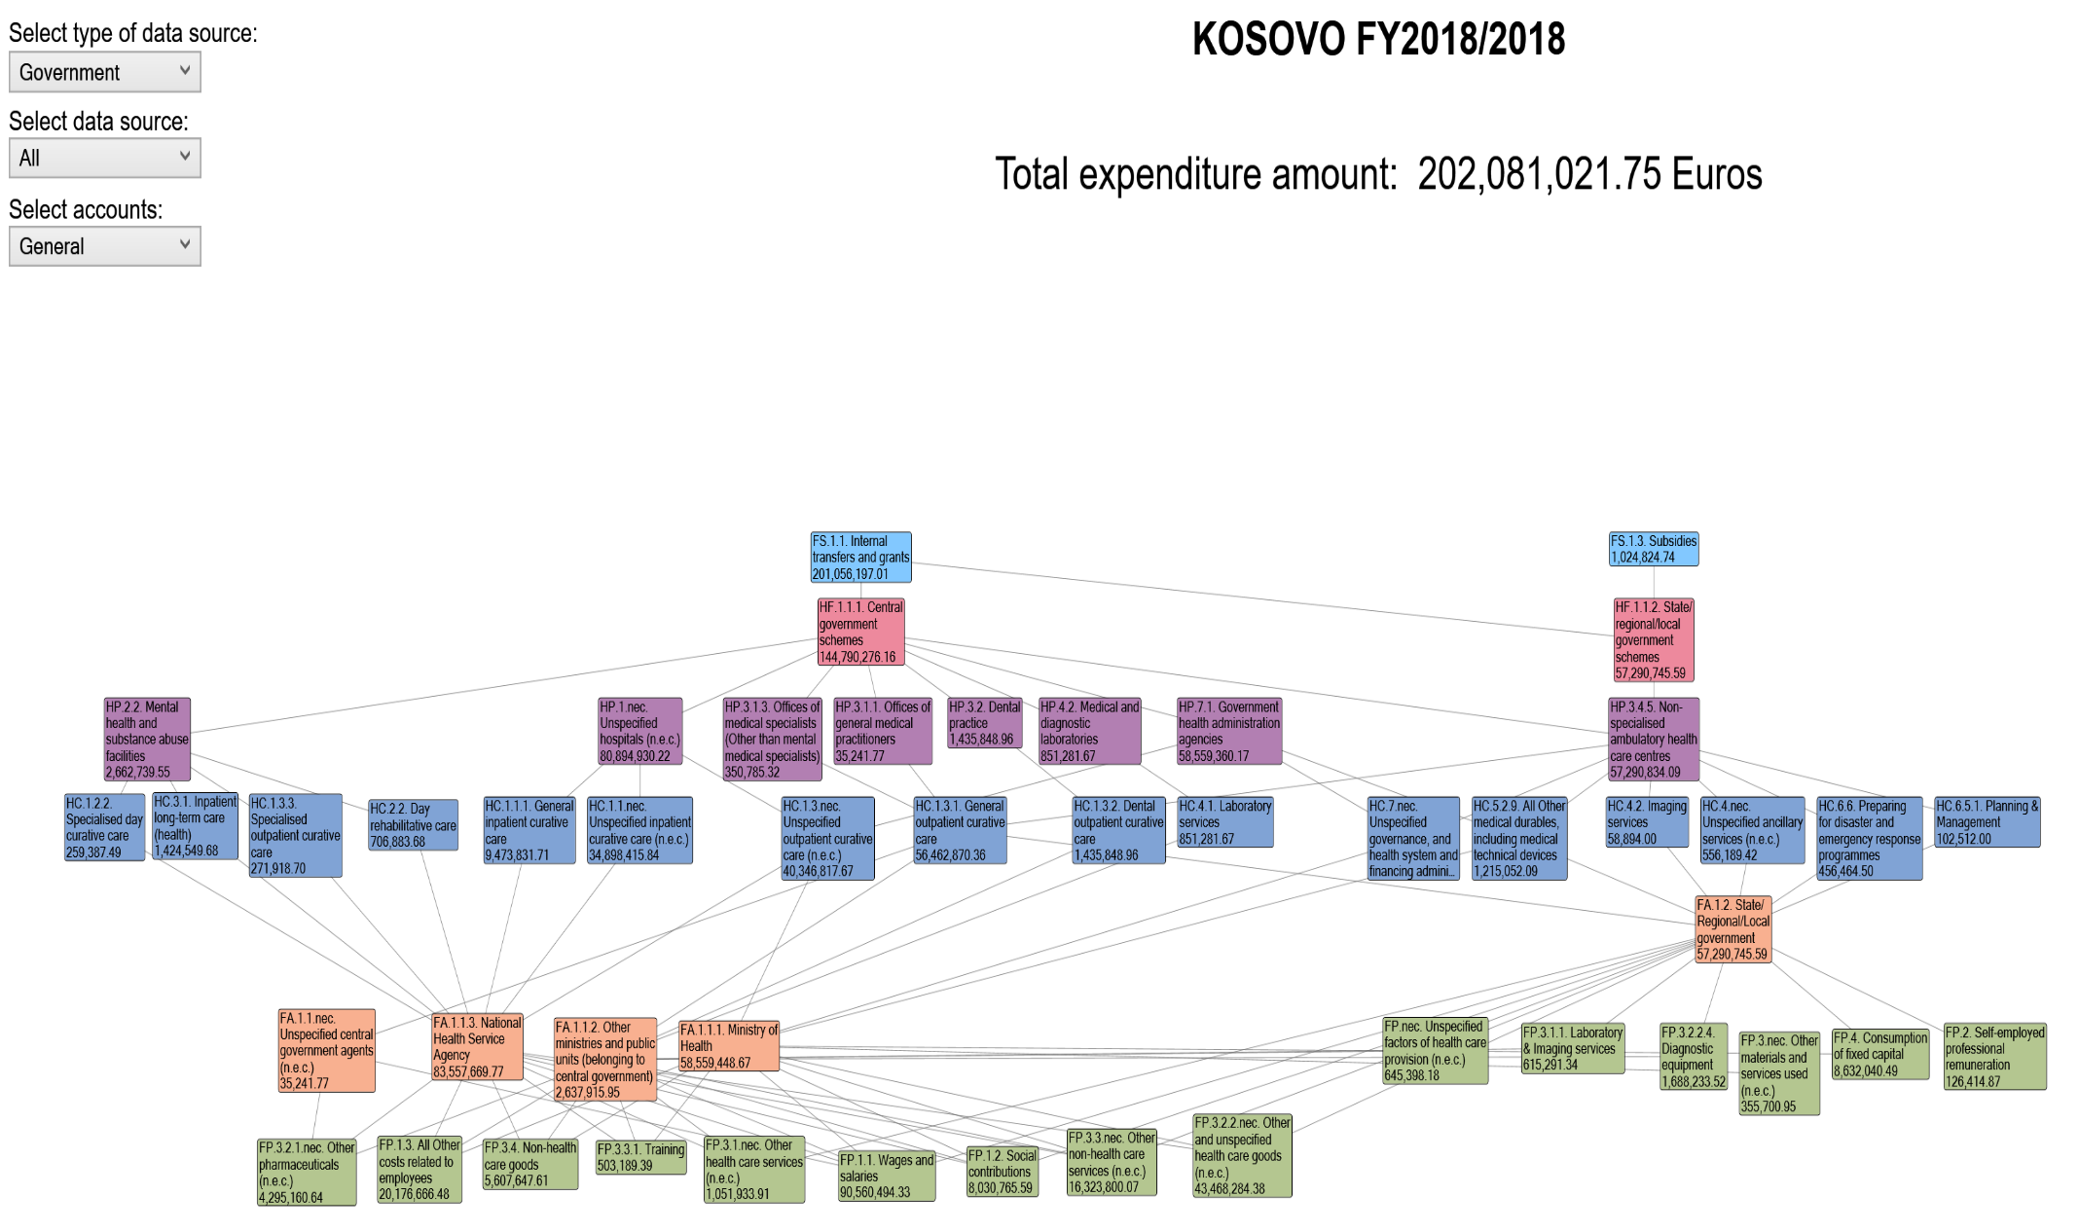
Graph No. 5: Donor expenditures (in the Ministry of Health) 2018, according to FS, HF, HP, HC and FA and FP
* This graph presents the donor expenditures in the MoH, distributed by funding source, service provider and nature of expenditure
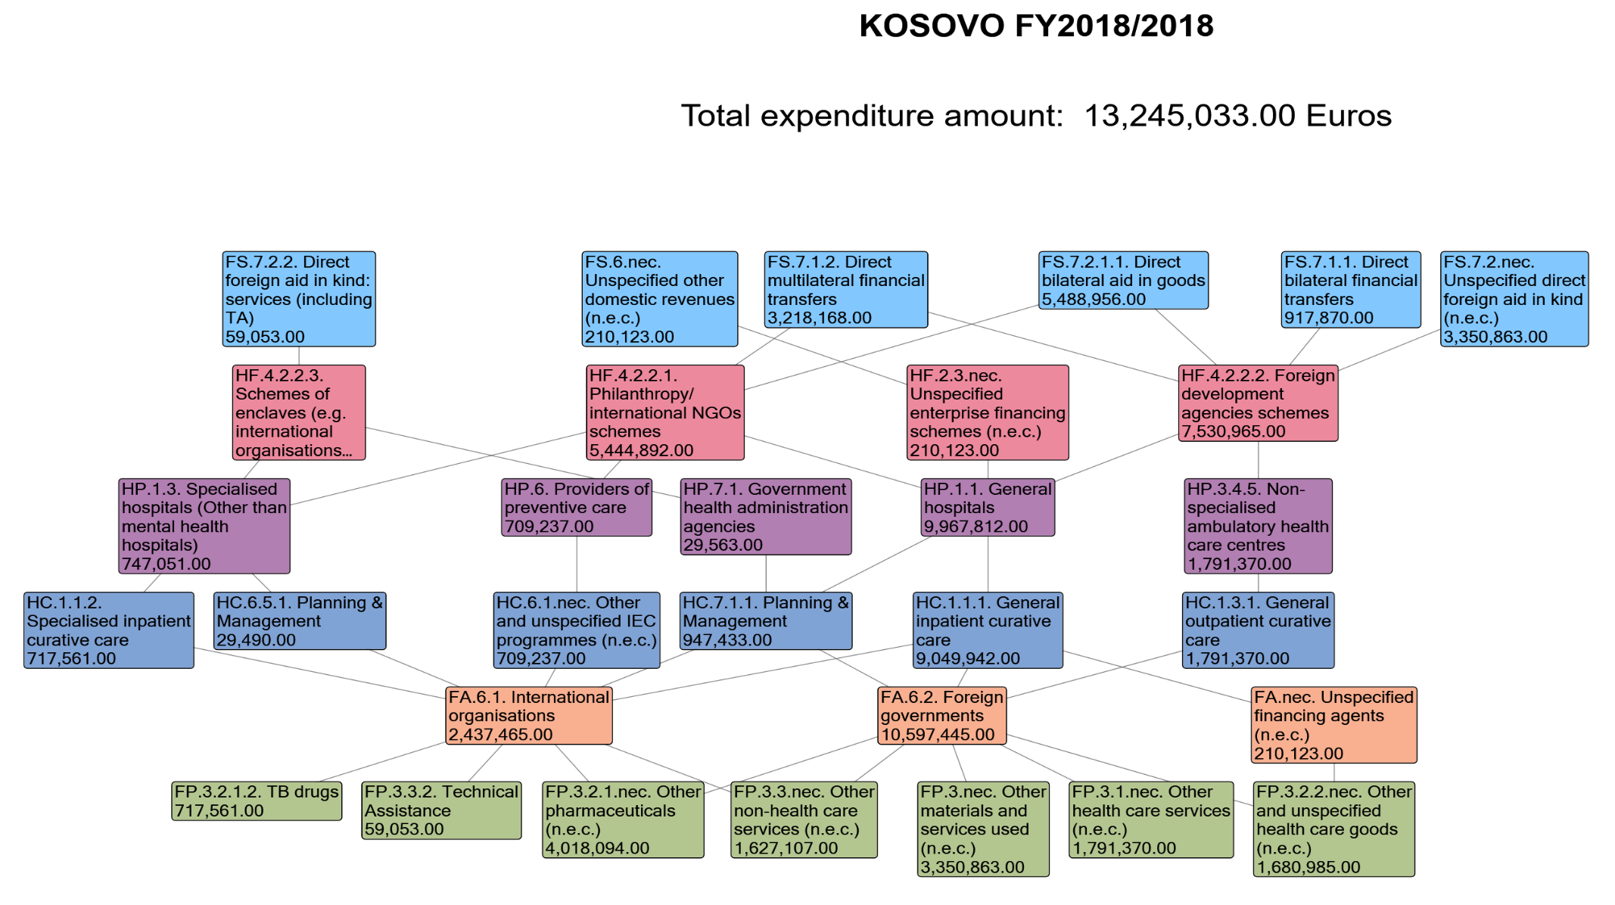

Graph No. 6: Citizen's pocket expenses for health, 2018:
* The following graph presents the total household expenditures for health services and health medicines and equipment, distributed according to the functions of the health system.
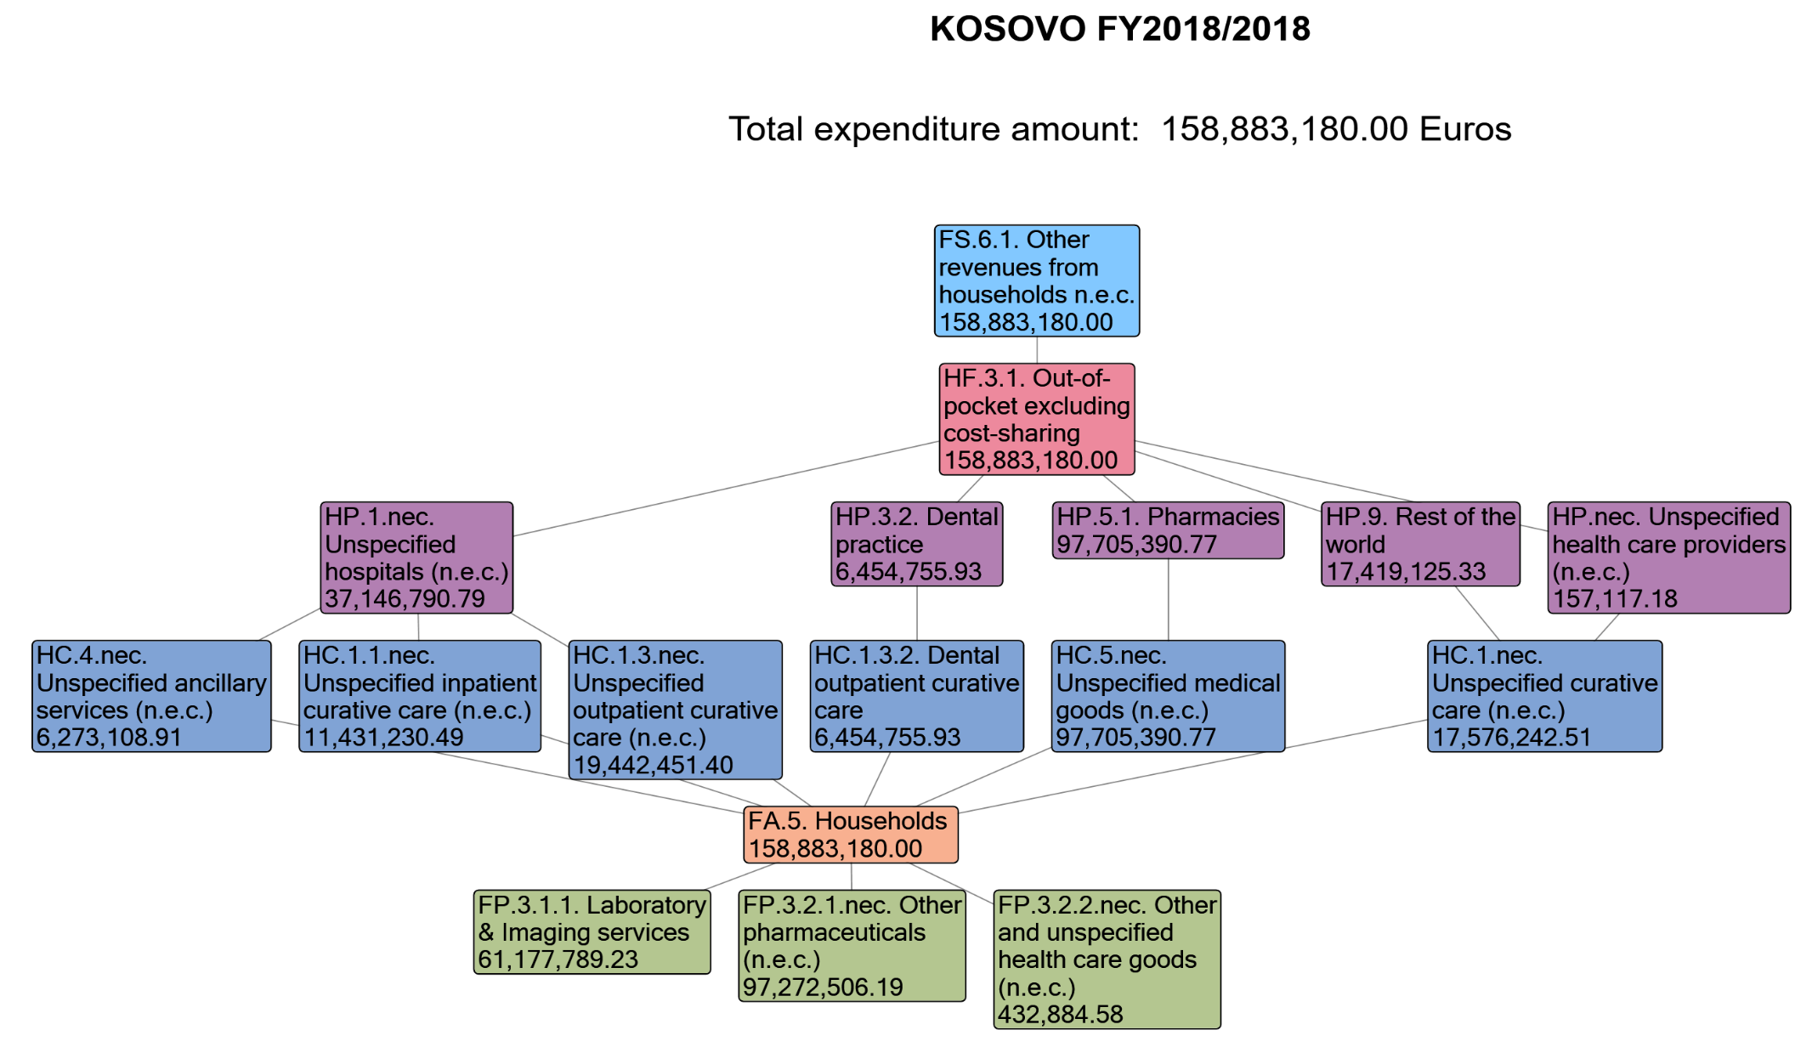

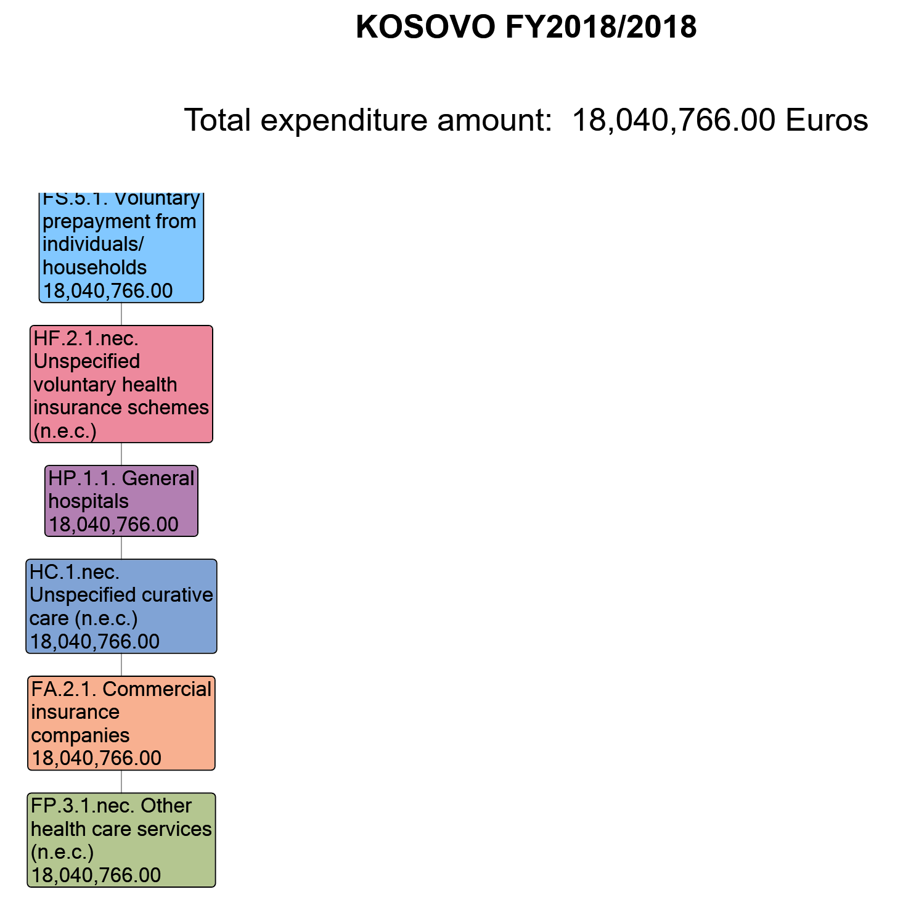
Graph No. 7: Expenditures for voluntary health insurance, 2018

Graph No. 8: Health care expenditures, Kosovo 2018
* The following graph presents the total expenditures for health services, distributed by public and private sector, Revenues of health care financing schemes; financing schemes; health care providers, healthcare functions and capital investments
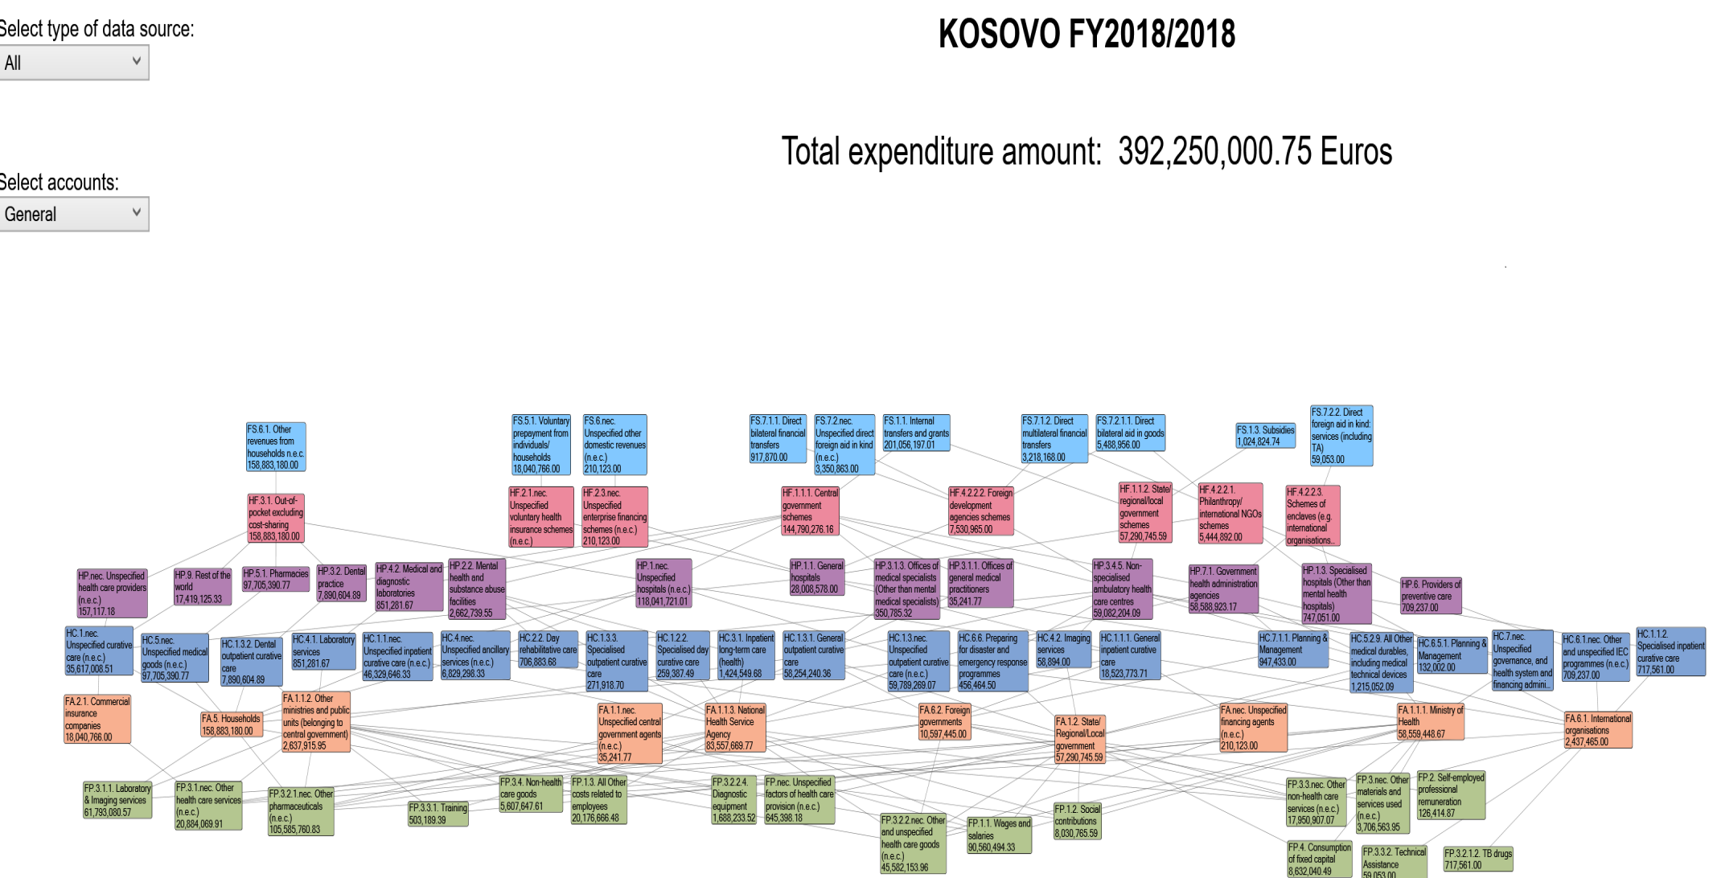

Abbreviations used in the HAPT system:

Clarification:
FS - Revenues of health care financing schemes
HF - Funding schemes
HP - Health care providers
HC - Health care functions
HK - Capital Investments

Translations of terminology in Albanian language:
Classific.  name | FS - Revenues of health care financing schemes | FS - Të ardhurat e skemave të financimit të kujdesit shëndetësor
Code | Name | Emri
FS.1.1 | Internal transfers and grants | Transfere dhe grante të brendshme
FS.1.2 | Transfers by government on behalf of specific groups | Transfere nga qeveria në emër të grupeve specifike
FS.1.3 | Subsidies | Subvencionet
FS.2 | Transfers distributed by government from foreign origin | Transferet e shpërndara nga qeveria me origjinë të huaj
FS.4.2 | Compulsory prepayment from employers | Parapagimi i detyrueshëm nga punëdhënësit
FS.5.1 | Voluntary prepayment from individuals/households | Parapagimi vullnetar nga individë / familje
FS.6.nec | Unspecified other domestic revenues | Të ardhura të tjera të papërcaktuara vendase
 | HF - Financing schemes | HF - Skemat e financimit
HF.1.1.1 | Central government schemes | Skemat e qeverisjes qendrore
HF.1.1.2 | State/regional/local government schemes | Skemat e qeverisjes shtetërore / lokale
HF.1.1.nec | Unspecified government schemes (n.e.c.) | Skema qeveritare të paspecifikuara
HF.2.1.1.3 | Other primary coverage schemes | Skema të tjera të mbulimit parësor
HF.2.1.nec | Unspecified voluntary health insurance schemes (n.e.c.) | Skemat e paspecifikuara të sigurimit shëndetësor vullnetar (n.e.c.)
HF.2.2.1 | NPISH financing schemes (excluding HF.2.2.2) | Skemat e financimit NPISH (përjashtuar HF.2.2.2)
HF.2.3.2 | Health care providers financing schemes | Skemat e financimit të ofruesve të kujdesit shëndetësor
HF.2.nec | Unspecified voluntary health care payment schemes (n.e.c.) | Skemat e paspecifikuara të pagesës së kujdesit shëndetësor
HF.4.1.2 | Other compulsory schemes (non-resident) | Skema të tjera të detyrueshme (jorezident)
HF.4.2.2.1 | Philanthropy/international NGOs schemes | Skemat e filantropisë / OJQ-ve ndërkombëtare
HF.4.2.2.4 | Scientific research training | Trajnim kërkimor shkencor
HF.nec | Unspecified financing schemes (n.e.c.) | Skemat e paspecifikuara të financimit
 | HP - Health care providers | HP - Ofruesit e kujdesit shëndetësor
HP.1 | Hospitals | Spitale
HP.1.1 | General hospitals | Spitalet e përgjithshme
HP.1.2 | Mental health hospitals | Spitalet e shëndetit mendor
HP.1.nec | Unspecified hospitals (n.e.c.) | Spitalet e paspecifikuara (n.e.c.)
HP.3 | Providers of ambulatory health care | Ofruesit e kujdesit shëndetësor ambulator
HP.3.1.1 | Offices of general medical practitioners | Zyrat e mjekëve të përgjithshëm
HP.3.1.nec | Unspecified medical practices (n.e.c.) | Praktikat mjekësore të paspecifikuara
HP.3.3 | Other health care practitioners | Praktikues të tjerë të kujdesit shëndetësor
HP.3.4.1 | Family planning centres | Qendrat e planifikimit familjar
HP.3.4.4 | Dialysis care centres | Qendrat e kujdesit për dializën
HP.3.5 | Providers of home health care services | Ofruesit e shërbimeve të kujdesit shëndetësor në shtëpi
HP.3.nec | Unspecified providers of ambulatory health care (n.e.c.) | Ofruesit e paspecifikuar të kujdesit shëndetësor ambulator
HP.4.9 | Other providers of ancillary services | Ofruesit e tjerë të shërbimeve ndihmëse
HP.7 | Providers of health care system administration and financing | Ofruesit e administrimit dhe financimit të sistemit të kujdesit shëndetësor
HP.7.1 | Government health administration agencies | Agjensitë qeveritare të administrimit shëndetësor
HP.nec | Unspecified health care providers (n.e.c.) | Ofruesit e kujdesit shëndetësor të paspecifikuar
 | HC - Health care functions | HC - Funksionet e kujdesit shëndetësor
HC.1.1.1 | General inpatient curative care | Kujdesi kurues i përgjithshëm spitalor
HC.1.1.2 | Specialised inpatient curative care | Kujdesi kurues i specializuar
HC.1.1.nec | Unspecified inpatient curative care (n.e.c.) | Kujdes kurativ i paspecifikuar
HC.1.2.2 | Specialised day curative care | Kujdesi kurues i specializuar ditor
HC.1.3.1 | General outpatient curative care | Kujdesi kurues i përgjithshëm ambulator
HC.1.3.3 | Specialised outpatient curative care | Kujdesi kurues ambulator i specializuar
HC.1.3.nec | Unspecified outpatient curative care | Kujdesi ambulator i paspecifikuar
HC.2.2 | Day rehabilitative care | Kujdes rehabilitues ditor
HC.3.2 | Day long-term care (health) | Kujdesi afatgjatë ditor (shëndetësia)
HC.4.1 | Laboratory services | Shërbimet laboratorike
HC.4.nec | Unspecified ancillary services (n.e.c.) | Shërbime ndihmëse të paspecifikuara
HC.5.1.1 | Prescribed medicines | Ilaçet e përshkruara
HC.5.1.3 | Other medical non-durable goods | Mallra të tjerë jo-të qëndrueshëm mjekësorë
HC.5.2.9 | All Other medical durables, including medical technical devices | Të gjitha mallrat e tjera mjekësore, përfshirë pajisjet teknike mjekësore
HC.6.1.1.1 | Tobacco IEC programmes | Programet e IEC-it të duhanit
HC.6.1.1.3 | Drugs IEC programmes | Programet e IEC-së për droga
HC.6.1.nec | Other and unspecified IEC programmes (n.e.c.) | Programe të tjera dhe të paspecifikuara të IEC (n.e.c.)
HC.6.5.3 | Procurement & supply management | Menaxhimi i prokurimit dhe furnizimit
HC.6.5.4. | Other and unspecified interventions | Ndërhyrje të tjera dhe të paspecifikuara
HC.7.2 | Administration of health financing | Administrimi i financimit të shëndetit
HC.7.3 | Salaries | Pagat
HC.9 | Other health care services not elsewhere classified (n.e.c.) | Shërbime të tjera të kujdesit shëndetësor që nuk klasifikohen diku tjetër (n.e.c.)
 | HK - Capital Account | HK - Investime Kapitale
HK.1.1.1.1 | Residential and non-residential buildings | Ndërtesa banimi dhe jo-rezidenciale
HK.1.1.1.2 | Other structures | Strukturat e tjera
HK.1.1.2.1 | Medical equipment | Pajisje mjekësore
HK.1.1.2.2 | Transport equipment | Pajisje transporti
HK.1.1.2.3 | ICT equipment | Pajisje TIK
HK.1.1.2.4 | Machinery and equipment n.e.c. | Makineritë dhe pajisjet
HK.1.2 | Changes in inventories | Ndryshimet në inventarë
HK.2.2 | Other non-produced non-financial assets | Pasuri të tjera jo të prodhuara jo-financiare

Annex 1: Tables from HAPT
Table Nr. 1:
 |  |  |  | Revenues of health care financing schemes |  | FS.1 |  |  |  |  |  | FS.5 |  |  |  | FS.6 |  |  |  |  |  | FS.7 |  |  |  |  |  |  |  |  |  |  |  |  |  |  |  |  |  | All FS
 |  |  |  |  |  |  |  | FS.1.1 |  | FS.1.3 |  |  |  | FS.5.1 |  |  |  | FS.6.1 |  | FS.6.nec |  |  |  | FS.7.1 |  |  |  |  |  | FS.7.2
 |  |  |  |  |  |  |  |  |  |  |  |  |  |  |  |  |  |  |  |  |  |  |  |  |  | FS.7.1.1 |  | FS.7.1.2 |  |  |  | FS.7.2.1 |  |  |  | FS.7.2.2 |  | FS.7.2.nec
 |  |  |  |  |  |  |  |  |  |  |  |  |  |  |  |  |  |  |  |  |  |  |  |  |  |  |  |  |  |  |  |  |  | FS.7.2.1.1
Financing schemes |  |  |  | Euros (EUR), Million |  | Transfers from government domestic revenue (allocated to health purposes) |  | Internal transfers and grants |  | Subsidies |  | Voluntary prepayment |  | Voluntary prepayment from individuals/households |  | Other domestic revenues n.e.c. |  | Other revenues from households n.e.c. |  | Unspecified other domestic revenues (n.e.c.) |  | Direct foreign transfers |  | Direct foreign financial transfers |  | Direct bilateral financial transfers |  | Direct multilateral financial transfers |  | Direct foreign aid in kind |  | Direct foreign aid in goods |  | Direct bilateral aid in goods |  | Direct foreign aid in kind: services (including TA) |  | Unspecified direct foreign aid in kind (n.e.c.)
HF.1 |  |  |  | Government schemes and compulsory contributory health care financing schemes |  | 202.08 |  | 201.06 |  | 1.02 |  |  |  |  |  |  |  |  |  |  |  |  |  |  |  |  |  |  |  |  |  |  |  |  |  |  |  |  |  | 202.08
 | HF.1.1 |  |  | Government schemes |  | 202.08 |  | 201.06 |  | 1.02 |  |  |  |  |  |  |  |  |  |  |  |  |  |  |  |  |  |  |  |  |  |  |  |  |  |  |  |  |  | 202.08
 |  | HF.1.1.1 |  | Central government schemes |  | 144.79 |  | 144.79 |  |  |  |  |  |  |  |  |  |  |  |  |  |  |  |  |  |  |  |  |  |  |  |  |  |  |  |  |  |  |  | 144.79
 |  | HF.1.1.2 |  | State/regional/local government schemes |  | 57.29 |  | 56.27 |  | 1.02 |  |  |  |  |  |  |  |  |  |  |  |  |  |  |  |  |  |  |  |  |  |  |  |  |  |  |  |  |  | 57.29
HF.2 |  |  |  | Voluntary health care payment schemes |  |  |  |  |  |  |  | 18.04 |  | 18.04 |  | 0.21 |  |  |  | 0.21 |  |  |  |  |  |  |  |  |  |  |  |  |  |  |  |  |  |  |  | 18.25
 | HF.2.1 |  |  | Voluntary health insurance schemes |  |  |  |  |  |  |  | 18.04 |  | 18.04 |  |  |  |  |  |  |  |  |  |  |  |  |  |  |  |  |  |  |  |  |  |  |  |  |  | 18.04
 |  | HF.2.1.nec |  | Unspecified voluntary health insurance schemes (n.e.c.) |  |  |  |  |  |  |  | 18.04 |  | 18.04 |  |  |  |  |  |  |  |  |  |  |  |  |  |  |  |  |  |  |  |  |  |  |  |  |  | 18.04
 | HF.2.3 |  |  | Enterprise financing schemes |  |  |  |  |  |  |  |  |  |  |  | 0.21 |  |  |  | 0.21 |  |  |  |  |  |  |  |  |  |  |  |  |  |  |  |  |  |  |  | 0.21
 |  | HF.2.3.nec |  | Unspecified enterprise financing schemes (n.e.c.) |  |  |  |  |  |  |  |  |  |  |  | 0.21 |  |  |  | 0.21 |  |  |  |  |  |  |  |  |  |  |  |  |  |  |  |  |  |  |  | 0.21
HF.3 |  |  |  | Household out-of-pocket payment |  |  |  |  |  |  |  |  |  |  |  | 158.88 |  | 158.88 |  |  |  |  |  |  |  |  |  |  |  |  |  |  |  |  |  |  |  |  |  | 158.88
 | HF.3.1 |  |  | Out-of-pocket excluding cost-sharing |  |  |  |  |  |  |  |  |  |  |  | 158.88 |  | 158.88 |  |  |  |  |  |  |  |  |  |  |  |  |  |  |  |  |  |  |  |  |  | 158.88
HF.4 |  |  |  | Rest of the world financing schemes (non-resident) |  |  |  |  |  |  |  |  |  |  |  |  |  |  |  |  |  | 13.03 |  | 4.14 |  | 0.92 |  | 3.22 |  | 8.90 |  | 5.49 |  | 5.49 |  | 0.06 |  | 3.35 |  | 13.03
 | HF.4.2 |  |  | Voluntary schemes (non-resident) |  |  |  |  |  |  |  |  |  |  |  |  |  |  |  |  |  | 13.03 |  | 4.14 |  | 0.92 |  | 3.22 |  | 8.90 |  | 5.49 |  | 5.49 |  | 0.06 |  | 3.35 |  | 13.03
 |  | HF.4.2.2 |  | Other schemes (non-resident) |  |  |  |  |  |  |  |  |  |  |  |  |  |  |  |  |  | 13.03 |  | 4.14 |  | 0.92 |  | 3.22 |  | 8.90 |  | 5.49 |  | 5.49 |  | 0.06 |  | 3.35 |  | 13.03
 |  |  | HF.4.2.2.1 | Philanthropy/international NGOs schemes |  |  |  |  |  |  |  |  |  |  |  |  |  |  |  |  |  | 5.44 |  | 1.43 |  |  |  | 1.43 |  | 4.02 |  | 4.02 |  | 4.02 |  |  |  |  |  | 5.44
 |  |  | HF.4.2.2.2 | Foreign development agencies schemes |  |  |  |  |  |  |  |  |  |  |  |  |  |  |  |  |  | 7.53 |  | 2.71 |  | 0.92 |  | 1.79 |  | 4.82 |  | 1.47 |  | 1.47 |  |  |  | 3.35 |  | 7.53
 |  |  | HF.4.2.2.3 | Schemes of enclaves (e.g. international organisations or embassies) |  |  |  |  |  |  |  |  |  |  |  |  |  |  |  |  |  | 0.06 |  |  |  |  |  |  |  | 0.06 |  |  |  |  |  | 0.06 |  |  |  | 0.06
All HF |  |  |  |  |  | 202.08 |  | 201.06 |  | 1.02 |  | 18.04 |  | 18.04 |  | 159.09 |  | 158.88 |  | 0.21 |  | 13.03 |  | 4.14 |  | 0.92 |  | 3.22 |  | 8.90 |  | 5.49 |  | 5.49 |  | 0.06 |  | 3.35 |  | 392.25
Memorandum items
 | Financing agents managing the financing schemes |  |  |  | 202.08 |  | 201.06 |  | 1.02 |  | 18.04 |  | 18.04 |  | 158.88 |  | 158.88 |  |  |  | 13.03 |  | 4.14 |  | 0.92 |  | 3.22 |  | 8.90 |  | 5.49 |  | 5.49 |  | 0.06 |  | 3.35 |  | 392.04
 |  | HF.RI.1.1 |  | Government (FA.1 General government) |  | 202.08 |  | 201.06 |  | 1.02 |  |  |  |  |  |  |  |  |  |  |  |  |  |  |  |  |  |  |  |  |  |  |  |  |  |  |  |  |  | 202.08
 |  | HF.RI.1.2 |  | Corporations (FA.2 Insurance + FA.3 Corporations) |  |  |  |  |  |  |  | 18.04 |  | 18.04 |  |  |  |  |  |  |  |  |  |  |  |  |  |  |  |  |  |  |  |  |  |  |  |  |  | 18.04
 |  | HF.RI.1.3 |  | Households (FA.5 Households) |  |  |  |  |  |  |  |  |  |  |  | 158.88 |  | 158.88 |  |  |  |  |  |  |  |  |  |  |  |  |  |  |  |  |  |  |  |  |  | 158.88
 |  | HF.RI.1.5 |  | Rest of the world (FA.6 Rest of the world) |  |  |  |  |  |  |  |  |  |  |  |  |  |  |  |  |  | 13.03 |  | 4.14 |  | 0.92 |  | 3.22 |  | 8.90 |  | 5.49 |  | 5.49 |  | 0.06 |  | 3.35 |  | 13.03
 | Financing schemes and the related cost-sharing together |  |  |  | 202.08 |  | 201.06 |  | 1.02 |  | 18.04 |  | 18.04 |  |  |  |  |  |  |  |  |  |  |  |  |  |  |  |  |  |  |  |  |  |  |  |  |  | 220.12
 |  | HF.RI.2 |  | Governmental schemes and compulsory contributory health insurance schemes together with cost sharing (HF.1 + HF.3.2.1) |  | 202.08 |  | 201.06 |  | 1.02 |  |  |  |  |  |  |  |  |  |  |  |  |  |  |  |  |  |  |  |  |  |  |  |  |  |  |  |  |  | 202.08
 |  | HF.RI.3 |  | Voluntary health insurance schemes together with cost sharing (HF.2.1+HF.3.2.2) |  |  |  |  |  |  |  | 18.04 |  | 18.04 |  |  |  |  |  |  |  |  |  |  |  |  |  |  |  |  |  |  |  |  |  |  |  |  |  | 18.04
Used data sources:
Donors | Project Hope, TIKA, Her Highness Sheikha Fatima Bint Mubara Abu Dhabi Office, Accesible and quality health care (AQH) - SDC), Japan, Luxembourg, Global Fund 1, Global Fund 2, Direct Relief, Action for mothers and children, Care for Kosovo kids, Liri Med, Madekos, MedicalGroup, Opharma, Pharma Leader, Exclusiv shpk, Italian Cooperation, WHO 1, WHO 2, You are sunflower, Medica SHPK, Helvetas/MAPL, Fortesa home, BAVARIA, Other 1, Other 2
Insurances | Insurance Company
Government sources | ASHNA, IK Komunat, KI SHSKUK, Komunat, Mental Health, Ministria e Drejtesise - IK, MInistria e Drejtsise, Ministria e Mbrojtjes, Ministria e Mbrojtjes - IK, Ministria e Shendetsis, MoH - Capital Expenditure, QSKUK, Secondary Hos
Households | Household

Table Nr. 2:
 |  |  | Financing schemes | HF.1 |  |  |  |  | HF.2 |  |  |  |  |  |  |  |  |  | HF.3 |  |  |  | HF.4 |  |  |  |  |  |  |  |  | All HF | Memorandum items
 |  |  | Financing schemes |  | HF.1.1 |  |  |  |  |  | HF.2.1 |  |  | HF.2.3 |  |  |  |  |  |  | HF.3.1 |  |  |  | HF.4.2 |  |  |  |  |  |  |  | Memorandum items | Financing agents managing the financing schemes |  |  |  |  |  |  | Financing schemes and the related cost-sharing together
 |  |  | Financing schemes |  |  |  | HF.1.1.1 | HF.1.1.2 |  |  |  |  | HF.2.1.nec |  |  |  | HF.2.3.nec |  |  |  |  |  |  |  |  |  | HF.4.2.2 |  |  |  |  |  | Memorandum items | Financing agents managing the financing schemes | HF.RI.1.1 | HF.RI.1.2 | HF.RI.1.3 |  | HF.RI.1.5 |  |  |  |  | HF.RI.2 | HF.RI.3
 |  |  | Financing schemes |  |  |  |  |  |  |  |  |  |  |  |  |  |  |  |  |  |  |  |  |  |  |  |  |  | HF.4.2.2.1 | HF.4.2.2.2 | HF.4.2.2.3 |  | Memorandum items | Financing agents managing the financing schemes
Health care providers |  |  | Euros (EUR), Million | Government schemes and compulsory contributory health care financing schemes | Government schemes | Central government schemes |  | State/regional/local government schemes |  | Voluntary health care payment schemes |  | Voluntary health insurance schemes | Unspecified voluntary health insurance schemes (n.e.c.) |  | Enterprise financing schemes | Unspecified enterprise financing schemes (n.e.c.) |  | Household out-of-pocket payment |  | Out-of-pocket excluding cost-sharing |  | Rest of the world financing schemes (non-resident) |  | Voluntary schemes (non-resident) |  | Other schemes (non-resident) |  | Philanthropy/international NGOs schemes |  | Foreign development agencies schemes | Schemes of enclaves (e.g. international organisations or embassies) |  |  |  | Government (FA.1 General government) | Corporations (FA.2 Insurance + FA.3 Corporations) |  | Households (FA.5 Households) |  | Rest of the world (FA.6 Rest of the world) |  |  | Governmental schemes and compulsory contributory health insurance schemes together with cost sharing (HF.1 + HF.3.2.1) |  | Voluntary health insurance schemes together with cost sharing (HF.2.1+HF.3.2.2)
HP.1 |  |  | Hospitals | 80.89 | 80.89 |  | 80.89 |  | 18.25 |  | 18.04 |  | 18.04 | 0.21 |  |  | 0.21 |  | 37.15 |  | 37.15 |  | 10.50 |  | 10.50 |  | 10.50 |  | 4.74 | 5.74 | 0.03 | 146.80 | 245.52 | 146.59 | 80.89 | 18.04 | 37.15 |  | 10.50 |  | 98.94 |  |  | 80.89 | 18.04
 | HP.1.1 |  | General hospitals |  |  |  |  |  | 18.25 |  | 18.04 |  | 18.04 | 0.21 |  |  | 0.21 |  |  |  |  |  | 9.76 |  | 9.76 |  | 9.76 |  | 4.02 | 5.74 |  | 28.01 | 45.84 | 27.80 |  | 18.04 |  |  | 9.76 |  | 18.04 |  |  |  | 18.04
 | HP.1.3 |  | Specialised hospitals (Other than mental health hospitals) |  |  |  |  |  |  |  |  |  |  |  |  |  |  |  |  |  |  |  | 0.75 |  | 0.75 |  | 0.75 |  | 0.72 |  | 0.03 | 0.75 | 0.75 | 0.75 |  |  |  |  | 0.75
 | HP.1.nec |  | Unspecified hospitals (n.e.c.) | 80.89 | 80.89 |  | 80.89 |  |  |  |  |  |  |  |  |  |  |  | 37.15 |  | 37.15 |  |  |  |  |  |  |  |  |  |  | 118.04 | 198.94 | 118.04 | 80.89 |  | 37.15 |  |  |  | 80.89 |  |  | 80.89
HP.2 |  |  | Residential long-term care facilities | 2.66 | 2.66 |  | 2.66 |  |  |  |  |  |  |  |  |  |  |  |  |  |  |  |  |  |  |  |  |  |  |  |  | 2.66 | 5.33 | 2.66 | 2.66 |  |  |  |  |  | 2.66 |  |  | 2.66
 | HP.2.2 |  | Mental health and substance abuse facilities | 2.66 | 2.66 |  | 2.66 |  |  |  |  |  |  |  |  |  |  |  |  |  |  |  |  |  |  |  |  |  |  |  |  | 2.66 | 5.33 | 2.66 | 2.66 |  |  |  |  |  | 2.66 |  |  | 2.66
HP.3 |  |  | Providers of ambulatory health care | 59.11 | 59.11 |  | 1.82 | 57.29 |  |  |  |  |  |  |  |  |  |  | 6.45 |  | 6.45 |  | 1.79 |  | 1.79 |  | 1.79 |  |  | 1.79 |  | 67.36 | 126.47 | 67.36 | 59.11 |  | 6.45 |  | 1.79 |  | 59.11 |  |  | 59.11
 | HP.3.1 |  | Medical practices | 0.39 | 0.39 |  | 0.39 |  |  |  |  |  |  |  |  |  |  |  |  |  |  |  |  |  |  |  |  |  |  |  |  | 0.39 | 0.77 | 0.39 | 0.39 |  |  |  |  |  | 0.39 |  |  | 0.39
 |  | HP.3.1.1 | Offices of general medical practitioners | 0.04 | 0.04 |  | 0.04 |  |  |  |  |  |  |  |  |  |  |  |  |  |  |  |  |  |  |  |  |  |  |  |  | 0.04 | 0.07 | 0.04 | 0.04 |  |  |  |  |  | 0.04 |  |  | 0.04
 |  | HP.3.1.3 | Offices of medical specialists (Other than mental medical specialists) | 0.35 | 0.35 |  | 0.35 |  |  |  |  |  |  |  |  |  |  |  |  |  |  |  |  |  |  |  |  |  |  |  |  | 0.35 | 0.70 | 0.35 | 0.35 |  |  |  |  |  | 0.35 |  |  | 0.35
 | HP.3.2 |  | Dental practice | 1.44 | 1.44 |  | 1.44 |  |  |  |  |  |  |  |  |  |  |  | 6.45 |  | 6.45 |  |  |  |  |  |  |  |  |  |  | 7.89 | 9.33 | 7.89 | 1.44 |  | 6.45 |  |  |  | 1.44 |  |  | 1.44
 | HP.3.4 |  | Ambulatory health care centres | 57.29 | 57.29 |  | 0.00 | 57.29 |  |  |  |  |  |  |  |  |  |  |  |  |  |  | 1.79 |  | 1.79 |  | 1.79 |  |  | 1.79 |  | 59.08 | 116.37 | 59.08 | 57.29 |  |  |  | 1.79 |  | 57.29 |  |  | 57.29
 |  | HP.3.4.5 | Non-specialised ambulatory health care centres | 57.29 | 57.29 |  | 0.00 | 57.29 |  |  |  |  |  |  |  |  |  |  |  |  |  |  | 1.79 |  | 1.79 |  | 1.79 |  |  | 1.79 |  | 59.08 | 116.37 | 59.08 | 57.29 |  |  |  | 1.79 |  | 57.29 |  |  | 57.29
HP.4 |  |  | Providers of ancillary services | 0.85 | 0.85 |  | 0.85 |  |  |  |  |  |  |  |  |  |  |  |  |  |  |  |  |  |  |  |  |  |  |  |  | 0.85 | 1.70 | 0.85 | 0.85 |  |  |  |  |  | 0.85 |  |  | 0.85
 | HP.4.2 |  | Medical and diagnostic laboratories | 0.85 | 0.85 |  | 0.85 |  |  |  |  |  |  |  |  |  |  |  |  |  |  |  |  |  |  |  |  |  |  |  |  | 0.85 | 1.70 | 0.85 | 0.85 |  |  |  |  |  | 0.85 |  |  | 0.85
HP.5 |  |  | Retailers and Other providers of medical goods |  |  |  |  |  |  |  |  |  |  |  |  |  |  |  | 97.71 |  | 97.71 |  |  |  |  |  |  |  |  |  |  | 97.71 | 97.71 | 97.71 |  |  | 97.71
 | HP.5.1 |  | Pharmacies |  |  |  |  |  |  |  |  |  |  |  |  |  |  |  | 97.71 |  | 97.71 |  |  |  |  |  |  |  |  |  |  | 97.71 | 97.71 | 97.71 |  |  | 97.71
HP.6 |  |  | Providers of preventive care |  |  |  |  |  |  |  |  |  |  |  |  |  |  |  |  |  |  |  | 0.71 |  | 0.71 |  | 0.71 |  | 0.71 |  |  | 0.71 | 0.71 | 0.71 |  |  |  |  | 0.71
HP.7 |  |  | Providers of health care system administration and financing | 58.56 | 58.56 |  | 58.56 |  |  |  |  |  |  |  |  |  |  |  |  |  |  |  | 0.03 |  | 0.03 |  | 0.03 |  |  |  | 0.03 | 58.59 | 117.15 | 58.59 | 58.56 |  |  |  | 0.03 |  | 58.56 |  |  | 58.56
 | HP.7.1 |  | Government health administration agencies | 58.56 | 58.56 |  | 58.56 |  |  |  |  |  |  |  |  |  |  |  |  |  |  |  | 0.03 |  | 0.03 |  | 0.03 |  |  |  | 0.03 | 58.59 | 117.15 | 58.59 | 58.56 |  |  |  | 0.03 |  | 58.56 |  |  | 58.56
HP.9 |  |  | Rest of the world |  |  |  |  |  |  |  |  |  |  |  |  |  |  |  | 17.42 |  | 17.42 |  |  |  |  |  |  |  |  |  |  | 17.42 | 17.42 | 17.42 |  |  | 17.42
HP.nec |  |  | Unspecified health care providers (n.e.c.) |  |  |  |  |  |  |  |  |  |  |  |  |  |  |  | 0.16 |  | 0.16 |  |  |  |  |  |  |  |  |  |  | 0.16 | 0.16 | 0.16 |  |  | 0.16
All HP |  |  |  | 202.08 | 202.08 |  | 144.79 | 57.29 | 18.25 |  | 18.04 |  | 18.04 | 0.21 |  |  | 0.21 |  | 158.88 |  | 158.88 |  | 13.03 |  | 13.03 |  | 13.03 |  | 5.44 | 7.53 | 0.06 | 392.25 | 612.16 | 392.04 | 202.08 | 18.04 | 158.88 |  | 13.03 |  | 220.12 |  |  | 202.08 | 18.04

Table Nr. 3:
 |  |  | Financing schemes | HF.1 |  |  |  | HF.2 |  |  |  |  | HF.3 |  | HF.4 |  |  |  |  |  | All HF | Memorandum items
 |  |  | Financing schemes |  | HF.1.1 |  |  |  | HF.2.1 |  | HF.2.3 |  |  | HF.3.1 |  | HF.4.2 |  |  |  |  |  | Memorandum items | Financing agents managing the financing schemes |  |  |  |  | Financing schemes and the related cost-sharing together
 |  |  | Financing schemes |  |  | HF.1.1.1 | HF.1.1.2 |  |  | HF.2.1.nec |  | HF.2.3.nec |  |  |  |  | HF.4.2.2 |  |  |  |  | Memorandum items | Financing agents managing the financing schemes | HF.RI.1.1 | HF.RI.1.2 | HF.RI.1.3 | HF.RI.1.5 | Financing schemes and the related cost-sharing together | HF.RI.2 | HF.RI.3
 |  |  | Financing schemes |  |  |  |  |  |  |  |  |  |  |  |  |  |  | HF.4.2.2.1 | HF.4.2.2.2 | HF.4.2.2.3 |  | Memorandum items | Financing agents managing the financing schemes |  |  |  |  | Financing schemes and the related cost-sharing together
Health care functions |  |  | Euros (EUR), Million | Government schemes and compulsory contributory health care financing schemes | Government schemes | Central government schemes | State/regional/local government schemes | Voluntary health care payment schemes | Voluntary health insurance schemes | Unspecified voluntary health insurance schemes (n.e.c.) | Enterprise financing schemes | Unspecified enterprise financing schemes (n.e.c.) | Household out-of-pocket payment | Out-of-pocket excluding cost-sharing | Rest of the world financing schemes (non-resident) | Voluntary schemes (non-resident) | Other schemes (non-resident) | Philanthropy/international NGOs schemes | Foreign development agencies schemes | Schemes of enclaves (e.g. international organisations or embassies) |  |  |  | Government (FA.1 General government) | Corporations (FA.2 Insurance + FA.3 Corporations) | Households (FA.5 Households) | Rest of the world (FA.6 Rest of the world) |  | Governmental schemes and compulsory contributory health insurance schemes together with cost sharing (HF.1 + HF.3.2.1) | Voluntary health insurance schemes together with cost sharing (HF.2.1+HF.3.2.2)
HC.1 |  |  | Curative care | 143.15 | 143.15 | 87.07 | 56.08 | 18.25 | 18.04 | 18.04 | 0.21 | 0.21 | 54.90 | 54.90 | 11.35 | 11.35 | 11.35 | 4.74 | 6.61 |  | 227.65 | 388.63 | 227.44 | 143.15 | 18.04 | 54.90 | 11.35 | 161.19 | 143.15 | 18.04
 | HC.1.1 |  | Inpatient curative care | 44.37 | 44.37 | 44.37 |  | 0.21 |  |  | 0.21 | 0.21 | 11.43 | 11.43 | 9.56 | 9.56 | 9.56 | 4.74 | 4.82 |  | 65.57 | 109.73 | 65.36 | 44.37 |  | 11.43 | 9.56 | 44.37 | 44.37
 |  | HC.1.1.1 | General inpatient curative care | 9.47 | 9.47 | 9.47 |  | 0.21 |  |  | 0.21 | 0.21 |  |  | 8.84 | 8.84 | 8.84 | 4.02 | 4.82 |  | 18.52 | 27.79 | 18.31 | 9.47 |  |  | 8.84 | 9.47 | 9.47
 |  | HC.1.1.2 | Specialised inpatient curative care |  |  |  |  |  |  |  |  |  |  |  | 0.72 | 0.72 | 0.72 | 0.72 |  |  | 0.72 | 0.72 | 0.72 |  |  |  | 0.72
 |  | HC.1.1.nec | Unspecified inpatient curative care (n.e.c.) | 34.90 | 34.90 | 34.90 |  |  |  |  |  |  | 11.43 | 11.43 |  |  |  |  |  |  | 46.33 | 81.23 | 46.33 | 34.90 |  | 11.43 |  | 34.90 | 34.90
 | HC.1.2 |  | Day curative care | 0.26 | 0.26 | 0.26 |  |  |  |  |  |  |  |  |  |  |  |  |  |  | 0.26 | 0.52 | 0.26 | 0.26 |  |  |  | 0.26 | 0.26
 |  | HC.1.2.2 | Specialised day curative care | 0.26 | 0.26 | 0.26 |  |  |  |  |  |  |  |  |  |  |  |  |  |  | 0.26 | 0.52 | 0.26 | 0.26 |  |  |  | 0.26 | 0.26
 | HC.1.3 |  | Outpatient curative care | 98.52 | 98.52 | 42.44 | 56.08 |  |  |  |  |  | 25.90 | 25.90 | 1.79 | 1.79 | 1.79 |  | 1.79 |  | 126.21 | 224.72 | 126.21 | 98.52 |  | 25.90 | 1.79 | 98.52 | 98.52
 |  | HC.1.3.1 | General outpatient curative care | 56.46 | 56.46 | 0.39 | 56.08 |  |  |  |  |  |  |  | 1.79 | 1.79 | 1.79 |  | 1.79 |  | 58.25 | 114.72 | 58.25 | 56.46 |  |  | 1.79 | 56.46 | 56.46
 |  | HC.1.3.2 | Dental outpatient curative care | 1.44 | 1.44 | 1.44 |  |  |  |  |  |  | 6.45 | 6.45 |  |  |  |  |  |  | 7.89 | 9.33 | 7.89 | 1.44 |  | 6.45 |  | 1.44 | 1.44
 |  | HC.1.3.3 | Specialised outpatient curative care | 0.27 | 0.27 | 0.27 |  |  |  |  |  |  |  |  |  |  |  |  |  |  | 0.27 | 0.54 | 0.27 | 0.27 |  |  |  | 0.27 | 0.27
 |  | HC.1.3.nec | Unspecified outpatient curative care (n.e.c.) | 40.35 | 40.35 | 40.35 |  |  |  |  |  |  | 19.44 | 19.44 |  |  |  |  |  |  | 59.79 | 100.14 | 59.79 | 40.35 |  | 19.44 |  | 40.35 | 40.35
 | HC.1.nec |  | Unspecified curative care (n.e.c.) |  |  |  |  | 18.04 | 18.04 | 18.04 |  |  | 17.58 | 17.58 |  |  |  |  |  |  | 35.62 | 53.66 | 35.62 |  | 18.04 | 17.58 |  | 18.04 |  | 18.04
HC.2 |  |  | Rehabilitative care | 0.71 | 0.71 | 0.71 |  |  |  |  |  |  |  |  |  |  |  |  |  |  | 0.71 | 1.41 | 0.71 | 0.71 |  |  |  | 0.71 | 0.71
 | HC.2.2 |  | Day rehabilitative care | 0.71 | 0.71 | 0.71 |  |  |  |  |  |  |  |  |  |  |  |  |  |  | 0.71 | 1.41 | 0.71 | 0.71 |  |  |  | 0.71 | 0.71
HC.1+HC.2 |  |  | Curative care and rehabilitative care | 143.86 | 143.86 | 87.78 | 56.08 | 18.25 | 18.04 | 18.04 | 0.21 | 0.21 | 54.90 | 54.90 | 11.35 | 11.35 | 11.35 | 4.74 | 6.61 |  | 228.36
 | HC.1.1+HC.2.1 |  | Inpatient curative and rehabilitative care | 44.37 | 44.37 | 44.37 |  | 0.21 |  |  | 0.21 | 0.21 | 11.43 | 11.43 | 9.56 | 9.56 | 9.56 | 4.74 | 4.82 |  | 65.57
 | HC.1.2+HC.2.2 |  | Day curative and rehabilitative care | 0.97 | 0.97 | 0.97 |  |  |  |  |  |  |  |  |  |  |  |  |  |  | 0.97
 | HC.1.3+HC.2.3 |  | Outpatient curative and rehabilitative care | 98.52 | 98.52 | 42.44 | 56.08 |  |  |  |  |  | 25.90 | 25.90 | 1.79 | 1.79 | 1.79 |  | 1.79 |  | 126.21
 | HC.1.nec + HC.2.nec |  | Other curative and rehabilitative care |  |  |  |  | 18.04 | 18.04 | 18.04 |  |  | 17.58 | 17.58 |  |  |  |  |  |  | 35.62
HC.3 |  |  | Long-term care (health) | 1.42 | 1.42 | 1.42 |  |  |  |  |  |  |  |  |  |  |  |  |  |  | 1.42 | 2.85 | 1.42 | 1.42 |  |  |  | 1.42 | 1.42
 | HC.3.1 |  | Inpatient long-term care (health) | 1.42 | 1.42 | 1.42 |  |  |  |  |  |  |  |  |  |  |  |  |  |  | 1.42 | 2.85 | 1.42 | 1.42 |  |  |  | 1.42 | 1.42
HC.4 |  |  | Ancillary services (non-specified by function) | 1.47 | 1.47 | 0.85 | 0.62 |  |  |  |  |  | 6.27 | 6.27 |  |  |  |  |  |  | 7.74 | 9.21 | 7.74 | 1.47 |  | 6.27 |  | 1.47 | 1.47
 | HC.4.1 |  | Laboratory services | 0.85 | 0.85 | 0.85 |  |  |  |  |  |  |  |  |  |  |  |  |  |  | 0.85 | 1.70 | 0.85 | 0.85 |  |  |  | 0.85 | 0.85
 | HC.4.2 |  | Imaging services | 0.06 | 0.06 |  | 0.06 |  |  |  |  |  |  |  |  |  |  |  |  |  | 0.06 | 0.12 | 0.06 | 0.06 |  |  |  | 0.06 | 0.06
 | HC.4.nec |  | Unspecified ancillary services (n.e.c.) | 0.56 | 0.56 |  | 0.56 |  |  |  |  |  | 6.27 | 6.27 |  |  |  |  |  |  | 6.83 | 7.39 | 6.83 | 0.56 |  | 6.27 |  | 0.56 | 0.56
HC.5 |  |  | Medical goods (non-specified by function) | 1.22 | 1.22 | 1.18 | 0.04 |  |  |  |  |  | 97.71 | 97.71 |  |  |  |  |  |  | 98.92 | 100.14 | 98.92 | 1.22 |  | 97.71 |  | 1.22 | 1.22
 | HC.5.2 |  | Therapeutic appliances and Other medical goods | 1.22 | 1.22 | 1.18 | 0.04 |  |  |  |  |  |  |  |  |  |  |  |  |  | 1.22 | 2.43 | 1.22 | 1.22 |  |  |  | 1.22 | 1.22
 |  | HC.5.2.9 | All Other medical durables, including medical technical devices | 1.22 | 1.22 | 1.18 | 0.04 |  |  |  |  |  |  |  |  |  |  |  |  |  | 1.22 | 2.43 | 1.22 | 1.22 |  |  |  | 1.22 | 1.22
 | HC.5.nec |  | Unspecified medical goods (n.e.c.) |  |  |  |  |  |  |  |  |  | 97.71 | 97.71 |  |  |  |  |  |  | 97.71 | 97.71 | 97.71 |  |  | 97.71
HC.6 |  |  | Preventive care | 0.56 | 0.56 |  | 0.56 |  |  |  |  |  |  |  | 0.74 | 0.74 | 0.74 | 0.71 |  | 0.03 | 1.30 | 1.86 | 1.30 | 0.56 |  |  | 0.74 | 0.56 | 0.56
 | HC.6.1 |  | Information, education and counseling (IEC) programmes |  |  |  |  |  |  |  |  |  |  |  | 0.71 | 0.71 | 0.71 | 0.71 |  |  | 0.71 | 0.71 | 0.71 |  |  |  | 0.71
 |  | HC.6.1.nec | Other and unspecified IEC programmes (n.e.c.) |  |  |  |  |  |  |  |  |  |  |  | 0.71 | 0.71 | 0.71 | 0.71 |  |  | 0.71 | 0.71 | 0.71 |  |  |  | 0.71
 | HC.6.5 |  | Epidemiological surveillance and risk and disease control programmes | 0.10 | 0.10 |  | 0.10 |  |  |  |  |  |  |  | 0.03 | 0.03 | 0.03 |  |  | 0.03 | 0.13 | 0.23 | 0.13 | 0.10 |  |  | 0.03 | 0.10 | 0.10
 |  | HC.6.5.1 | Planning & Management | 0.10 | 0.10 |  | 0.10 |  |  |  |  |  |  |  | 0.03 | 0.03 | 0.03 |  |  | 0.03 | 0.13 | 0.23 | 0.13 | 0.10 |  |  | 0.03 | 0.10 | 0.10
 | HC.6.6 |  | Preparing for disaster and emergency response programmes | 0.46 | 0.46 |  | 0.46 |  |  |  |  |  |  |  |  |  |  |  |  |  | 0.46 | 0.91 | 0.46 | 0.46 |  |  |  | 0.46 | 0.46
HC.7 |  |  | Governance, and health system and financing administration | 53.56 | 53.56 | 53.56 |  |  |  |  |  |  |  |  | 0.95 | 0.95 | 0.95 |  | 0.92 | 0.03 | 54.51 | 108.07 | 54.51 | 53.56 |  |  | 0.95 | 53.56 | 53.56
 | HC.7.1 |  | Governance and Health system administration |  |  |  |  |  |  |  |  |  |  |  | 0.95 | 0.95 | 0.95 |  | 0.92 | 0.03 | 0.95 | 0.95 | 0.95 |  |  |  | 0.95
 |  | HC.7.1.1 | Planning & Management |  |  |  |  |  |  |  |  |  |  |  | 0.95 | 0.95 | 0.95 |  | 0.92 | 0.03 | 0.95 | 0.95 | 0.95 |  |  |  | 0.95
 | HC.7.nec |  | Unspecified governance, and health system and financing administration (n.e.c.) | 53.56 | 53.56 | 53.56 |  |  |  |  |  |  |  |  |  |  |  |  |  |  | 53.56 | 107.12 | 53.56 | 53.56 |  |  |  | 53.56 | 53.56
All HC |  |  |  | 202.08 | 202.08 | 144.79 | 57.29 | 18.25 | 18.04 | 18.04 | 0.21 | 0.21 | 158.88 | 158.88 | 13.03 | 13.03 | 13.03 | 5.44 | 7.53 | 0.06 | 392.25 | 612.16 | 392.04 | 202.08 | 18.04 | 158.88 | 13.03 | 220.12 | 202.08 | 18.04

Table Nr. 4:
 |  |  | Health care providers | HP.1 |  |  |  | HP.2 |  | HP.3 |  |  |  |  |  |  | HP.4 |  | HP.5 |  | HP.6 | HP.7 |  | HP.9 | HP.nec | All HP
 |  |  | Health care providers |  | HP.1.1 | HP.1.3 | HP.1.nec |  | HP.2.2 |  | HP.3.1 |  |  | HP.3.2 | HP.3.4 |  |  | HP.4.2 |  | HP.5.1 |  |  | HP.7.1
 |  |  | Health care providers |  |  |  |  |  |  |  |  | HP.3.1.1 | HP.3.1.3 |  |  | HP.3.4.5
Health care functions |  |  | Euros (EUR), Million | Hospitals | General hospitals | Specialised hospitals (Other than mental health hospitals) | Unspecified hospitals (n.e.c.) | Residential long-term care facilities | Mental health and substance abuse facilities | Providers of ambulatory health care | Medical practices | Offices of general medical practitioners | Offices of medical specialists (Other than mental medical specialists) | Dental practice | Ambulatory health care centres | Non-specialised ambulatory health care centres | Providers of ancillary services | Medical and diagnostic laboratories | Retailers and Other providers of medical goods | Pharmacies | Providers of preventive care | Providers of health care system administration and financing | Government health administration agencies | Rest of the world | Unspecified health care providers (n.e.c.)
HC.1 |  |  | Curative care | 139.58 | 27.09 | 0.72 | 111.77 | 0.53 | 0.53 | 66.14 | 0.39 | 0.04 | 0.35 | 7.89 | 57.87 | 57.87 |  |  |  |  |  | 3.82 | 3.82 | 17.42 | 0.16 | 227.65
 | HC.1.1 |  | Inpatient curative care | 65.57 | 9.05 | 0.72 | 55.80 |  |  |  |  |  |  |  |  |  |  |  |  |  |  |  |  |  |  | 65.57
 |  | HC.1.1.1 | General inpatient curative care | 18.52 | 9.05 |  | 9.47 |  |  |  |  |  |  |  |  |  |  |  |  |  |  |  |  |  |  | 18.52
 |  | HC.1.1.2 | Specialised inpatient curative care | 0.72 |  | 0.72 |  |  |  |  |  |  |  |  |  |  |  |  |  |  |  |  |  |  |  | 0.72
 |  | HC.1.1.nec | Unspecified inpatient curative care (n.e.c.) | 46.33 |  |  | 46.33 |  |  |  |  |  |  |  |  |  |  |  |  |  |  |  |  |  |  | 46.33
 | HC.1.2 |  | Day curative care |  |  |  |  | 0.26 | 0.26 |  |  |  |  |  |  |  |  |  |  |  |  |  |  |  |  | 0.26
 |  | HC.1.2.2 | Specialised day curative care |  |  |  |  | 0.26 | 0.26 |  |  |  |  |  |  |  |  |  |  |  |  |  |  |  |  | 0.26
 | HC.1.3 |  | Outpatient curative care | 55.97 |  |  | 55.97 | 0.27 | 0.27 | 66.14 | 0.39 | 0.04 | 0.35 | 7.89 | 57.87 | 57.87 |  |  |  |  |  | 3.82 | 3.82 |  |  | 126.21
 |  | HC.1.3.1 | General outpatient curative care |  |  |  |  |  |  | 58.25 | 0.39 | 0.04 | 0.35 |  | 57.87 | 57.87 |  |  |  |  |  |  |  |  |  | 58.25
 |  | HC.1.3.2 | Dental outpatient curative care |  |  |  |  |  |  | 7.89 |  |  |  | 7.89 |  |  |  |  |  |  |  |  |  |  |  | 7.89
 |  | HC.1.3.3 | Specialised outpatient curative care |  |  |  |  | 0.27 | 0.27 |  |  |  |  |  |  |  |  |  |  |  |  |  |  |  |  | 0.27
 |  | HC.1.3.nec | Unspecified outpatient curative care (n.e.c.) | 55.97 |  |  | 55.97 |  |  |  |  |  |  |  |  |  |  |  |  |  |  | 3.82 | 3.82 |  |  | 59.79
 | HC.1.nec |  | Unspecified curative care (n.e.c.) | 18.04 | 18.04 |  |  |  |  |  |  |  |  |  |  |  |  |  |  |  |  |  |  | 17.42 | 0.16 | 35.62
HC.2 |  |  | Rehabilitative care |  |  |  |  | 0.71 | 0.71 |  |  |  |  |  |  |  |  |  |  |  |  |  |  |  |  | 0.71
 | HC.2.2 |  | Day rehabilitative care |  |  |  |  | 0.71 | 0.71 |  |  |  |  |  |  |  |  |  |  |  |  |  |  |  |  | 0.71
HC.1+HC.2 |  |  | Curative care and rehabilitative care | 139.58 | 27.09 | 0.72 | 111.77 | 1.24 | 1.24 | 66.14 | 0.39 | 0.04 | 0.35 | 7.89 | 57.87 | 57.87 |  |  |  |  |  | 3.82 | 3.82 | 17.42 | 0.16 | 228.36
 | HC.1.1+HC.2.1 |  | Inpatient curative and rehabilitative care | 65.57 | 9.05 | 0.72 | 55.80 |  |  |  |  |  |  |  |  |  |  |  |  |  |  |  |  |  |  | 65.57
 | HC.1.2+HC.2.2 |  | Day curative and rehabilitative care |  |  |  |  | 0.97 | 0.97 |  |  |  |  |  |  |  |  |  |  |  |  |  |  |  |  | 0.97
 | HC.1.3+HC.2.3 |  | Outpatient curative and rehabilitative care | 55.97 |  |  | 55.97 | 0.27 | 0.27 | 66.14 | 0.39 | 0.04 | 0.35 | 7.89 | 57.87 | 57.87 |  |  |  |  |  | 3.82 | 3.82 |  |  | 126.21
 | HC.1.nec + HC.2.nec |  | Other curative and rehabilitative care | 18.04 | 18.04 |  |  |  |  |  |  |  |  |  |  |  |  |  |  |  |  |  |  | 17.42 | 0.16 | 35.62
HC.3 |  |  | Long-term care (health) |  |  |  |  | 1.42 | 1.42 |  |  |  |  |  |  |  |  |  |  |  |  |  |  |  |  | 1.42
 | HC.3.1 |  | Inpatient long-term care (health) |  |  |  |  | 1.42 | 1.42 |  |  |  |  |  |  |  |  |  |  |  |  |  |  |  |  | 1.42
HC.4 |  |  | Ancillary services (non-specified by function) | 6.27 |  |  | 6.27 |  |  | 0.62 |  |  |  |  | 0.62 | 0.62 | 0.85 | 0.85 |  |  |  |  |  |  |  | 7.74
 | HC.4.1 |  | Laboratory services |  |  |  |  |  |  |  |  |  |  |  |  |  | 0.85 | 0.85 |  |  |  |  |  |  |  | 0.85
 | HC.4.2 |  | Imaging services |  |  |  |  |  |  | 0.06 |  |  |  |  | 0.06 | 0.06 |  |  |  |  |  |  |  |  |  | 0.06
 | HC.4.nec |  | Unspecified ancillary services (n.e.c.) | 6.27 |  |  | 6.27 |  |  | 0.56 |  |  |  |  | 0.56 | 0.56 |  |  |  |  |  |  |  |  |  | 6.83
HC.5 |  |  | Medical goods (non-specified by function) |  |  |  |  |  |  | 0.04 |  |  |  |  | 0.04 | 0.04 |  |  | 97.71 | 97.71 |  | 1.18 | 1.18 |  |  | 98.92
 | HC.5.2 |  | Therapeutic appliances and Other medical goods |  |  |  |  |  |  | 0.04 |  |  |  |  | 0.04 | 0.04 |  |  |  |  |  | 1.18 | 1.18 |  |  | 1.22
 |  | HC.5.2.9 | All Other medical durables, including medical technical devices |  |  |  |  |  |  | 0.04 |  |  |  |  | 0.04 | 0.04 |  |  |  |  |  | 1.18 | 1.18 |  |  | 1.22
 | HC.5.nec |  | Unspecified medical goods (n.e.c.) |  |  |  |  |  |  |  |  |  |  |  |  |  |  |  | 97.71 | 97.71 |  |  |  |  |  | 97.71
HC.6 |  |  | Preventive care | 0.03 |  | 0.03 |  |  |  | 0.56 |  |  |  |  | 0.56 | 0.56 |  |  |  |  | 0.71 |  |  |  |  | 1.30
 | HC.6.1 |  | Information, education and counseling (IEC) programmes |  |  |  |  |  |  |  |  |  |  |  |  |  |  |  |  |  | 0.71 |  |  |  |  | 0.71
 |  | HC.6.1.nec | Other and unspecified IEC programmes (n.e.c.) |  |  |  |  |  |  |  |  |  |  |  |  |  |  |  |  |  | 0.71 |  |  |  |  | 0.71
 | HC.6.5 |  | Epidemiological surveillance and risk and disease control programmes | 0.03 |  | 0.03 |  |  |  | 0.10 |  |  |  |  | 0.10 | 0.10 |  |  |  |  |  |  |  |  |  | 0.13
 |  | HC.6.5.1 | Planning & Management | 0.03 |  | 0.03 |  |  |  | 0.10 |  |  |  |  | 0.10 | 0.10 |  |  |  |  |  |  |  |  |  | 0.13
 | HC.6.6 |  | Preparing for disaster and emergency response programmes |  |  |  |  |  |  | 0.46 |  |  |  |  | 0.46 | 0.46 |  |  |  |  |  |  |  |  |  | 0.46
HC.7 |  |  | Governance, and health system and financing administration | 0.92 | 0.92 |  |  |  |  | 0.00 |  |  |  |  | 0.00 | 0.00 |  |  |  |  |  | 53.59 | 53.59 |  |  | 54.51
 | HC.7.1 |  | Governance and Health system administration | 0.92 | 0.92 |  |  |  |  |  |  |  |  |  |  |  |  |  |  |  |  | 0.03 | 0.03 |  |  | 0.95
 |  | HC.7.1.1 | Planning & Management | 0.92 | 0.92 |  |  |  |  |  |  |  |  |  |  |  |  |  |  |  |  | 0.03 | 0.03 |  |  | 0.95
 | HC.7.nec |  | Unspecified governance, and health system and financing administration (n.e.c.) |  |  |  |  |  |  | 0.00 |  |  |  |  | 0.00 | 0.00 |  |  |  |  |  | 53.56 | 53.56 |  |  | 53.56
All HC |  |  |  | 146.80 | 28.01 | 0.75 | 118.04 | 2.66 | 2.66 | 67.36 | 0.39 | 0.04 | 0.35 | 7.89 | 59.08 | 59.08 | 0.85 | 0.85 | 97.71 | 97.71 | 0.71 | 58.59 | 58.59 | 17.42 | 0.16 | 392.25

Table Nr. 5:
 |  |  | Factors of health care provision | FP.1 |  |  |  | FP.2 | FP.3 |  |  |  |  |  |  |  |  |  |  |  |  |  |  |  |  | FP.4 | FP.nec | All FP
 |  |  | Factors of health care provision |  | FP.1.1 | FP.1.2 | FP.1.3 |  |  | FP.3.1 |  |  | FP.3.2 |  |  |  |  |  |  | FP.3.3 |  |  |  | FP.3.4 | FP.3.nec
 |  |  | Factors of health care provision |  |  |  |  |  |  |  | FP.3.1.1 | FP.3.1.nec |  | FP.3.2.1 |  |  | FP.3.2.2 |  |  |  | FP.3.3.1 | FP.3.3.2 | FP.3.3.nec
 |  |  | Factors of health care provision |  |  |  |  |  |  |  |  |  |  |  | FP.3.2.1.2 | FP.3.2.1.nec |  | FP.3.2.2.4 | FP.3.2.2.nec
Health care providers |  |  | Euros (EUR), Million | Compensation of employees | Wages and salaries | Social contributions | All Other costs related to employees | Self-employed professional remuneration | Materials and services used | Health care services | Laboratory & Imaging services | Other health care services (n.e.c.) | Health care goods | Pharmaceuticals | TB drugs | Other pharmaceuticals (n.e.c.) | Other health care goods | Diagnostic equipment | Other and unspecified health care goods (n.e.c.) | Non-health care services | Training | Technical Assistance | Other non-health care services (n.e.c.) | Non-health care goods | Other materials and services used (n.e.c.) | Consumption of fixed capital | Unspecified factors of health care provision (n.e.c.)
HP.1 |  |  | Hospitals | 55.34 | 46.28 | 0.36 | 8.70 |  | 91.46 | 55.21 | 37.15 | 18.07 | 19.66 | 8.49 | 0.72 | 7.78 | 11.17 |  | 11.17 | 8.83 | 0.04 | 0.03 | 8.76 | 4.40 | 3.35 |  |  | 146.80
 | HP.1.1 |  | General hospitals |  |  |  |  |  | 28.01 | 18.04 |  | 18.04 | 5.70 | 4.02 |  | 4.02 | 1.68 |  | 1.68 | 0.92 |  |  | 0.92 |  | 3.35 |  |  | 28.01
 | HP.1.3 |  | Specialised hospitals (Other than mental health hospitals) |  |  |  |  |  | 0.75 |  |  |  | 0.72 | 0.72 | 0.72 |  |  |  |  | 0.03 |  | 0.03 |  |  |  |  |  | 0.75
 | HP.1.nec |  | Unspecified hospitals (n.e.c.) | 55.34 | 46.28 | 0.36 | 8.70 |  | 62.70 | 37.17 | 37.15 | 0.03 | 13.25 | 3.76 |  | 3.76 | 9.49 |  | 9.49 | 7.88 | 0.04 |  | 7.84 | 4.40 |  |  |  | 118.04
HP.2 |  |  | Residential long-term care facilities | 1.71 | 1.42 | 0.01 | 0.27 |  | 0.95 | 0.00 |  | 0.00 | 0.13 | 0.13 |  | 0.13 |  |  |  | 0.39 | 0.03 |  | 0.36 | 0.44 |  |  |  | 2.66
 | HP.2.2 |  | Mental health and substance abuse facilities | 1.71 | 1.42 | 0.01 | 0.27 |  | 0.95 | 0.00 |  | 0.00 | 0.13 | 0.13 |  | 0.13 |  |  |  | 0.39 | 0.03 |  | 0.36 | 0.44 |  |  |  | 2.66
HP.3 |  |  | Providers of ambulatory health care | 42.07 | 35.51 | 6.37 | 0.19 | 0.13 | 20.94 | 9.67 | 6.85 | 2.82 | 4.09 | 0.41 |  | 0.41 | 3.68 | 1.69 | 1.99 | 7.15 | 0.01 |  | 7.14 | 0.03 |  | 3.63 | 0.60 | 67.36
 | HP.3.1 |  | Medical practices | 0.03 | 0.03 |  |  |  | 0.36 |  |  |  | 0.36 | 0.27 |  | 0.27 | 0.08 | 0.08 |  |  |  |  |  |  |  |  |  | 0.39
 |  | HP.3.1.1 | Offices of general medical practitioners | 0.03 | 0.03 |  |  |  | 0.01 |  |  |  | 0.01 | 0.01 |  | 0.01 |  |  |  |  |  |  |  |  |  |  |  | 0.04
 |  | HP.3.1.3 | Offices of medical specialists (Other than mental medical specialists) |  |  |  |  |  | 0.35 |  |  |  | 0.35 | 0.27 |  | 0.27 | 0.08 | 0.08 |  |  |  |  |  |  |  |  |  | 0.35
 | HP.3.2 |  | Dental practice | 1.19 | 1.00 | 0.01 | 0.19 |  | 6.70 | 6.45 | 6.45 | 0.00 | 0.14 | 0.14 |  | 0.14 |  |  |  | 0.08 | 0.01 |  | 0.07 | 0.03 |  |  |  | 7.89
 | HP.3.4 |  | Ambulatory health care centres | 40.85 | 34.48 | 6.37 |  | 0.13 | 13.88 | 3.21 | 0.40 | 2.82 | 3.60 |  |  |  | 3.60 | 1.60 | 1.99 | 7.07 |  |  | 7.07 | 0.00 |  | 3.63 | 0.60 | 59.08
 |  | HP.3.4.5 | Non-specialised ambulatory health care centres | 40.85 | 34.48 | 6.37 |  | 0.13 | 13.88 | 3.21 | 0.40 | 2.82 | 3.60 |  |  |  | 3.60 | 1.60 | 1.99 | 7.07 |  |  | 7.07 | 0.00 |  | 3.63 | 0.60 | 59.08
HP.4 |  |  | Providers of ancillary services | 0.58 | 0.58 |  |  |  | 0.22 | 0.22 | 0.22 |  |  |  |  |  |  |  |  |  |  |  |  |  |  |  | 0.05 | 0.85
 | HP.4.2 |  | Medical and diagnostic laboratories | 0.58 | 0.58 |  |  |  | 0.22 | 0.22 | 0.22 |  |  |  |  |  |  |  |  |  |  |  |  |  |  |  | 0.05 | 0.85
HP.5 |  |  | Retailers and Other providers of medical goods |  |  |  |  |  | 97.71 |  |  |  | 97.71 | 97.27 |  | 97.27 | 0.43 |  | 0.43 |  |  |  |  |  |  |  |  | 97.71
 | HP.5.1 |  | Pharmacies |  |  |  |  |  | 97.71 |  |  |  | 97.71 | 97.27 |  | 97.27 | 0.43 |  | 0.43 |  |  |  |  |  |  |  |  | 97.71
HP.6 |  |  | Providers of preventive care |  |  |  |  |  | 0.71 |  |  |  |  |  |  |  |  |  |  | 0.71 |  |  | 0.71 |  |  |  |  | 0.71
HP.7 |  |  | Providers of health care system administration and financing | 19.07 | 6.76 | 1.29 | 11.02 |  | 34.52 |  |  |  | 31.99 |  |  |  | 31.99 |  | 31.99 | 1.43 | 0.42 | 0.03 | 0.98 | 0.75 | 0.36 | 5.00 |  | 58.59
 | HP.7.1 |  | Government health administration agencies | 19.07 | 6.76 | 1.29 | 11.02 |  | 34.52 |  |  |  | 31.99 |  |  |  | 31.99 |  | 31.99 | 1.43 | 0.42 | 0.03 | 0.98 | 0.75 | 0.36 | 5.00 |  | 58.59
HP.9 |  |  | Rest of the world |  |  |  |  |  | 17.42 | 17.42 | 17.42 |  |  |  |  |  |  |  |  |  |  |  |  |  |  |  |  | 17.42
HP.nec |  |  | Unspecified health care providers (n.e.c.) |  |  |  |  |  | 0.16 | 0.16 | 0.16 |  |  |  |  |  |  |  |  |  |  |  |  |  |  |  |  | 0.16
All HP |  |  |  | 118.77 | 90.56 | 8.03 | 20.18 | 0.13 | 264.08 | 82.68 | 61.79 | 20.88 | 153.57 | 106.30 | 0.72 | 105.59 | 47.27 | 1.69 | 45.58 | 18.51 | 0.50 | 0.06 | 17.95 | 5.61 | 3.71 | 8.63 | 0.65 | 392.25

Table Nr.6:
 |  |  |  | Financing agents | FA.1 |  |  |  |  |  |  | FA.2 |  | FA.5 | FA.6 |  |  | FA.nec | All FA
 |  |  |  | Financing agents |  | FA.1.1 |  |  |  |  | FA.1.2 |  | FA.2.1 |  |  | FA.6.1 | FA.6.2
 |  |  |  | Financing agents |  |  | FA.1.1.1 | FA.1.1.2 | FA.1.1.3 | FA.1.1.nec
Financing schemes |  |  |  | Euros (EUR), Million | General government | Central government | Ministry of Health | Other ministries and public units (belonging to central government) | National Health Service Agency | Unspecified central government agents (n.e.c.) | State/Regional/Local government | Insurance corporations | Commercial insurance companies | Households | Rest of the world | International organisations | Foreign governments | Unspecified financing agents (n.e.c.)
HF.1 |  |  |  | Government schemes and compulsory contributory health care financing schemes | 202.08 | 144.79 | 58.56 | 2.64 | 83.56 | 0.04 | 57.29 |  |  |  |  |  |  |  | 202.08
 | HF.1.1 |  |  | Government schemes | 202.08 | 144.79 | 58.56 | 2.64 | 83.56 | 0.04 | 57.29 |  |  |  |  |  |  |  | 202.08
 |  | HF.1.1.1 |  | Central government schemes | 144.79 | 144.79 | 58.56 | 2.64 | 83.56 | 0.04 |  |  |  |  |  |  |  |  | 144.79
 |  | HF.1.1.2 |  | State/regional/local government schemes | 57.29 |  |  |  |  |  | 57.29 |  |  |  |  |  |  |  | 57.29
HF.2 |  |  |  | Voluntary health care payment schemes |  |  |  |  |  |  |  | 18.04 | 18.04 |  |  |  |  | 0.21 | 18.25
 | HF.2.1 |  |  | Voluntary health insurance schemes |  |  |  |  |  |  |  | 18.04 | 18.04 |  |  |  |  |  | 18.04
 |  | HF.2.1.nec |  | Unspecified voluntary health insurance schemes (n.e.c.) |  |  |  |  |  |  |  | 18.04 | 18.04 |  |  |  |  |  | 18.04
 | HF.2.3 |  |  | Enterprise financing schemes |  |  |  |  |  |  |  |  |  |  |  |  |  | 0.21 | 0.21
 |  | HF.2.3.nec |  | Unspecified enterprise financing schemes (n.e.c.) |  |  |  |  |  |  |  |  |  |  |  |  |  | 0.21 | 0.21
HF.3 |  |  |  | Household out-of-pocket payment |  |  |  |  |  |  |  |  |  | 158.88 |  |  |  |  | 158.88
 | HF.3.1 |  |  | Out-of-pocket excluding cost-sharing |  |  |  |  |  |  |  |  |  | 158.88 |  |  |  |  | 158.88
HF.4 |  |  |  | Rest of the world financing schemes (non-resident) |  |  |  |  |  |  |  |  |  |  | 13.03 | 2.44 | 10.60 |  | 13.03
 | HF.4.2 |  |  | Voluntary schemes (non-resident) |  |  |  |  |  |  |  |  |  |  | 13.03 | 2.44 | 10.60 |  | 13.03
 |  | HF.4.2.2 |  | Other schemes (non-resident) |  |  |  |  |  |  |  |  |  |  | 13.03 | 2.44 | 10.60 |  | 13.03
 |  |  | HF.4.2.2.1 | Philanthropy/international NGOs schemes |  |  |  |  |  |  |  |  |  |  | 5.44 | 2.38 | 3.07 |  | 5.44
 |  |  | HF.4.2.2.2 | Foreign development agencies schemes |  |  |  |  |  |  |  |  |  |  | 7.53 |  | 7.53 |  | 7.53
 |  |  | HF.4.2.2.3 | Schemes of enclaves (e.g. international organisations or embassies) |  |  |  |  |  |  |  |  |  |  | 0.06 | 0.06 |  |  | 0.06
All HF |  |  |  |  | 202.08 | 144.79 | 58.56 | 2.64 | 83.56 | 0.04 | 57.29 | 18.04 | 18.04 | 158.88 | 13.03 | 2.44 | 10.60 | 0.21 | 392.25
Memorandum items
 | Financing agents managing the financing schemes |  |  |  | 202.08 | 144.79 | 58.56 | 2.64 | 83.56 | 0.04 | 57.29 | 18.04 | 18.04 | 158.88 | 13.03 | 2.44 | 10.60 |  | 392.04
 |  | HF.RI.1.1 |  | Government (FA.1 General government) | 202.08 | 144.79 | 58.56 | 2.64 | 83.56 | 0.04 | 57.29 |  |  |  |  |  |  |  | 202.08
 |  | HF.RI.1.2 |  | Corporations (FA.2 Insurance + FA.3 Corporations) |  |  |  |  |  |  |  | 18.04 | 18.04 |  |  |  |  |  | 18.04
 |  | HF.RI.1.3 |  | Households (FA.5 Households) |  |  |  |  |  |  |  |  |  | 158.88 |  |  |  |  | 158.88
 |  | HF.RI.1.5 |  | Rest of the world (FA.6 Rest of the world) |  |  |  |  |  |  |  |  |  |  | 13.03 | 2.44 | 10.60 |  | 13.03
 | Financing schemes and the related cost-sharing together |  |  |  | 202.08 | 144.79 | 58.56 | 2.64 | 83.56 | 0.04 | 57.29 | 18.04 | 18.04 |  |  |  |  |  | 220.12
 |  | HF.RI.2 |  | Governmental schemes and compulsory contributory health insurance schemes together with cost sharing (HF.1 + HF.3.2.1) | 202.08 | 144.79 | 58.56 | 2.64 | 83.56 | 0.04 | 57.29 |  |  |  |  |  |  |  | 202.08
 |  | HF.RI.3 |  | Voluntary health insurance schemes together with cost sharing (HF.2.1+HF.3.2.2) |  |  |  |  |  |  |  | 18.04 | 18.04 |  |  |  |  |  | 18.04

Data on the area of ​​the Republic of Kosovo were obtained from the Kosovo Cadastral Agency (April 2017)

