Republika e Kosovës
Republika Kosova-Republic of Kosovo
Qeveria –Vlada-Government

MINISTRIA E SHËNDETËSISË/MINISTARSTVO ZDRAVSTVA/MINISTRY OF HEALTH

National Health Accounts Report 2021

Prishtina,
November 2022

Foreword

The analysis and tabular presentation of the information in this Report, namely the reporting on the expenditure of financial resources in the health sector within a year, has been prepared with the aim of understanding the needs for the concentration of care while determining the interests of the country for health investments in the future, based on data, namely based on understanding the resources and use of all funds (public, private and donor contributions) in the health care sector.

The National Health Accounts Report is required by the management of the Ministry of Health to assist the Ministry of Health and assist other interested parties to understand the dynamics of health care spending in the country and to improve the overall regulation of the health sector.

Table of contents
Foreword 2
List of abbreviations 6
1. INTRODUCTION 7
2. METHODOLOGY 8
3. ABOUT KOSOVO 10
3.1 Administrative division of Kosovo 10
3.2 Population 11
3.3 Health in Kosovo 12
3.4 Planning / spending of medicines in the public sector 14
4. FINANCING OF THE HEALTH SYSTEM IN RETROSPECT 17
5. FINANCING OF THE HEALTH SYSTEM IN 2021 23
5.1. Public sector 23
5.2. Private Sector 26
5.3. Donations received in 2021 at the Hospital and University Clinical Service of Kosovo 27
6. Conclusions and recommendations 28
7. Annexes – Charts from HAPT software 29

List of figures, tables and appendices
Figure 1. Administrative division of Kosovo 10
Figure 2. Classification of the resident population in the Republic of Kosovo by age group 11
Figure 3. Population pyramid (KAS 2021) 12

TABLES
Table 1: The 12-month budget required for the pharmaceutical program in the Ministry of Health by therapeutic groups 14
Table 2: The 12-month budget required from the Central Pharmacy of HUCSK, by therapeutic groups 15
Table 3: Summary of medicines planning, by therapeutic groups, for MoH and HUCSK, for 2021 15
Table 4. Expenditures in the Ministry of Health, for the years 2011 - 2021, according to economic categories (in Euros) 18
Table 5.Expenditures in HUCSK, for the years 2015 - 2021, according to economic categories (in Euros) 18
Table 6.Expenditures in PHC, for the years 2011 - 2021, according to economic categories (in Euros) 19
Table 7.Expenditures of other departments of the public sector for health, in 2021 (in Euros) 19
Table 8.Expenditures for the Health Insurance Fund, for the year 2021, according to economic categories (in Euros) 20
Table 9.Expenses from donations for 2021 received by the Ministry of Health 20
Table 10. Public sector expenditures for health, 2011-2021 (in Euros) 21
Table 11.GDP, and % of GDP of health expenditures during the period 2015-2021 (in millions of Euros) 21
Table 13.Citizens' out-of-pocket expenditures for health disaggregated by subcategory, 2021 26
Table 14.Expenditure on voluntary health insurance, 2021 27
Table 15.Donations received in 2021 by HUCSK 27
Table 16.Summary of total expenses for 2021................................................. 27

Annexes
Annexes A –Charts from HAPT software
Annex 1.Total expenditure on health in 2021. 31
Annex 2.Total expenditure on health from the Government Grant 32
Annex 3.Total expenditure on health by Donors. 33
Annex 4.Total expenses for health, out-of-pocket payments. 34
Annex 5.Total health expenses paid by Private Insurance Companies. 35

Annexes B– Tables from HAPT software

Annex 6:Income of health care financing schemes in relation to financing schemes.................................... ................................................ ..........................................36

Annex 7:Funding schemes in relation to health care providers..............37

Annex 8:Funding schemes in relation to health care functions.........39

Annex 9:Health care providers in relation to health care functions................................................. ................................................ ....................................42

Annex 10:Funding organizations in relation to funding schemes............................44

Annex 11:Health care provision factors in relation to health care providers................................................. ................................................ ......................................45

List of abbreviations

MoH | Ministry of Health of the Republic of Kosovo
HUCSK | Hospital and University Clinical Service of Kosova
WHO | World Health Organization
HAPT | Health Accounts Production Tool
KAS | Kosovo Agency of Statistics
PHC | Primary Health Care
SHC | Secondary Health Care
THC | Tertiary Health Care
WB | World Bank
CBK | Central Bank of Kosovo
MFMC | Main Family Medicine Centre
FMC | Family Medicine Centre
FMA | Family Medicine Ambulance
MoJ | Ministry of Justice
MIA | Ministry of Internal Affairs
HIF | Health Insurance Fund
GDP | Gross Domestic Product
NA | National Accounts
HBS | Household Budget Survey
FS | Revenues of health care financing schemes
FS | Financing Schemes
HCP | Health Care Providers
HCF | Health Care Functions
CA | Capital Account

1. INTRODUCTION
The National Health Accounts Report summarises all health expenditures during the 2021, including the public, private sector and all donations, feeding into the relevant software designed by the WHO;

The aim is to present the most clearly disaggregated financing of the health sector in the country; based on the current possibilities of our country for the aggregation/disaggregation of data according to the category/institution/service financed and provided to the citizens.

The document was compiled by the inter-departmental Commission for the reporting of the National Health Accounts:
- Mr. Arsim Qavdarbasha, Ministry of Health;
- Mrs. Kadrije Berisha, Ministry of Health;
- Mr. Liridon Dervishaj, Health Insurance Fund;
- Mrs. Nazmie Fazliu, Budget Department, MFLT;
- Mr. Halim Kastrati, Treasury, Ministry of Finance, Labour and Transfers;
- Mrs. Luljeta Selimi, Kosovo Agency of Statistics;
- Mrs. Esida Bujupi, Division of Macroeconomic Policies, MFLT;
- Mrs. Vjosa Kalaja, Ministry of Health;
- Mr. Ragip Hyseni, Ministry of Health and
- Mrs. Kosovare Murseli, Ministry of Health.

The Commission developed this Report using the assistance and cooperation with the WHO Office in the Republic of Kosovo, and the expertise of WHO consultants. The Report was prepared through HAPT (Health Accounts Production Tool) software, the standard WHO module for all reporting countries. All amounts used in this Report are in EUR, unless otherwise noted in the table.
The Report includes as much detailed information as possible about health expenditures; moreover, it presents information on the health system in general in Kosovo, namely the services provided by the (public) health system in Kosovo.
The specific aim of this Report is to align our way of reporting costs with that of WHO using the HAPT software. For all those interested in better understanding this way of reporting (WHO System of Health Accounts), see the link in the footnote of this sentence.

2. METHODOLOGY
The analysis of health financing in Kosovo, despite ongoing problems in building relevant professional capacities for this process, has continued with the preparations and drafting of the 2021 National Health Accounts Report, employing the following methodology:
Various data sources were used for the drafting of this Report, such as the Reports of the Department of Budget and Finance of the Ministry of Health, Reports of donations from the Department of European Integration and Policy Coordination of the Ministry of Health, Reports of the Treasury of the Ministry of Finance for the budgets of MoH, HIF, HUCSK and Municipalities; data from the Kosovo Agency of Statistics, data on health expenditures of other departments, data from the Central Bank of Kosovo, etc.
As for the private sector, the Household Budget Survey, which is carried out by the Kosovo Agency of Statistics on a periodic basis, is still used as the most adequate source of data. Expenditures from the private sector, or as they are called “out-of-pocket payments”, are the only expenditures for which assumptions were used to estimate them. Unlike out-of-pocket expenses, all other expenses are current.
The following methodology was employed to estimate these expenses:
the percentage of household expenditures on health to total household expenditures (taken from the Household Budget Survey - from the Kosovo Agency of Statistics) is multiplied by the nominal value of private consumption (or final consumption of households) taken from the National Accounts published by the Kosovo Agency of Statistics. For more information, see the formula below.
$$\left(out-of-pocket payments\right)= \frac{Household expenditures on health}{Total household expenditures}×Nominal value of private consumption$$

Also, specific expenses in the category of out-of-pocket expenses have been divided based on disaggregated data obtained again from the Kosovo Agency of Statistics. This assessment was carried out according to the recommendations of consultants engaged by WHO to provide technical assistance to the Ministry of Health in Kosovo.

Several limitations have been identified regarding this methodology:
- One of the main limitations of this study consists in the assumptions used to calculate private (out-of-pocket) expenses. The assumption that private spending on health compared to total private consumption spending is about 3% is based on the Household Budget Survey, carried in 2017.
Consequently, this Report does not take into account changes in consumer behaviour in terms of taking care of their own health over the years or the increase in the weight of health expenditures during the pandemic period (2020 and 2021).
- Even if we refer to the composition of the consumer basket used to calculate the Consumer Price Index, it is noted that the weight of the health category in total consumption has decreased from 3.3% in 2016 to 2.1% in 2020 and 2021, to increase again to 2.6% in 2022. The downward trend of this weight is not in line with economic intuition considering that the vast majority of households in Kosovo have faced increased expenses for the prevention of infection with COVID-19 or treatment in case of infection during the pandemic period, especially considering the significant number of the infected population.
- Another limitation of this study is the assessment of health expenditures made by Kosovar citizens abroad. Currently, the study’s estimates for these expenses are derived from the 2017 Household Budget Survey, but these appear to be low compared to information obtained from other unofficial sources, and therefore should be taken with caution.

3. ABOUT KOSOVO
The Republic of Kosovo has an area of ​​10,905.25 km². It is located in the south-eastern part of Europe, bordered by Albania in the south-west, Montenegro in the north-west, Serbia in the north-east and Macedonia in the south. The territory lies between latitudes 41° 51’ and 43° 16’, and longitudes 19° 59’ and 21° 47’.
The territory of the Republic of Kosovo is characterized by different altitudes. The lowest point of Kosovo is located in the valley of the Drini i Bardhe river, on the border with Albania and reaches a height of 270 m above sea level, and the highest point is located in the west of Kosovo, in Gjeravice - 2,656 m.
The climate of the Republic of Kosovo is mostly continental, resulting in warm summers and cold winters, with Mediterranean and continental influences.

3.1 Administrative division of Kosovo
Currently, Kosovo consists of 38 municipalities with 1,469 settlements organized according to the laws of the country.

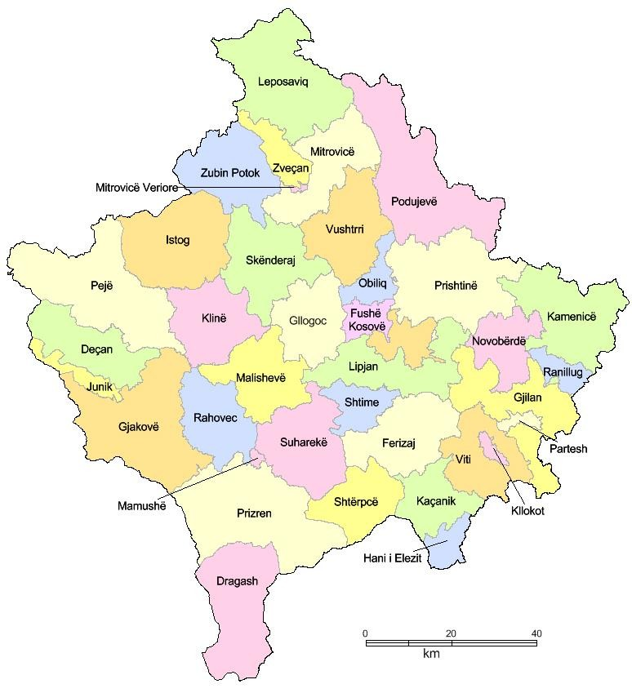
Figure 1. Administrative division of Kosovo

3.2 Population

The population in Kosovo for the year 2021 is estimated to be 1,773,971 residents.
Population census is a necessity, practice and standard, required to be carried out on yearly basis by the official statistical institutions of a country. This is due to the fact that in the period between two censuses (ten-year period) significant changes occur in the population of a country, municipality or settlement.
Annual statistical data on the population (demography) are fundamental for the study and determination of a wide range of analyses. Especially, analysis of social and economic issues at certain levels: municipal, national and regional. Population data constitute the essential component for national accounts estimates, employment and other socio-economic issues.
During 2021, the population of Kosovo experienced a natural increase of 14,391 people. It is estimated that during this year, 7,353 people changed their place of residence (municipality); 4,122 people immigrated (including returnees) to Kosovo; and 42,728 people emigrated.
Meanwhile, the balance of international migration (net migration) for 2021 was negative, estimated at 38,606 inhabitants. Meanwhile, the resident population of Kosovo, for the period 1 January – 31 December 2021, decreased by 24,215 inhabitants.

Figure 2. Classification of the resident population in the Republic of Kosovo by age group
24
%
67
%
9
%
Population by age group 2021

0
- 14 years old
15
- 64 years old
65
and older

Population pyramids present the structure of the population by census years, age and sex.
In the 2011 population census, the population that lived outside of Kosovo for more than 12 months was not included. It should also be noted that the population census did not included the municipalities of North Mitrovica, Zveçan, Zubin Potok and Leposaviq. In 2011, the Municipality of Mitrovica was not divided into the South and North municipalities, but the population of the northern part did not participate in the census. Therefore, due to the change in methodology, there is a disproportion with the total number of the population compared to previous years.

Figure 3. Population pyramid (KAS 2021)
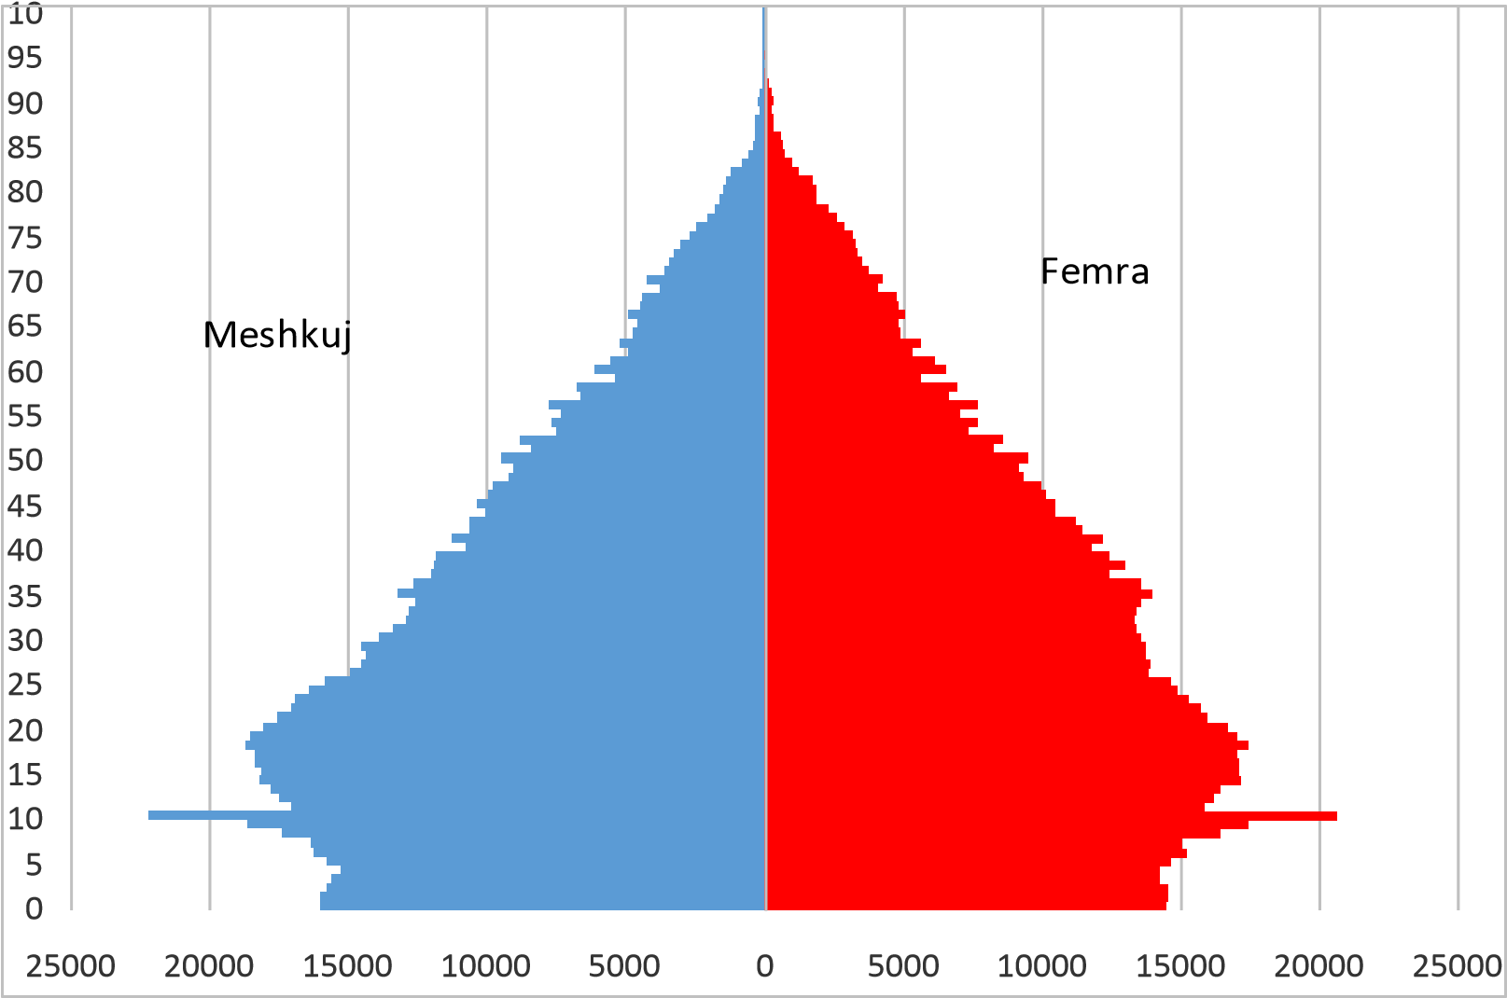

3.3 Health in Kosovo
As regards to the primary health care, Kosovo has a total of 472 Primary Health Care institutions, of which: 38 Main Family Medicine Centres (MFMCs); 167 Family Medicine Centres (FMCs); and 267 Family Medicine Ambulances (FMAs).
Secondary Health Care consists of: Hospital of Prizren, Hospital of Peja, Hospital of Gjilan, Hospital of Vushtrri, Hospital of Mitrovica, Hospital of Gjakova, Hospital of Ferizaj, Mental Health Centres with Homes for Community Integration (Prishtina, Mitrovica, Gjilan, Prizren, Peje, Gjakove and Gjilan); and Centre for Integration and Rehabilitation of Chronic Psychiatric Patients in Shtime.
Tertiary Health Care consists of the University Clinical Centre of Kosovo; University Dentistry Clinical Centre of Kosovo; National Centre of Occupational Medicine in Gjakova; National Sports Medicine Centre; National Telemedicine Centre;
Hospital and University Clinical Service of Kosova (HUCSK) is a unique institution, established according to the Law on Health by the Government of the Republic of Kosovo, while the Statute of the Kosovo Hospital and University Clinical Service has been approved by the Government of the Republic of Kosovo. HUCSK consists of secondary and tertiary level health care institutions in the public health sector.
Hospital and University Clinical Service of Kosova in the organizational structure in 2021 had a total of 7,225 employees. According to professional qualifications, there are 1,557 or 23% specialist doctors, 3,926 or 59% of nursing staff and 1,188 or 18% of non-health administrative and technical staff from various fields of the total number of employees in HUCSK, while last year, 469 people were engaged without pay).
During 2021, a total of 6.5 million services have been provided in HUCSK, despite the challenges of the COVID-19 pandemic situation. Out of these services, 742,994 recovery days were with a total of 145,567 hospitalized patients. Of the hospitalized patients, 33,666 operations were carried out at the level of the units of HUCSK, 1,223,415 outpatient visits and 568,042 other diagnostic visits were carried out, while 3,789,875 laboratory services (laboratory parameters) were provided for 562,349 patients. The number of births in HUCSK units is 19,682, while the number of children born is 20,281. Also, 117,431 haemodialysis services and 405,586 other or special services were performed, subject to the type of service and unit.
The average number of days of recovery for patients is 5.1 days, while the average utilization of capacities in HUCSK is 51%.

3.4 Planning /spending of medicines in the public sector
This sub-section of the National Health Accounts Report will provide a quantitative analysis of spending (planning) for medicines across the country, according to data collected by the MoH for PHC and HUCSK.
The following tables present the planning of the MoH and HUCSK for the supply of medications according to therapeutic groups.
According to the tables below, it turns out that in the budget for public health in the country, according to the List of Essential Medicines, the amount of EUR 39,064,112.57 was planned (and mostly spent) for medications, according to therapeutic groups.

Table 1: The 12-month budget required for the pharmaceutical program in the Ministry of Health by therapeutic groups
No. | Therapeutic group | Value
1 | Analgesics, Antipyretics and Anti-inflammatories | 400,000
2 | Antiallergic drugs | 126,800
3 | Anticonvulsants and Antiepileptics | 216,000
4 | Anti – infectious | 930,400
5 | Cardiovascular | 389,400
6 | Dermatological | 84,800
7 | Diuretics | 41,600
8 | Gastrointestinal | 357,800
9 | Hormones and Antidiabetics | 5,167,200
10 | Gynaecological preparations | 11,400
11 | Ophthalmological preparations | 129,000
12 | Psychotherapeutics | 25,800
13 | Respiratory tract | 210,000
14 | Fluids and electrolyte substitutes | 293,200
15 | Vitamins and minerals | 110,000
16 | Immunoglobulins and specific vaccines | 90,000
17 | Antiretroviral therapy | 40,000
18 | Specific programs | 2,013,360
19 | Consumables | 1,134,000
20 | Service | 100,000
Total |  | 11,870,760
Source: Pharmacy Division in the Ministry of Health, 2022

Table 2: The 12-month budget required from the Central Pharmacy of HCUSK, by therapeutic groups
No. | Therapeutic group | Value
1 | Antineoplastics and immunosuppressants | 1,906,681
2 | Medicines that affect the blood | 1,602,103
3 | Medicines that affect coagulation | 1,811,064
4 | Cytotoxic and adjuvant drugs | 12,250,716
5 | Solutions that correct water, electrolytes and acid-base balance | 1,808,987
6 | Blood coagulation factors | 1,478,663
7 | Diagnostic agents | 683,112
8 | Medical gases | 923,097
9 | Hormones, other endocrine drugs and contraceptives | 519,208
10 | Anaesthetics and analgesics | 1,031,453
11 | Access group antibiotics | 1,384,377
12 | Modifying agents used in rheumatological disorders | 817,861
13 | Medicines for hepatitis c (□) | 859,129
14 | Antiasthmatics and other drugs for chronic obstructive pulmonary disease | 116,898
Total 2021 |  | 27,193,352
Source: HUCSK, 2022

Table 3: Summary of medicines planning, by therapeutic groups, for MoH and HUCSK, for 2021
No. | Therapeutic group | Value
1 | Analgesics, Antipyretics and Anti-inflammatories | 400,000
2 | Antiallergic drugs | 126,800
3 | Anticonvulsants and Antiepileptics | 216,000
4 | Anti – infectious | 930,400
5 | Cardiovascular | 389,400
6 | Dermatological | 84,800
7 | Diuretics | 41,600
8 | Gastrointestinal | 357,800
9 | Hormones and Antidiabetics | 5,167,200
10 | Gynaecological preparations | 11,400
11 | Ophthalmological preparations | 129,000
12 | Psychotherapeutics | 25,800
13 | Respiratory tract | 210,000
14 | Fluids and electrolyte substitutes | 293,200
15 | Vitamins and minerals | 110,000
16 | Immunoglobulins and specific vaccines | 90,000
17 | Antiretroviral therapy | 40,000
18 | Specific programs | 2,013,360
19 | Consumables | 1,134,000
20 | Services | 100,000
21 | Antineoplastics and immunosuppressants | 1,906,681
22 | Medicines that affect the blood | 1,602,103
23 | Medicines that affect coagulation | 1,811,064
24 | Cytotoxic and adjuvant medicines | 12,250,716
25 | Solutions that correct water, electrolytes and acid-base balance | 1,808,987
26 | Blood coagulation factors | 1,478,663
27 | Diagnostic agents | 683,112
28 | Medical gases | 923,097
29 | Hormones, other endocrine drugs and contraceptives | 519,208
30 | Anaesthetics and analgesics | 1,031,453
31 | Access group antibiotics | 1,384,377
32 | Modifying agents used in rheumatological disorders | 817,861
33 | Medicines for hepatitis c | 859,129
34 | Antiasthmatics and other drugs for chronic obstructive pulmonary disease | 116,898
Total 2021 |  | 39,064,112

4. FINANCING OF THE HEALTH SYSTEM IN RETROSPECT

The limited budget of the public health sector, causing a serious disparity between the needs of the citizen/patient, forces families to bear the cost, primarily for medicines and consumables (out-of-hospital medicines), as well as for health services, in cases where these services are not provided in the public sector.
During 2021, the Ministry of Health, continuing the fight against the COVID-19 pandemic, has used additional financial support from the Government, as well as from donors.
The program of treatment outside public health institutions (at home or abroad) managed with financial means of Health Insurance Fund continued for services not provided in the public health system.
Since these funds, dedicated by the state for the Program of Medical Treatment Outside Public Health Institutions, are still not sufficient for all the needs of citizens for health services; therefore, a number of citizens seek treatment abroad, spending significant amounts of financial resources, which unfortunately, we currently cannot record or make an objective assessment, which could be used for the purposes of this Report, except for the Household Budget Survey carried out periodically by KAS.
This fact can explain the differences in the estimation of out-of-pocket payments between the reports of national health accounts and those of international institutions.
Find below the fluctuation in the expenses of the Ministry of Health during the last decade:

Table 4. Expenditures in the Ministry of Health, for the years 2011 - 2021, according to economic categories (in Euros)
Economic category | 2021 | 2020 | 2019 | 2018 | 2017 | 2016 | 2015 | 2014 | 2013 | 2012 | 2011
Salaries and wages | 11,508,451 | 8,222,716 | 7,436,352 | 8,050,649 | 8,313,972 | 7,940,750 | 7,652,757 | 52,854,734 | 44,408,183 | 42,527,654 | 38,827,166
Goods and services | 34,270,481 | 27,154,586 | 10,175,832 | 34,337,304 | 29,507,959 | 24,676,108 | 9,166,585 | 36,324,871 | 38,332,671 | 29,167,678 | 29,397,827
Utilities | 199,977 | 83,183 | 157,332 | 155,408 | 183,802 | 183,845 | 196,571 | 3,739,731 | 3,388,643 | 3,871,062 | 3,292,171
Subsidies and transfers | 4,748,974 | 1,731,449 | 1,929,033 | 11,016,744 | 14,364,873 | 9,935,261 | 9,716,570 | 9,683,042 | 4,763,603 | 2,841,184 | 2,206,483
Non-financial assets | 11,983,609 | 14,165,306 | 6,454,579 | 4,999,345 | 5,213,494 | 7,146,481 | 4,990,190 | 8,807,593 | 8,628,310 | 8,897,476 | 6,158,817
Total expenses | 62,711,491 | 51,357,239 | 26,153,128 | 58,559,449 | 57,584,100 | 49,882,445 | 31,722,673 | 111,409,971 | 99,521,409 | 87,305,055 | 79,882,464
*In this table, expenditures are presented according to the economic categories of the Ministry of Health for the period 2011-2021.

Table 5. Expenditures in HUCSK, for the years 2015 - 2021, according to economic categories (in Euros)
Economic category | 2021 | 2020 | 2019 | 2018 | 2017 | 2016 | 2015
Salaries and wages | 73,820,177 | 64,029,760 | 62,736,817 | 58,242,230 | 51,586,625 | 51,294,777 | 49,882,132
Goods and services | 48,653,315 | 52,779,078 | 40,972,359 | 13,659,911 | 13,049,585 | 10,812,241 | 27,286,586
Utilities | 3,586,553 | 2,120,297 | 3,756,559 | 3,617,547 | 2,060,463 | 3,351,393 | 3,482,745
Subsidies and transfers | 0 | 0 | 0 | 0 | 0 | 0 | 0
Non-financial assets | 9,207,283 | 7,092,604 | 16,697,379 | 9,473.831.71 | 3,856,439 | 3,772,213 | 5,490,853
Total | 135,267,328 | 126,021,739 | 124,163,113 | 84,993,519 | 70,553,112 | 69,230,624 | 86,142,316
* This table presents the expenses according to the economic categories of HUCSK for the period 2015-2021

Table 6.Expenditures in PHC, for the years 2011 - 2021, according to economic categories (in Euros)
Economic categories | 2021 | 2020 | 2019 | 2018 | 2017 | 2016 | 2015 | 2014 | 2013 | 2012 | 2011
Salaries and wages | 49,157,801 | 44,199,382 | 42,348,732 | 40,971,614 | 39,296,553 | 39,363,941 | 38,276,205 | 34,381,291 | 31,133,814 | 30,963,725 | 29,881,861
Goods and services | 12,929,448 | 22,357,630 | 7,860,596 | 7,666,861 | 6,228,039 | 5,794,995 | 5,859,230 | 5,465,355 | 6,199,678 | 6,020,434 | 4,972,348
Utilities | 1,608,419 | 1,379,296 | 1,451,808 | 1,396,815 | 1,407,892 | 1,452,879 | 1,477,955 | 1,319,799 | 1,455,494 | 1,406,139 | 1,412,824
Subsidies and transfers | 485,341 | 2,039,446 | 1,255,284 | 1,024,825 | 714,106 | 685,918 | 794,023 | 961,902 | 1,075,243 | 837,048 | 866,047
Non-financial assets | 5,889,535 | 6,741,846 | 8,485,716 | 6,230,629 | 4,594,592 | 3,997,867 | 4,841,654 | 7,036,755 | 5,822,963 | 6,085,427 | 6,477,587
Total | 70,070,544 | 76,717,600 | 61,402,137 | 57,290,744 | 52,241,181 | 51,295,600 | 51,249,067 | 49,165,102 | 45,687,192 | 45,312,774 | 43,610,666
* As noted in Table 6, the budget allocated for health at the primary level (PHC) has had an increasing trend over the years, mainly in the Salaries and Wages category.

The expenditures of other departments of the public sector for health for the year 2021 were:

Table 7. Expenditures of other departments of the public sector for health, in 2021 (in Euros)
Description of expenditures | Ministry of Justice | ANSA | Ministry of Defence | Total by budget categories
Salaries and Wages | 66,401 | 28,572 | 78,951 | 173,924
Goods and Services | 76,330 | 11,147 | 51,372 | 138,850
Utilities | 0 | 0 | 23,472 | 23,472
Subsidies and Transfers | 94,575 | 0 | 0 | 94,575
Capital expenditures | 0 | 0 | 0 | 0
Total expenses | 237,307 | 39,719 | 153,795 | 430,821
* Table 7 shows that other ministries spend on health mainly in terms of preventive and primary care.

Table 8. Expenditures for the Health Insurance Fund, for the year 2021, according to economic categories (in Euros)
Economic category | 2021 | 2020 | 2019
Salaries and Wages | 340,712 | 327,527 | 357,960
Goods and services | 216,242 | 294,288 | 269,304
Utilities | 18,989 | 17,091 | 22,217
Subsidies and transfers | 9,400,993 | 7,999,984 | 8,699,979
Non-financial assets | 168,870 | 153,687 | 61,804
Total expenses | 10,145,806 | 8,792,577 | 9,411,265
*According to table 8, it is noted that the budget of the Health Insurance Fund is mainly allocated to the category Subsidies and Transfers for Medical Treatment Outside Public Health Institutions.

Table 9.Expenses from donations for 2021 received by the Ministry of Health
Donation | 2021
Medical equipment | 3,242,095
Medical products | 11,272,666
Others | 195,942
Total expenses | 14,710,703
Source – HUCSK

Table 10 presents health expenditures financed directly by government grants and donations, respectively summarizes the total expenditures in the public sector during the period 2011-2021. This table shows that spending on health by the public sector during this period has experienced an increase of 2.5 times (from over 123 million Euros in 2011 to over 293 million Euros in 2021).

Table 10. Public sector expenditures for health, 2011-2021 (in Euros)
Institutions | 2021 | 2020 | 2019 | 2018 | 2017 | 2016 | 2015 | 2014 | 2013 | 2012 | 2011
Ministry of Health | 62,711,491 | 51,357,239 | 26,153,128 | 58,559,449 | 57,584,100 | 49,882,445 | 31,722,673 | 111,409,971 | 99,521,409 | 87,305,055 | 79,882,464
HUCSK | 135,267,328 | 126,021,739 | 124,163,113 | 84,993,519 | 70,553,112 | 69,230,624 | 86,142,316 | 0 | 0 | 0 | 0
Municipalities (PHC) | 70,070,544 | 76,717,600 | 61,402,137 | 57,290,744 | 52,241,181 | 51,295,600 | 51,249,067 | 49,165,102 | 45,687,192 | 45,312,774 | 43,610,666
TUHF | 10,145,806 | 8,792,577 | 9,411,265 | 0 | 0 | 0 | 0 | 0 | 0 | 0 | 0
Donations | 14,710,703 | 7,761,394 | 0 | 0 | 0 | 0 | 0 | 0 | 0 | 0 | 0
Other ministries | 430,821 | 2,137,717 | 156,603 | 1,237,309 | 0 | 0 | 0 | 0 | 0 | 0 | 0
Total expenses | 293,336,694 | 272,788,266 | 221,286,246 | 202,081,021 | 180,378,393 | 170,408,669 | 169,114,056 | 160,575,073 | 145,208,601 | 132,617,829 | 123,493,130

Meanwhile, the following table summarizes the expenses, or financing of the health system, from the public and private sectors. At the same time, this table also explains the step-by-step methodology of how private health expenditures are calculated, or better said - evaluated, according to the methodology proposed by the WHO. This table clearly shows that total health expenditure, as a ratio of nominal GDP, has increased over time, with the most pronounced increase recorded during 2020, to be followed by a lower rate in 2021, as result of rapid GDP growth. While in nominal terms, all types of expenses have increased over the years.

Table 11. GDP, and % of GDP of health expenditures during the period 2015-2021 (in millions of Euros)
in mln Euro | 2021 | 2020 | 2019 | 2018 | 2017 | 2016 | 2015
Nominal GDP | 7,957.9 | 6,771.6 | 7,056.2 | 6,671.5 | 6,356.5 | 6,037.3 | 5,674.4 | Source: years 2015-2021: KAS
Final consumption of households | 6,572.5 | 5,718.0 | 5,621.2 | 5,296.1 | 5,009.0 | 4,910.5 | 4,803.7 | Source: years 2015-2021: KAS
Private expenditures on health (% of final consumption of households) | 3.00% | 3.00% | 3.0% | 3.0% | 3.0% | 3.0% | 3.0% | Source: KAS
Private expenses | 197.17 | 171.54 | 168.64 | 158.88 | 150.27 | 147.31 | 144.11 | Calculation = Household final consumption x Private expenditure (% of household final consumption)
Private insurance costs | 21.99 | 16.72 | 19.61 | 18.04 | 17.00 | 16.29 | 13.38 | Source: KAS
Public expenditure, including donations | 293.34 | 272.79 | 221.29 | 202.08 | 180.38 | 170.41 | 169.11 | Source: Treasury and MoH
Total expenses | 512.43 | 461.05 | 409.53 | 379.00 | 347.64 | 334.01 | 326.3 | Calculation= Public expenditure (including donations) + Private expenditure + Private insurance expenditure
% of GDP for public health, including donations | 3.69% | 4.03% | 3.14% | 3.03% | 2.84% | 2.82% | 2.98% | Calculation = Total Public Expenditure on Health / Nominal GDP
% of GDP for private spending | 2.48% | 2.53% | 2.39% | 2.38% | 2.36% | 2.44% | 2.54% | Calculation = Total Private Health Expenditure / Nominal GDP
% of GDP for private insurance costs | 0.28% | 0.25% | 0.28% | 0.27% | 0.27% | 0.27% | 0.24% | Calculation = Total Private Insurance Expenditure/ Nominal GDP
% of GDP for total health expenditure | 6.44% | 6.81% | 5.80% | 5.68% | 5.47% | 5.53% | 5.76% | Calculation = (Total Public Expenditure on Health + Total Private Expenditure on Health) / Nominal GDP

5. FINANCING OF THE HEALTH SYSTEM IN 2021
This section focuses only on health expenditures during 2021. First, data from the public sector is provided, followed then by the private one.
2021 has been characterized by a pronounced economic recovery after the easing of the restrictive measures taken in the context of the Covid-19 pandemic and reflects not only the basic effect of the significant decline in 2020, but also the intensity of the factors that have fuelled growth during of 2021.
Before disclosing the data on expenditures by the public and private sectors, it is worth disclosing data on the economic context of our country. During 2021, according to the official data of the Kosovo Agency of Statistics (KAS), the real GDP recorded an unprecedented double-digit increase of 10.7%, while the nominal one was around 17.5%. The components (from the GDP expenditure method) that contributed to this satisfactory real economic growth were total consumption (especially private consumption) and total export (especially export of services).
Health financing during 2021 continued to be carried out mainly from the budget of the Republic of Kosovo, own revenues and borrowing from the World Bank and CEB. Own revenues in Primary Health Care are used to partially finance the implementation of capital projects for municipal health.

5.1. Public sector
The public health sector in Kosovo consists of all health and administrative institutions, which are dependent on the state budget to develop their activities, including various government departments and the executive agencies of the departments which have the task of monitoring the implementation of legality in sector.
The following table (no. 12) shows the expenditure data from the public sector, divided according to economic categories and the relevant budget organization. It can be seen that the main spender is HUCSK, then municipalities, then MoH, etc. Total expenditures from the public sector for 2021 were over 293 million Euros.

Table 12. - Summary of total expenses for 2021
Economic category | MoH | HUCSK | Municipalities | Fund | MoJ | MD | ANSA | Donations | TOTAL
Salaries and wages | 11,508,451 | 73,820,177 | 49,157,801 | 340,712 | 66,401 | 78,951 | 28,572 | 0 | 135,001,065
Goods and services | 34,270,481 | 48,653,315 | 12,929,172 | 216,242 | 76,330 | 51,372 | 11,147 | 14,710,703 | 110,918,762
Utilities | 199,977 | 3,586,553 | 1,608,419 | 18,989 | 0 | 23,472 | 0 | 0 | 5,437,410
Subsidies and transfers | 4,748,974 | 0 | 485,341 | 9,400,993 | 94,575 | 0 | 0 | 0 | 14,729,883
Non-financial assets | 11,983,609 | 9,207,283 | 5,889,535 | 168,870 | 0 | 0 | 0 | 0 | 27,249,297
Total expenses | 62,711,491 | 135,267,328 | 70,070,269 | 10,145,806 | 237,307 | 153,795 | 39,719 | 14,710,703 | 293,336,417

*Note: We have an increase in salary expenses due to the support of Government decisions for the health sector (increase in salary) and we also have an increase in goods and services for pandemic management; as well as increasing the number of temporary staff for pandemic management.
Specifically, 469 workers have been engaged in support of HUCSK; for support in Primary Health Care 641, 41 in NIPHK and 10 in NCBTK. These payments have influenced the budget expenses within the Ministry of Health, as the carrier of the activities.

5.2. Private Sector
The private health sector consists of private health institutions, licensed by the Ministry of Health for the provision of health services, within the framework of the Law on Health and by-laws that regulate this field.
The services provided in the private sector are hospital, outpatient, diagnostic (laboratory and imaging), physiotherapy services, etc.
These costs are based on the assessment, which was made according to the methodology suggested by the WHO. For more details on how the assessment was made, see the methodology chapter and the table above named: GDP, and % of GDP for health (total) 2015-2021. The database for this assessment is: Annual National Accounts 2008-2020 and the Household Budget Survey (2017) from the Kosovo Agency of Statistics.

Table 13. Citizens' out-of-pocket expenditures for health disaggregated by subcategory, 2021
Service / expense | 2021 | 2020
Medications | 133,591,795 | 116,224,024
Other pharmaceutical products, except medications | 51,922 | 45,172
Medical equipment and other aids | 31,748 | 27,620
Public out-of-hospital (ambulatory) health services | 3,028,245 | 2,634,554
Private out-of-hospital (ambulatory) health services | 18,348,583 | 15,963,152
Public dental services | 1,756,973 | 1,528,555
Private dental services | 6,655,401 | 5,790,157
Medical analyses, laboratory, radioscopy (Roentgen) - public | 2,451,676 | 2,132,943
Medical analyses, laboratory, radioscopy (Roentgen) - private | 9,139,227 | 7,951,070
Public hospital services | 1,555,038 | 1,352,874
Private hospital services | 5,958,249 | 5,183,639
Accommodation, food, transport by ambulance in Kosovo | 182,725 | 158,969
Health services abroad | 12,953,716 | 11,269,652
Accommodation, food, transport by ambulance abroad | 1,405,573 | 1,222,840
Traditional medicines | 0.00 | 0
Other medical services | 62,929.36 | 54,748
Total | 197,173,800 | 171,539,970
*Note: This table does not include expenses for citizens' private health insurance.

The data in Table 14 were provided by the Central Bank of Kosovo and the Kosovo Agency of Statistics and reflect the expenses related to voluntary health insurance in our country. This data is part of the calculations in the table above, but only provides another perspective with additional data.

Table 14.Expenditure on voluntary health insurance, 2021
 | Gross written premiums from "Accident and Health" insurance
 | Number of policies | Premiums registered in Euro
The year 2021 | 165,048 | 21,922,048
*Note: This table presents the premiums paid by the citizens of Kosovo for insurance policies in accidents and for health services in private insurance companies.

5.3. Donations received in 2021 at the Hospital and University Clinical Service of Kosovo

Part of the achievements in the work results is also the support from local and international institutions and organizations in strengthening our health capacities for providing the best possible health care. During 2021, the Office for International Cooperation and Donation Coordination of HUCSK has received a significant number of donations in the form of medical equipment, medical products and various non-medical materials for the needs of HUCSK.
According to the donations received, there are 25 medical devices with a value of 3,242,095.16 Euros; 92 other medical products in the value of 11,272,666.25 euros and 40 other materials in the value of 195,941.50 Euros.
Based on official reports, HUCSK during 2021 received a total of 157 donations of equipment and other medical products in the total value of 14,710,702.91

Table 15.Donations received in 2021 by HUCSK

Equipment-Products | Number of donations | Value of donations
Medical equipment | 25 | 3,242,095.16
Medical products | 92 | 11,272,666.25
Others | 40 | 195,941.50
TOTAL | 157 | 14,710,702.91

Table 16. - Summary of total expenses for 2021
Economic category | MoH | HUCSK | Municipalities | Fund | MoJ | MD | ANSA | Donations | Out of pocket payments | Private Insurance | TOTAL
Salaries and wages | 11,508,451 | 73,820,177 | 49,157,801 | 340,712 | 66,401 | 78,951 | 28,572 | 0 | 0 | 0 | 135,001,066
Goods and services | 34,270,481 | 48,653,315 | 12,929,172 | 216,242 | 76,330 | 51,372 | 11,147 | 14,710,703 | 197,173,800 | 21,922,048 | 330,014,611
Utilities | 199,977 | 3,586,553 | 1,608,419 | 18,989 | 0 | 23,472 | 0 | 0 | 0 | 0 | 5,437,409
Subsidies and transfers | 4,748,974 | 0 | 485,341 | 9,400,993 | 94,575 | 0 | 0 | 0 | 0 | 0 | 14,729,883
Non-financial assets | 11,983,609 | 9,207,283 | 5,889,535 | 168,870 | 0 | 0 | 0 | 0 | 0 | 0 | 27,249,297
Total expenses | 62,711,491 | 135,267,328 | 70,070,269 | 10,145,806 | 237,307 | 153,795 | 39,719 | 14,710,703 | 197,173,800 | 21,922,048 | 512,432,266

6. Conclusions and recommendations

The conclusions of the National Health Accounts Report for 2021 are:
- The lack of health insurance has caused the cost to be shifted to the citizen's pocket, primarily for medications and consumables (out-of-hospital medications), as well as for health services, in cases where these services are not provided in the public sector.
- For out-of-pocket payments, data based on the Household Budget Survey and are the only expenses for which assumptions have been used to estimate them. Unlike out-of-pocket costs, all other costs are actual, and therefore no assumptions are used to estimate them; and
- Development of regular surveys and studies by KAS as a reliable official source of information on the level of private spending on health!

The recommendations of the National Health Accounts Report for 2021 are listed below:
- The Ministry of Health and the Government should create a mechanism that will affect the reduction of the level of out-of-pocket funding, based on two proposals:
  - Updating the essential list of medicines; and
  - Regulation of medicine prices through legal acts.
  - Functionalization of the Health Insurance Fund should be a priority, in order to reduce the level of out-of-pocket financing, including:
    - Supplementation/amendment of by-laws which regulate treatment outside public health institutions;
- KAS should review the way of operation when drawing up the assumptions used to calculate private health expenditures against total private consumption expenditures based on the Household Budget Survey, because this report does not take into account changes in consumer behaviour regarding care to their own health over the years or the increase in the weight of health expenditures during the pandemic period (2020 and 2021). Even if we refer to the composition of the consumer basket, the weight of the health category in total consumption has decreased from 2016 to 2020 and 2021 and this downward trend is not in line with economic intuition considering that the vast majority of households in Kosovo have faced increased expenses for the prevention of infection with Covid-19 or treatment in case of infection during the pandemic period, especially considering the significant number of the infected population.

7. Annexes: A – Charts from HAPT software

Annex 1.Total expenditure on health in 2021
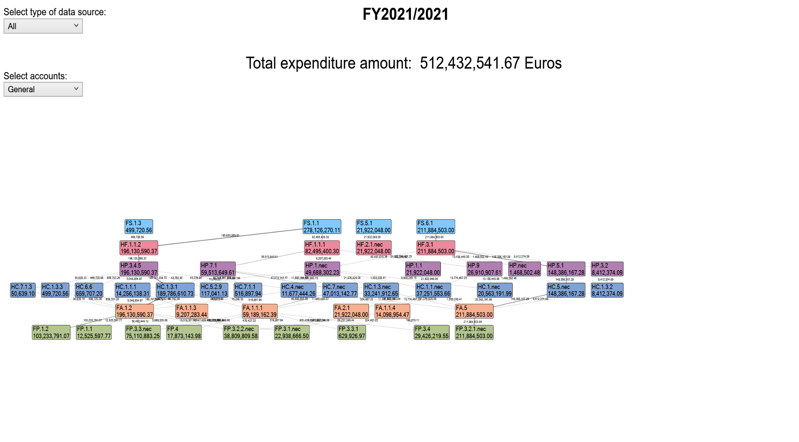

Annex 2.Total expenditure on health from the Government Grant
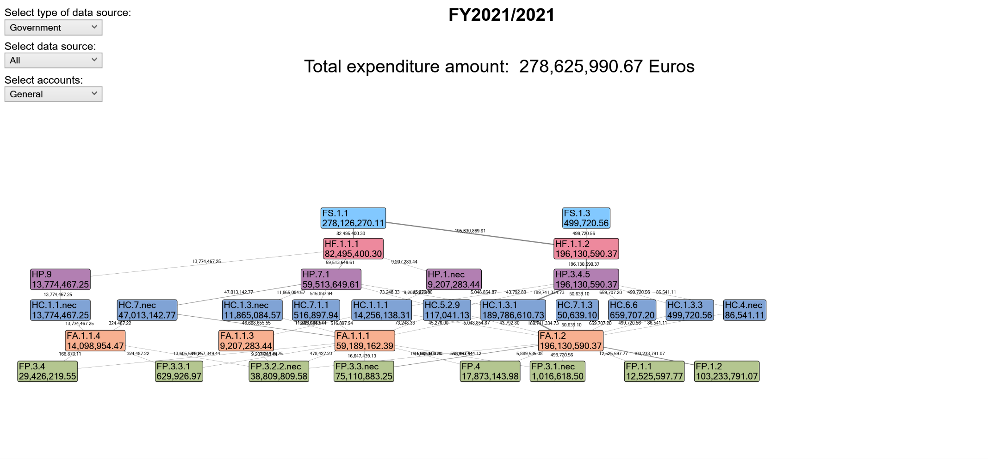

Annex 3.Total expenditure on health by donors.
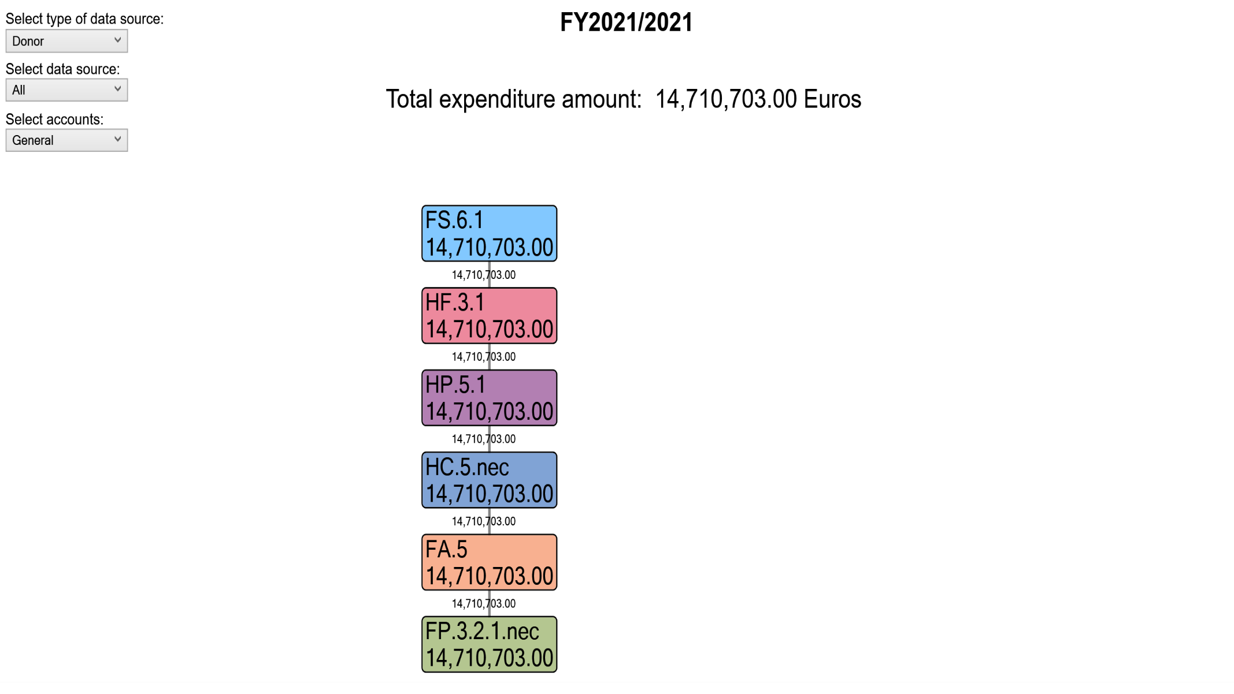

Annex 4.Total expenditure on health, out-of-pocket payments
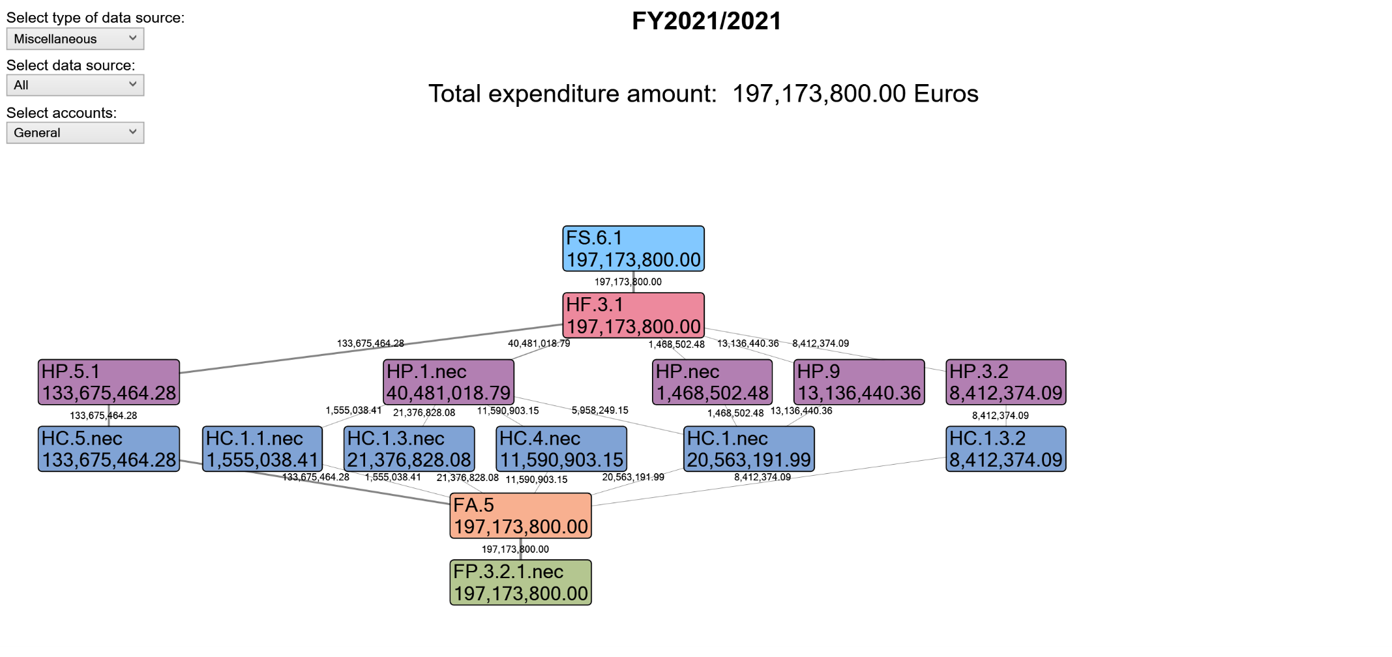

Annex 5.Total expenditures on health paid by private insurance companies
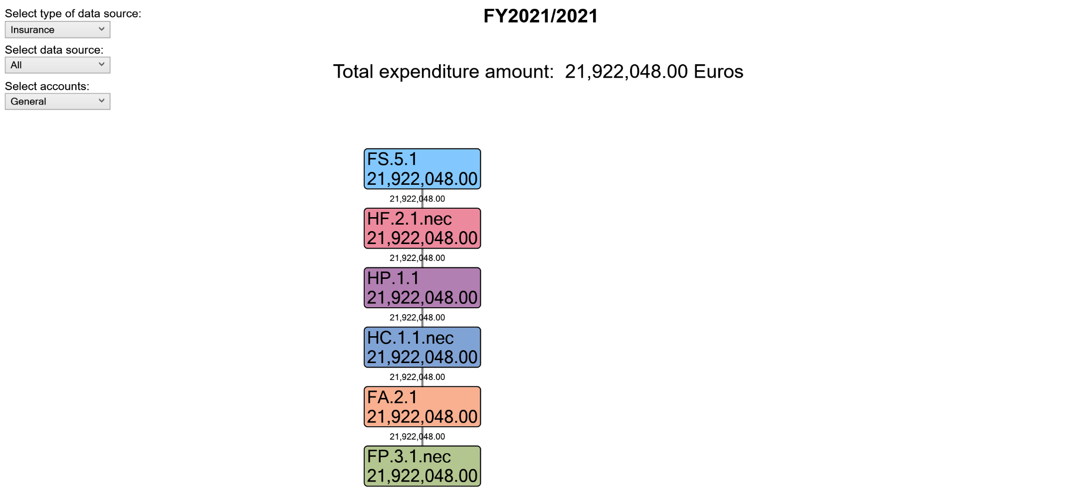

Annexes: B– Tables from HAPT software

Annex 6: Income of health care financing schemes in relation to financing schemes
Currency: Euros (EUR)
 |  |  | Revenues of health care financing schemes | FS.1 |  |  | FS.5 |  | FS.6 |  | All FS
 |  |  | Revenues of health care financing schemes |  | FS.1.1 | FS.1.3 |  | FS.5.1 |  | FS.6.1
Financing schemes |  |  | Euros (EUR), Million | Transfers from government domestic revenue (allocated to health purposes) | Internal transfers and grants | Subsidies | Voluntary prepayment | Voluntary prepayment from individuals/households | Other domestic revenues n.e.c. | Other revenues from households n.e.c.
HF.1 |  |  | Government schemes and compulsory contributory health care financing schemes | 329.93 | 329.34 | 0.59 |  |  |  |  | 329.93
 | HF.1.1 |  | Government schemes | 329.93 | 329.34 | 0.59 |  |  |  |  | 329.93
 |  | HF.1.1.1 | Central government schemes | 97.69 | 97.69 |  |  |  |  |  | 97.69
 |  | HF.1.1.2 | State/regional/local government schemes | 232.25 | 231.65 | 0.59 |  |  |  |  | 232.25
HF.2 |  |  | Voluntary health care payment schemes |  |  |  | 25.96 | 25.96 |  |  | 25.96
 | HF.2.1 |  | Voluntary health insurance schemes |  |  |  | 25.96 | 25.96 |  |  | 25.96
 |  | HF.2.1.nec | Unspecified voluntary health insurance schemes (nec) |  |  |  | 25.96 | 25.96 |  |  | 25.96
HF.3 |  |  | Household out-of-pocket payment |  |  |  |  |  | 250.90 | 250.90 | 250.90
 | HF.3.1 |  | Out-of-pocket excluding cost-sharing |  |  |  |  |  | 250.90 | 250.90 | 250.90
All HF |  |  |  | 329.93 | 329.34 | 0.59 | 25.96 | 25.96 | 250.90 | 250.90 | 606.79
Memorandum items
 | Financing agents managing the financing schemes |  |  | 329.93 | 329.34 | 0.59 | 25.96 | 25.96 | 250.90 | 250.90 | 606.79
 |  | HF.RI.1.1 | Government (FA.1 General government) | 329.93 | 329.34 | 0.59 |  |  |  |  | 329.93
 |  | HF.RI.1.2 | Corporations (FA.2 Insurance + FA.3 Corporations) |  |  |  | 25.96 | 25.96 |  |  | 25.96
 |  | HF.RI.1.3 | Households (FA.5 Households) |  |  |  |  |  | 250.90 | 250.90 | 250.90
 | Financing schemes and the related cost-sharing together |  |  | 329.93 | 329.34 | 0.59 | 25.96 | 25.96 |  |  | 355.89
 |  | HF.RI.2 | Governmental schemes and compulsory contributory health insurance schemes together with cost sharing (HF.1 + HF.3.2.1) | 329.93 | 329.34 | 0.59 |  |  |  |  | 329.93
 |  | HF.RI.3 | Voluntary health insurance schemes together with cost sharing (HF.2.1+HF.3.2.2) |  |  |  | 25.96 | 25.96 |  |  | 25.96
Used data sources:
Donors | All Donors
NGOs
EMP
Insurances | Private Insurance Company
Government sources | ANSA, TUHF, IK TUHF, IK Municipalities, IK Ministry of Health, IK SHSKUK, Municipalities, Ministry of Justice, Ministry of Defense, Ministry of Health, HUCSK
Private sector OOP
Households

Annex 7:Funding schemes in relation to health care providers
 |  |  | Financing schemes | HF.1 |  |  |  | HF.2 |  |  | HF.3 |  | All HF | Memorandum items
 |  |  | Financing schemes |  | HF.1.1 |  |  |  | HF.2.1 |  |  | HF.3.1 |  | Memorandum items | Financing agents managing the financing schemes |  |  |  | Financing schemes and the related cost-sharing together
 |  |  | Financing schemes |  |  | HF.1.1.1 | HF.1.1.2 |  |  | HF.2.1.nec |  |  |  | Memorandum items | Financing agents managing the financing schemes | HF.RI.1.1 | HF.RI.1.2 | HF.RI.1.3 | Financing schemes and the related cost-sharing together | HF.RI.2 | HF.RI.3
Health care providers |  |  | Euros (EUR), Million | Government schemes and compulsory contributory health care financing schemes | Government schemes | Central government schemes | State/regional/local government schemes | Voluntary health care payment schemes | Voluntary health insurance schemes | Unspecified voluntary health insurance schemes (nec) | Household out-of-pocket payment | Out-of-pocket excluding cost-sharing |  | Memorandum items | Financing agents managing the financing schemes | Government (FA.1 General government) | Corporations (FA.2 Insurance + FA.3 Corporations) | Households (FA.5 Households) | Financing schemes and the related cost-sharing together | Governmental schemes and compulsory contributory health insurance schemes together with cost sharing (HF.1 + HF.3.2.1) | Voluntary health insurance schemes together with cost sharing (HF.2.1+HF.3.2.2)
HP.1 |  |  | Hospitals | 10.90 | 10.90 | 10.90 |  | 25.96 | 25.96 | 25.96 | 47.94 | 47.94 | 84.80 | 121.66 | 84.80 | 10.90 | 25.96 | 47.94 | 36.86 | 10.90 | 25.96
 | HP.1.1 |  | General hospitals |  |  |  |  | 25.96 | 25.96 | 25.96 |  |  | 25.96 | 51.92 | 25.96 |  | 25.96 |  | 25.96 |  | 25.96
 | HP.1.nec |  | Unspecified hospitals (n.e.c.) | 10.90 | 10.90 | 10.90 |  |  |  |  | 47.94 | 47.94 | 58.84 | 69.74 | 58.84 | 10.90 |  | 47.94 | 10.90 | 10.90
HP.3 |  |  | Providers of ambulatory health care | 232.25 | 232.25 |  | 232.25 |  |  |  | 9.96 | 9.96 | 242.21 | 474.45 | 242.21 | 232.25 |  | 9.96 | 232.25 | 232.25
 | HP.3.2 |  | Dental practice |  |  |  |  |  |  |  | 9.96 | 9.96 | 9.96 | 9.96 | 9.96 |  |  | 9.96
 | HP.3.4 |  | Ambulatory health care centers | 232.25 | 232.25 |  | 232.25 |  |  |  |  |  | 232.25 | 464.49 | 232.25 | 232.25 |  |  | 232.25 | 232.25
 |  | HP.3.4.5 | Non-specialized ambulatory health care centers | 232.25 | 232.25 |  | 232.25 |  |  |  |  |  | 232.25 | 464.49 | 232.25 | 232.25 |  |  | 232.25 | 232.25
HP.5 |  |  | Retailers and Other providers of medical goods |  |  |  |  |  |  |  | 175.71 | 175.71 | 175.71 | 175.71 | 175.71 |  |  | 175.71
 | HP.5.1 |  | Pharmacies |  |  |  |  |  |  |  | 175.71 | 175.71 | 175.71 | 175.71 | 175.71 |  |  | 175.71
HP.7 |  |  | Providers of health care system administration and financing | 70.47 | 70.47 | 70.47 |  |  |  |  |  |  | 70.47 | 140.95 | 70.47 | 70.47 |  |  | 70.47 | 70.47
 | HP.7.1 |  | Government health administration agencies | 70.47 | 70.47 | 70.47 |  |  |  |  |  |  | 70.47 | 140.95 | 70.47 | 70.47 |  |  | 70.47 | 70.47
HP.9 |  |  | Rest of the world | 16.31 | 16.31 | 16.31 |  |  |  |  | 15.56 | 15.56 | 31.87 | 48.18 | 31.87 | 16.31 |  | 15.56 | 16.31 | 16.31
HP.nec |  |  | Unspecified health care providers (n.e.c.) |  |  |  |  |  |  |  | 1.74 | 1.74 | 1.74 | 1.74 | 1.74 |  |  | 1.74
All HP |  |  |  | 329.93 | 329.93 | 97.69 | 232.25 | 25.96 | 25.96 | 25.96 | 250.90 | 250.90 | 606.79 | 962.68 | 606.79 | 329.93 | 25.96 | 250.90 | 355.89 | 329.93 | 25.96

Annex 8:Funding schemes in relation to health care functions
 |  |  | Financing schemes | HF.1 |  |  |  | HF.2 |  |  | HF.3 |  | All HF | Memorandum items
 |  |  | Financing schemes |  | HF.1.1 |  |  |  | HF.2.1 |  |  | HF.3.1 |  | Memorandum items | Financing agents managing the financing schemes |  |  |  | Financing schemes and the related cost-sharing together
 |  |  | Financing schemes |  |  | HF.1.1.1 | HF.1.1.2 |  |  | HF.2.1.nec |  |  |  | Memorandum items | Financing agents managing the financing schemes | HF.RI.1.1 | HF.RI.1.2 | HF.RI.1.3 | Financing schemes and the related cost-sharing together | HF.RI.2 | HF.RI.3
Health care functions |  |  | Euros (EUR), Million | Government schemes and compulsory contributory health care financing schemes | Government schemes | Central government schemes | State/regional/local government schemes | Voluntary health care payment schemes | Voluntary health insurance schemes | Unspecified voluntary health insurance schemes (nec) | Household out-of-pocket payment | Out-of-pocket excluding cost-sharing |  | Memorandum items | Financing agents managing the financing schemes | Government (FA.1 General government) | Corporations (FA.2 Insurance + FA.3 Corporations) | Households (FA.5 Households) | Financing schemes and the related cost-sharing together | Governmental schemes and compulsory contributory health insurance schemes together with cost sharing (HF.1 + HF.3.2.1) | Voluntary health insurance schemes together with cost sharing (HF.2.1+HF.3.2.2)
HC.1 |  |  | Curative care | 272.57 | 272.57 | 41.32 | 231.25 | 25.96 | 25.96 | 25.96 | 61.47 | 61.47 | 359.99 | 658.52 | 359.99 | 272.57 | 25.96 | 61.47 | 298.53 | 272.57 | 25.96
 | HC.1.1 |  | Inpatient curative care | 33.19 | 33.19 | 27.21 | 5.98 | 25.96 | 25.96 | 25.96 | 1.84 | 1.84 | 60.99 | 120.14 | 60.99 | 33.19 | 25.96 | 1.84 | 59.15 | 33.19 | 25.96
 |  | HC.1.1.1 | General inpatient curative care | 16.88 | 16.88 | 10.90 | 5.98 |  |  |  |  |  | 16.88 | 33.76 | 16.88 | 16.88 |  |  | 16.88 | 16.88
 |  | HC.1.1.nec | Unspecified inpatient curative care (nec) | 16.31 | 16.31 | 16.31 |  | 25.96 | 25.96 | 25.96 | 1.84 | 1.84 | 44.11 | 86.38 | 44.11 | 16.31 | 25.96 | 1.84 | 42.27 | 16.31 | 25.96
 | HC.1.3 |  | Outpatient curative care | 239.38 | 239.38 | 14.10 | 225.27 |  |  |  | 35.27 | 35.27 | 274.65 | 514.03 | 274.65 | 239.38 |  | 35.27 | 239.38 | 239.38
 |  | HC.1.3.1 | General outpatient curative care | 224.73 | 224.73 | 0.05 | 224.68 |  |  |  |  |  | 224.73 | 449.47 | 224.73 | 224.73 |  |  | 224.73 | 224.73
 |  | HC.1.3.2 | Dental outpatient curative care |  |  |  |  |  |  |  | 9.96 | 9.96 | 9.96 | 9.96 | 9.96 |  |  | 9.96
 |  | HC.1.3.3 | Specialized outpatient curative care | 0.59 | 0.59 |  | 0.59 |  |  |  |  |  | 0.59 | 1.18 | 0.59 | 0.59 |  |  | 0.59 | 0.59
 |  | HC.1.3.nec | Unspecified outpatient curative care (nec) | 14.05 | 14.05 | 14.05 |  |  |  |  | 25.31 | 25.31 | 39.36 | 53.41 | 39.36 | 14.05 |  | 25.31 | 14.05 | 14.05
 | HC.1.nec |  | Unspecified curative care (nec) |  |  |  |  |  |  |  | 24.35 | 24.35 | 24.35 | 24.35 | 24.35 |  |  | 24.35
HC.1+HC.2 |  |  | Curative care and rehabilitative care | 272.57 | 272.57 | 41.32 | 231.25 | 25.96 | 25.96 | 25.96 | 61.47 | 61.47 | 359.99
 | HC.1.1+HC.2.1 |  | Inpatient curative and rehabilitative care | 33.19 | 33.19 | 27.21 | 5.98 | 25.96 | 25.96 | 25.96 | 1.84 | 1.84 | 60.99
 | HC.1.3+HC.2.3 |  | Outpatient curative and rehabilitative care | 239.38 | 239.38 | 14.10 | 225.27 |  |  |  | 35.27 | 35.27 | 274.65
 | HC.1.nec + HC.2.nec |  | Other curative and rehabilitative care |  |  |  |  |  |  |  | 24.35 | 24.35 | 24.35
HC.4 |  |  | Ancillary services (non-specified by function) | 0.10 | 0.10 |  | 0.10 |  |  |  | 13.73 | 13.73 | 13.83 | 13.93 | 13.83 | 0.10 |  | 13.73 | 0.10 | 0.10
 | HC.4.nec |  | Unspecified ancillary services (nec) | 0.10 | 0.10 |  | 0.10 |  |  |  | 13.73 | 13.73 | 13.83 | 13.93 | 13.83 | 0.10 |  | 13.73 | 0.10 | 0.10
HC.5 |  |  | Medical goods (non-specified by function) | 0.14 | 0.14 | 0.09 | 0.05 |  |  |  | 175.71 | 175.71 | 175.85 | 175.99 | 175.85 | 0.14 |  | 175.71 | 0.14 | 0.14
 | HC.5.2 |  | Therapeutic appliances and other medical goods | 0.14 | 0.14 | 0.09 | 0.05 |  |  |  |  |  | 0.14 | 0.28 | 0.14 | 0.14 |  |  | 0.14 | 0.14
 |  | HC.5.2.9 | All other medical durables, including medical technical devices | 0.14 | 0.14 | 0.09 | 0.05 |  |  |  |  |  | 0.14 | 0.28 | 0.14 | 0.14 |  |  | 0.14 | 0.14
 | HC.5.nec |  | Unspecified medical goods (nec) |  |  |  |  |  |  |  | 175.71 | 175.71 | 175.71 | 175.71 | 175.71 |  |  | 175.71
HC.6 |  |  | Preventive care | 0.78 | 0.78 |  | 0.78 |  |  |  |  |  | 0.78 | 1.56 | 0.78 | 0.78 |  |  | 0.78 | 0.78
 | HC.6.6 |  | Preparing for disaster and emergency response programs | 0.78 | 0.78 |  | 0.78 |  |  |  |  |  | 0.78 | 1.56 | 0.78 | 0.78 |  |  | 0.78 | 0.78
HC.7 |  |  | Governance, and health system and financing administration | 56.34 | 56.34 | 56.28 | 0.06 |  |  |  |  |  | 56.34 | 112.68 | 56.34 | 56.34 |  |  | 56.34 | 56.34
 | HC.7.1 |  | Governance and Health system administration | 0.67 | 0.67 | 0.61 | 0.06 |  |  |  |  |  | 0.67 | 1.34 | 0.67 | 0.67 |  |  | 0.67 | 0.67
 |  | HC.7.1.1 | Planning & Management | 0.61 | 0.61 | 0.61 |  |  |  |  |  |  | 0.61 | 1.22 | 0.61 | 0.61 |  |  | 0.61 | 0.61
 |  | HC.7.1.3 | Procurement & supply management | 0.06 | 0.06 |  | 0.06 |  |  |  |  |  | 0.06 | 0.12 | 0.06 | 0.06 |  |  | 0.06 | 0.06
 | HC.7.nec |  | Unspecified governance, and health system and financing administration (nec) | 55.67 | 55.67 | 55.67 |  |  |  |  |  |  | 55.67 | 111.34 | 55.67 | 55.67 |  |  | 55.67 | 55.67
All HC |  |  |  | 329.93 | 329.93 | 97.69 | 232.25 | 25.96 | 25.96 | 25.96 | 250.90 | 250.90 | 606.79 | 962.68 | 606.79 | 329.93 | 25.96 | 250.90 | 355.89 | 329.93 | 25.96

Annex 9: Health care providers in relation to health care functions
 |  |  | Health care providers | HP.1 |  |  | HP.3 |  |  |  | HP.5 |  | HP.7 |  | HP.9 | HP.nec | All HP
 |  |  | Health care providers |  | HP.1.1 | HP.1.nec |  | HP.3.2 | HP.3.4 |  |  | HP.5.1 |  | HP.7.1
 |  |  | Health care providers |  |  |  |  |  |  | HP.3.4.5
Health care functions |  |  | Euros (EUR), Million | Hospitals | General hospitals | Unspecified hospitals (nec) | Providers of ambulatory health care | Dental practice | Ambulatory health care centers | Non-specialized ambulatory health care centers | Retailers and Other providers of medical goods | Pharmacies | Providers of health care system administration and financing | Government health administration agencies | Rest of the world | Unspecified health care providers (nec)
HC.1 |  |  | Curative care | 71.07 | 25.96 | 45.11 | 241.21 | 9.96 | 231.25 | 231.25 |  |  | 14.10 | 14.10 | 31.87 | 1.74 | 359.99
 | HC.1.1 |  | Inpatient curative care | 38.70 | 25.96 | 12.74 | 5.98 |  | 5.98 | 5.98 |  |  |  |  | 16.31 |  | 60.99
 |  | HC.1.1.1 | General inpatient curative care | 10.90 |  | 10.90 | 5.98 |  | 5.98 | 5.98 |  |  |  |  |  |  | 16.88
 |  | HC.1.1.nec | Unspecified inpatient curative care (nec) | 27.80 | 25.96 | 1.84 |  |  |  |  |  |  |  |  | 16.31 |  | 44.11
 | HC.1.3 |  | Outpatient curative care | 25.31 |  | 25.31 | 235.23 | 9.96 | 225.27 | 225.27 |  |  | 14.10 | 14.10 |  |  | 274.65
 |  | HC.1.3.1 | General outpatient curative care |  |  |  | 224.68 |  | 224.68 | 224.68 |  |  | 0.05 | 0.05 |  |  | 224.73
 |  | HC.1.3.2 | Dental outpatient curative care |  |  |  | 9.96 | 9.96 |  |  |  |  |  |  |  |  | 9.96
 |  | HC.1.3.3 | Specialized outpatient curative care |  |  |  | 0.59 |  | 0.59 | 0.59 |  |  |  |  |  |  | 0.59
 |  | HC.1.3.nec | Unspecified outpatient curative care (nec) | 25.31 |  | 25.31 |  |  |  |  |  |  | 14.05 | 14.05 |  |  | 39.36
 | HC.1.nec |  | Unspecified curative care (nec) | 7.06 |  | 7.06 |  |  |  |  |  |  |  |  | 15.56 | 1.74 | 24.35
HC.1+HC.2 |  |  | Curative care and rehabilitative care | 71.07 | 25.96 | 45.11 | 241.21 | 9.96 | 231.25 | 231.25 |  |  | 14.10 | 14.10 | 31.87 | 1.74 | 359.99
 | HC.1.1+HC.2.1 |  | Inpatient curative and rehabilitative care | 38.70 | 25.96 | 12.74 | 5.98 |  | 5.98 | 5.98 |  |  |  |  | 16.31 |  | 60.99
 | HC.1.3+HC.2.3 |  | Outpatient curative and rehabilitative care | 25.31 |  | 25.31 | 235.23 | 9.96 | 225.27 | 225.27 |  |  | 14.10 | 14.10 |  |  | 274.65
 | HC.1.nec + HC.2.nec |  | Other curative and rehabilitative care | 7.06 |  | 7.06 |  |  |  |  |  |  |  |  | 15.56 | 1.74 | 24.35
HC.4 |  |  | Ancillary services (non-specified by function) | 13.73 |  | 13.73 | 0.10 |  | 0.10 | 0.10 |  |  |  |  |  |  | 13.83
 | HC.4.nec |  | Unspecified ancillary services (nec) | 13.73 |  | 13.73 | 0.10 |  | 0.10 | 0.10 |  |  |  |  |  |  | 13.83
HC.5 |  |  | Medical goods (non-specified by function) |  |  |  | 0.05 |  | 0.05 | 0.05 | 175.71 | 175.71 | 0.09 | 0.09 |  |  | 175.85
 | HC.5.2 |  | Therapeutic appliances and other medical goods |  |  |  | 0.05 |  | 0.05 | 0.05 |  |  | 0.09 | 0.09 |  |  | 0.14
 |  | HC.5.2.9 | All other medical durables, including medical technical devices |  |  |  | 0.05 |  | 0.05 | 0.05 |  |  | 0.09 | 0.09 |  |  | 0.14
 | HC.5.nec |  | Unspecified medical goods (nec) |  |  |  |  |  |  |  | 175.71 | 175.71 |  |  |  |  | 175.71
HC.6 |  |  | Preventive care |  |  |  | 0.78 |  | 0.78 | 0.78 |  |  |  |  |  |  | 0.78
 | HC.6.6 |  | Preparing for disaster and emergency response programs |  |  |  | 0.78 |  | 0.78 | 0.78 |  |  |  |  |  |  | 0.78
HC.7 |  |  | Governance, and health system and financing administration |  |  |  | 0.06 |  | 0.06 | 0.06 |  |  | 56.28 | 56.28 |  |  | 56.34
 | HC.7.1 |  | Governance and Health system administration |  |  |  | 0.06 |  | 0.06 | 0.06 |  |  | 0.61 | 0.61 |  |  | 0.67
 |  | HC.7.1.1 | Planning & Management |  |  |  |  |  |  |  |  |  | 0.61 | 0.61 |  |  | 0.61
 |  | HC.7.1.3 | Procurement & supply management |  |  |  | 0.06 |  | 0.06 | 0.06 |  |  |  |  |  |  | 0.06
 | HC.7.nec |  | Unspecified governance, and health system and financing administration (nec) |  |  |  |  |  |  |  |  |  | 55.67 | 55.67 |  |  | 55.67
All HC |  |  |  | 84.80 | 25.96 | 58.84 | 242.21 | 9.96 | 232.25 | 232.25 | 175.71 | 175.71 | 70.47 | 70.47 | 31.87 | 1.74 | 606.79

Annex 10: Funding organizations in relation to funding schemes
 |  |  | Financing agents | FA.1 |  |  |  |  |  | FA.2 |  | FA.5 | All FA
 |  |  | Financing agents |  | FA.1.1 |  |  |  | FA.1.2 |  | FA.2.1
 |  |  | Financing agents |  |  | FA.1.1.1 | FA.1.1.3 | FA.1.1.4
Financing schemes |  |  | Euros (EUR), Million | General government | Central government | Ministry of Health | National Health Service Agency | National Health Insurance Agency | State/Regional/Local government | Insurance corporations | Commercial insurance companies | Households
HF.1 |  |  | Government schemes and compulsory contributory health care financing schemes | 329.93 | 97.69 | 70.09 | 10.90 | 16.70 | 232.25 |  |  |  | 329.93
 | HF.1.1 |  | Government schemes | 329.93 | 97.69 | 70.09 | 10.90 | 16.70 | 232.25 |  |  |  | 329.93
 |  | HF.1.1.1 | Central government schemes | 97.69 | 97.69 | 70.09 | 10.90 | 16.70 |  |  |  |  | 97.69
 |  | HF.1.1.2 | State/regional/local government schemes | 232.25 |  |  |  |  | 232.25 |  |  |  | 232.25
HF.2 |  |  | Voluntary health care payment schemes |  |  |  |  |  |  | 25.96 | 25.96 |  | 25.96
 | HF.2.1 |  | Voluntary health insurance schemes |  |  |  |  |  |  | 25.96 | 25.96 |  | 25.96
 |  | HF.2.1.nec | Unspecified voluntary health insurance schemes (nec) |  |  |  |  |  |  | 25.96 | 25.96 |  | 25.96
HF.3 |  |  | Household out-of-pocket payment |  |  |  |  |  |  |  |  | 250.90 | 250.90
 | HF.3.1 |  | Out-of-pocket excluding cost-sharing |  |  |  |  |  |  |  |  | 250.90 | 250.90
All HF |  |  |  | 329.93 | 97.69 | 70.09 | 10.90 | 16.70 | 232.25 | 25.96 | 25.96 | 250.90 | 606.79
Memorandum items
 | Financing agents managing the financing schemes |  |  | 329.93 | 97.69 | 70.09 | 10.90 | 16.70 | 232.25 | 25.96 | 25.96 | 250.90 | 606.79
 |  | HF.RI.1.1 | Government (FA.1 General government) | 329.93 | 97.69 | 70.09 | 10.90 | 16.70 | 232.25 |  |  |  | 329.93
 |  | HF.RI.1.2 | Corporations (FA.2 Insurance + FA.3 Corporations) |  |  |  |  |  |  | 25.96 | 25.96 |  | 25.96
 |  | HF.RI.1.3 | Households (FA.5 Households) |  |  |  |  |  |  |  |  | 250.90 | 250.90
 | Financing schemes and the related cost-sharing together |  |  | 329.93 | 97.69 | 70.09 | 10.90 | 16.70 | 232.25 | 25.96 | 25.96 |  | 355.89
 |  | HF.RI.2 | Governmental schemes and compulsory contributory health insurance schemes together with cost sharing (HF.1 + HF.3.2.1) | 329.93 | 97.69 | 70.09 | 10.90 | 16.70 | 232.25 |  |  |  | 329.93
 |  | HF.RI.3 | Voluntary health insurance schemes together with cost sharing (HF.2.1+HF.3.2.2) |  |  |  |  |  |  | 25.96 | 25.96 |  | 25.96

Annex 11: Health care provision factors in relation to health care providers
 |  |  | Factors of health care provision | FP.1 |  |  | FP.3 |  |  |  |  |  |  |  |  |  |  |  | FP.4 | All FP
 |  |  | Factors of health care provision |  | FP.1.1 | FP.1.2 |  | FP.3.1 |  | FP.3.2 |  |  |  |  | FP.3.3 |  |  | FP.3.4
 |  |  | Factors of health care provision |  |  |  |  |  | FP.3.1.nec |  | FP.3.2.1 |  | FP.3.2.2 |  |  | FP.3.3.1 | FP.3.3.nec
 |  |  | Factors of health care provision |  |  |  |  |  |  |  |  | FP.3.2.1.nec |  | FP.3.2.2.nec
Health care providers |  |  | Euros (EUR), Million | Compensation of employees | Wages and salaries | Social contributions | Materials and services used | Health care services | Other health care services (nec) | Health care goods | Pharmaceuticals | Other pharmaceuticals (nec) | Other health care goods | Other and unspecified health care goods (nec) | Non-health care services | Training | Other non-health care services (nec) | Non-health care goods | Consumption of fixed capital
HP.1 |  |  | Hospitals |  |  |  | 84.80 | 25.96 | 25.96 | 58.84 | 47.94 | 47.94 | 10.90 | 10.90 |  |  |  |  |  | 84.80
 | HP.1.1 |  | General hospitals |  |  |  | 25.96 | 25.96 | 25.96 |  |  |  |  |  |  |  |  |  |  | 25.96
 | HP.1.nec |  | Unspecified hospitals (nec) |  |  |  | 58.84 |  |  | 58.84 | 47.94 | 47.94 | 10.90 | 10.90 |  |  |  |  |  | 58.84
HP.3 |  |  | Providers of ambulatory health care | 137.08 | 14.83 | 122.24 | 98.16 | 0.59 | 0.59 | 28.34 | 9.96 | 9.96 | 18.38 | 18.38 | 69.23 |  | 69.23 |  | 6.97 | 242.21
 | HP.3.2 |  | Dental practice |  |  |  | 9.96 |  |  | 9.96 | 9.96 | 9.96 |  |  |  |  |  |  |  | 9.96
 | HP.3.4 |  | Ambulatory health care centers | 137.08 | 14.83 | 122.24 | 88.20 | 0.59 | 0.59 | 18.38 |  |  | 18.38 | 18.38 | 69.23 |  | 69.23 |  | 6.97 | 232.25
 |  | HP.3.4.5 | Non-specialized ambulatory health care centers | 137.08 | 14.83 | 122.24 | 88.20 | 0.59 | 0.59 | 18.38 |  |  | 18.38 | 18.38 | 69.23 |  | 69.23 |  | 6.97 | 232.25
HP.5 |  |  | Retailers and Other providers of medical goods |  |  |  | 175.71 |  |  | 175.71 | 175.71 | 175.71 |  |  |  |  |  |  |  | 175.71
 | HP.5.1 |  | Pharmacies |  |  |  | 175.71 |  |  | 175.71 | 175.71 | 175.71 |  |  |  |  |  |  |  | 175.71
HP.7 |  |  | Providers of health care system administration and financing |  |  |  | 56.28 | 0.61 | 0.61 | 0.57 |  |  | 0.57 | 0.57 | 20.46 | 0.75 | 19.71 | 34.64 | 14.19 | 70.47
 | HP.7.1 |  | Government health administration agencies |  |  |  | 56.28 | 0.61 | 0.61 | 0.57 |  |  | 0.57 | 0.57 | 20.46 | 0.75 | 19.71 | 34.64 | 14.19 | 70.47
HP.9 |  |  | Rest of the world |  |  |  | 31.87 |  |  | 31.67 | 15.56 | 15.56 | 16.11 | 16.11 |  |  |  | 0.20 |  | 31.87
HP.nec |  |  | Unspecified health care providers (nec) |  |  |  | 1.74 |  |  | 1.74 | 1.74 | 1.74 |  |  |  |  |  |  |  | 1.74
All HP |  |  |  | 137.08 | 14.83 | 122.24 | 448.55 | 27.16 | 27.16 | 296.86 | 250.90 | 250.90 | 45.96 | 45.96 | 89.69 | 0.75 | 88.94 | 34.84 | 21.16 | 606.79

System of Health Accounts according to WHO: https://score.tools.who.int/fileadmin/uploads/score/Documents/Optimize_Health_Service_Data/SHA2011/System%20of%20Health%20Accounts_2017.pdf
Work report of HUCSK 2021
This Planning/Spending will be reworked accurately and in future reports will be placed in the HAPT tables.

