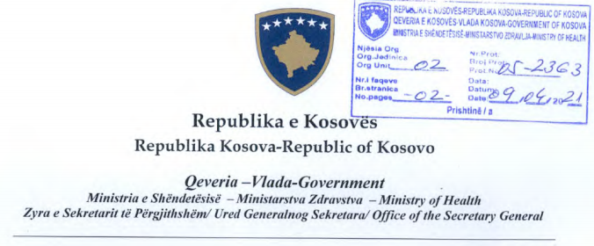
No. 03/2021
Date: 09.04.2021
The Secretary General of the Ministry of Health, pursuant to Article 18 of the Law No. 06/L-113 on the Organization and Functioning of the State Administration and Independent Agencies of the Republic of Kosovo, pursuant to Law No. 07/L-006 on Preventing and Combating COVID-19 Pandemics in the Territory of the Republic of Kosovo, based on Article 89 of the Law No. 04/L-125 on Health, in accordance with Article 4 of the Law No. 02/L-109 for Prevention and Fighting Against Infectious Diseases, and pursuant to the Decision of the Government of the Republic of Kosovo No. 01/11, dated 15/03/2020 for Declaration of Public Health Emergency, pursuant to the Decision of the Government of the Republic of Kosovo No. 01/05, dated 05/04/2021 for General and Specific Measures for Controlling, Preventing and Combating the COVID-19 pandemic, issues the following:
Information Circular 03/2021
To: Directorates of Inspection of Municipalities of the Republic of Kosovo;
Purpose: Implementation of point 42 and 43 of the Decision of the Government of the Republic of Kosovo No. 01/05, dated 05/04/2021 for General and Specific Measures for Controlling, Preventing and Combating the COVID-19 pandemic, in conformity with Law No. 07/L-006 on Preventing and Combating COVID-19 Pandemics in the Territory of the Republic of Kosovo.
Circular to be sent to:
-MLGA
-Directorate of Inspection of Municipalities
-Cabinet of the Minister, MoH
-Legal Department, MoH
-Archive, MoH

